For Immediate Release

Date: 6/24/2024

DSD Merchandisers, LLC
6226 Industrial Way Suite A. Livermore, CA 94551 Phone: 1-925-449-2044
DSD Merchandisers, LLC Announces Voluntary Recall of Deluxe Roasted & Salted Mixed Nuts Due to Undeclared Peanut
DSD Merchandisers, LLC is voluntarily recalling UPC 6-51433-99651-6 Deluxe Roasted & Salted Mixed Nuts, Sell by: 10/09/24, due to the presence of undeclared peanut. People who have an allergy or severe sensitivity to specific type of allergen peanuts run the risk of serious or life-threatening allergic reaction if they consume these products.
This product is sold to Farm Fresh to You who then distributes through E-commerce through Farm Fresh to You or Full and/or Full Circle subscribers. Farm Fresh to You subscribers are located in California & Nevada. Full Circle subscribers are located in Washington, Oregon, Idaho, and Alaksa. These consumers would have received their product through mail. Product is packaged in clear plastic tubs that contain 5oz product. Product label is located at the top of the 5oz tub. The product inside of the tub is a mix of various tree nuts including Cashews, Almonds, Hazelnuts, Pecan Halves, Macadamia and the undeclared ingredient (Peanut). The product label does not contain a name brand only product name (Deluxe Roasted and Salted Mixed Nuts). Sell By printed on the label is 10-09-2024.
The recall was initiated after a consumer contacted DSD merchandisers, LLC through our website to report they purchased product and upon consuming noticed that the product contained peanut which they then noted the label did not note Peanut on the Ingredient Statement nor the Allergen Statement portion of the label the label just contained a packed on same equipment as product containing peanut statement. Subsequent investigation indicates the problem was caused by a temporary breakdown in the company's formulation change processes and packaging label change process.
Consumers who have purchased this product Distributed by DSD merchandisers, LLC are urged to return product via mail marked “ATTENTION: RETURNED GOODS” to the address stated on this Release Letter.
For more information or assistance regarding this recall, consumers can contact DSD Merchandisers, LLC at 1-925-449-2044 (Monday to Friday, 9:30 a.m. to 5 p.m. EST).
This voluntary recall is being conducted in cooperation with the Food and Drug Administration (FDA). We appreciate your cooperation and apologize for any inconvenience caused.
Product details are on the second page of this notice.

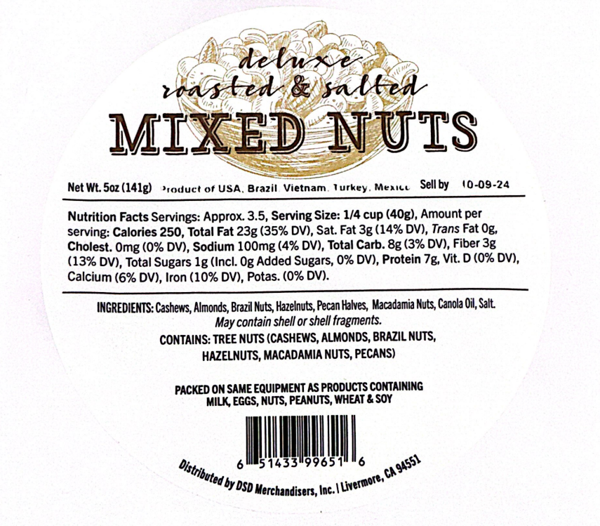

We appreciate your assistance,

DSD Merchandisers, LLC

