FIRST LOOK INTO DAVINCHY’S WORLD
“FOLLOW THE CODES”

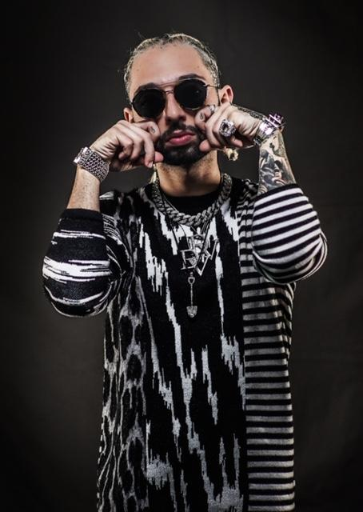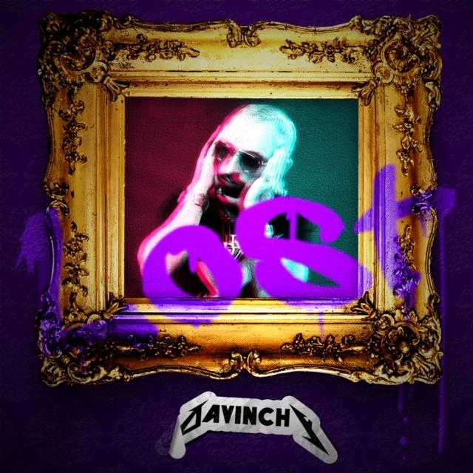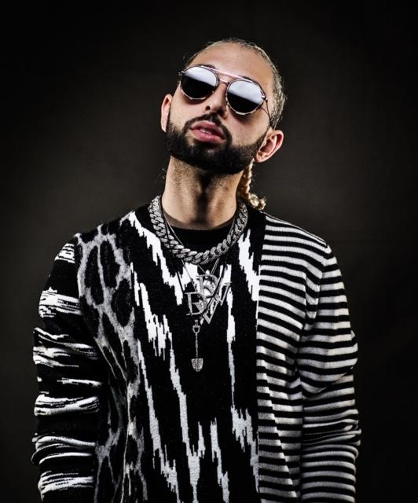

RECORDING ARTIST DAVINCHY OPENS THE WINDOWS OF HIS SOUL WITH HIS UPCOMING URBAN/POP DEBUT ALBUM ‘FOLLOW THE CODES’ WHICH HAS LAUNCHED ITS FIRST SINGLE AND VIDEO IN THE AMERICAN MARKET WITH ‘LOST’

FOR IMMEDIATE RELEASE

(New York, NY)- February 14, 2019 - Davinchy is an American singer, songwriter and accomplished jewelry designer, coming from Russian and Persian (Bucharian) descent from a family of strong Jewish religious ties who built a jewelry empire in NYC and Miami.

Davinchy became known to the public eye at the age of 14th where he sang in English, Spanish, and Italian, making him the youngest contestant on America’s TV nationwide singing competition Minuto de Fama. Three years later, Davinchy climbed the charts with his single “Hard to Say No” to #3 in Billboard Breakout for Hot Dance Play.

Through his travels he became fascinated with the eclectic secrets about the universe and gained a massive knowledge about his Jewish heritage, but most importantly he discovered himself and what he wanted to express through his art.

“Being an artist is not only painting a canvas or making music, for me its creating in multiple ways...even love is an art and we should definitely utilize to benefit not only ourselves but everyone else around us and that is what inspired me to do music, because I found myself.”

Davinchy’s new single “LOST” is now hitting the Apple Music, Spotify and other major playlists and his video with over one million views is rocking across all platforms. ‘Lost’ mixes the influences and inspirations of his early years listening to artists like Lady Gaga, Vista, George Michael, Placido Domingo and Lil Wayne amongst others.

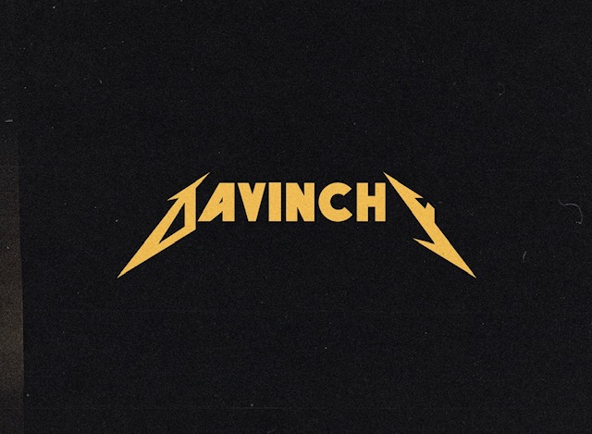

Since 2018 Davinchy has been preparing “Lost” in collaboration with globally known music producer Yeyo and the Trapical Vibes team, who helped direct him and achieve a unique (pop/rock urban fusion) where Davinchy can show the world his love and knowledge about music, life, deep secrets and mystical findings of the world.

“In today’s world a lot of people are lost and need help to find some kind of hope in their lives and know their purposes. ‘Lost’ for me is very big and I hope one day I can revive a lot of lost souls and I can bring them back, that’s my purpose for ‘Lost’.

Davinchy’s new single “LOST” and music video premiered January 15th, 2019 in New York City, the city that saw him take his first steps in his musical career. He will be astonishing audiences in North America then continue to conquer the West Asian region including Russia, Israel, then Europe followed by the East and South East Asian markets and soon the whole world.

LOST is available on iTunes & Spotify
EPK : https://youtu.be/dRLCTRUzaYw

LOST on the Web:
Web: www.Davinchy.com
Facebook: https://www.facebook.com/davinchyworld
Twitter: https://twitter.com/davinchyy
Instagram: https://www.instagram.com/davinchy/
Youtube: https://youtu.be/j36BP_ARY_k

To learn more about Davinchy and his music, as well as events, visit:
www.Davinchy.com.

For interviews, music and further information
CONTACT: Jannette Cabanita, JCPR Agency
jc@jcpr-agency.com
Cell: 917.324.2691
_______
About Trapical Vibes
Trapical Vibes is a multi-platinum, Grammy, ASCAP and BMI Award winning production and songwriting team. Based in Miami and with over a decade experience working with some of the top names in the Latin and Anglo music market industry.
Instagram Twitter Facebook

