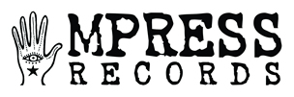

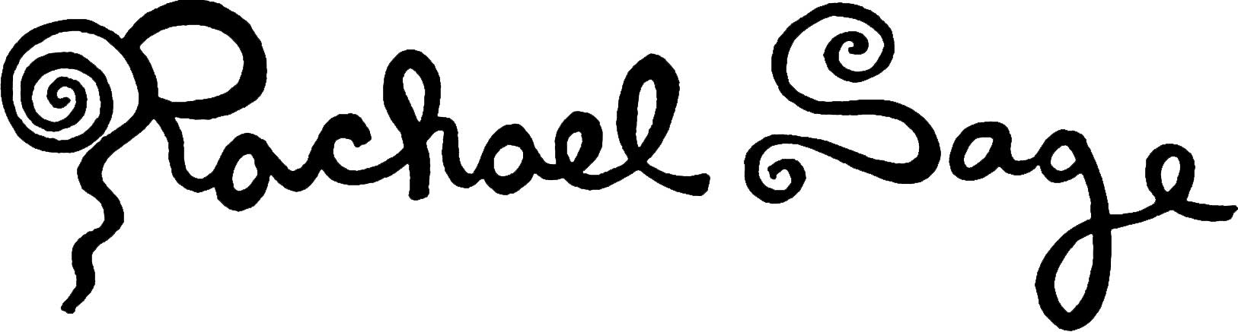

For immediate release
November 22, 2016

Rachael Sage To Join Howard Jones On Spring 2017 Tour

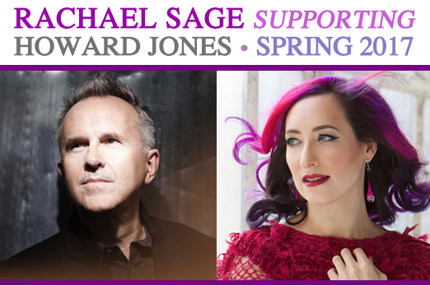

New York, NY: Award-winning singer-songwriter and multi-instrumentalist Rachael Sage will be joining iconic synth-pop pioneer and hitmaker Howard Jones on the U.K. leg of his 2017 Spring Tour. Sage has often named Jones as one of her most beloved artists and a seminal influence on her songwriting, and while she has rarely covered other artists' music, she used to perform his songs including "No One Is To Blame" at her regular solo piano gig while attending Stanford University.

"I've been touring for many years and enjoyed every minute of my eclectic, adventurous indie career so far", enthuses Sage. "But when the phone rang a few days ago and I was told I would be supporting Howard Jones, it was quite literally a dream come true. It will be a huge honor to share the stage with one of my all-time favorite artists, and I can't wait to meet him in person!"
Having released twelve albums of original material since founding her own label MPress Records, she originally identified with Jones' music as a teenager because, as she puts it, "He came from a classical place at the piano and so did I. He played synthesizer and so did I. But mainly it was because his lyrics just seemed so incredibly honest and compassionate. And vocally, it felt like he was singing just to you."

Though based in New York City, Rachael has recently been spending more time in England, where she's developed a strong fan-base by performing at events such as the Cornbury Music Festival, London Pride and London Acoustic Music Festival as well as larger tours with a variety of artists including Judy Collins, Sadie & The Hotheads (featuring Elizabeth McGovern) and John Barrowman. In the U.S., she's shared stages with Ani DiFranco, Shawn Colvin, Marc Cohn and many others. "I just love performing, and any captive audience is one I feel fortunate to have a chance to engage and hopefully, uplift. I'm one of those introverted extroverts who feels most comfortable on stage, and after gigs I love meeting people and hearing their reactions to the music. I can't wait to meet fellow Howard Jones fans, both on and off the stage."

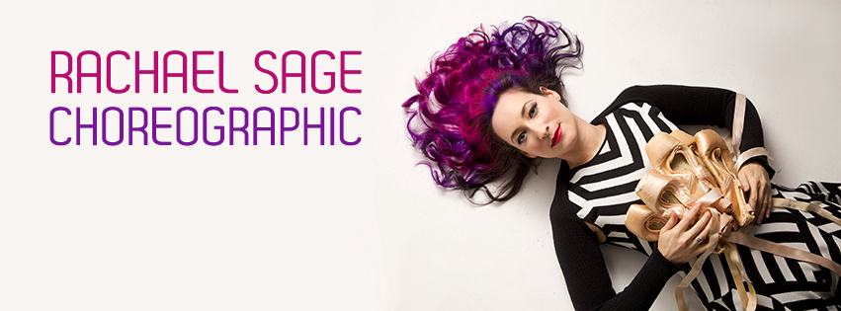

Sage's current album, "Choreographic", was released in the U.S. this past May and will be out in the U.K./Europe on November 18th, via ILS/Universal/Caroline. She describes it as "a love-letter to dance" and the collection was inspired by her own relationship to ballet, which she studied for many years before shifting full-time to music. As a young student at The School Of American Ballet, she juggled intensive dance studies along with her ongoing passion for writing and recording her own songs, which had been sparked by early exposure to her parents' record collections. Steeped in The Beatles, Buddy Holly and Elvis by her father and classical, Broadway and folk music by her mother, Sage received a 4-track recorder for her Bat Mitzvah, followed by a Jupiter 8 synthesizer. She then acquired various drum machines and eventually, computer-based sequencers to augment what had become a full-blown studio in her parents' basement.
"I would bring my whole synthesizer and drum-machine rig to local talent shows. Once people thought of me as a 'one woman orchestra', I started getting asked to write music for Shakespeare productions and various other plays. In high school I was fascinated by electronic music, but mainly because I was just doing my own thing and wanted to make it sound as big as possible. I'd never even played with another musician until my 20's, where I encountered my first collaborator in the form of a violinist. What was amazing about the '80's was the diversity in music. As a kid I loved and absorbed all of it, especially Howard Jones. The instrumentation may have been more electronic, but the songs were never more heartfelt and universal. It was a great time to be learning the crafts of songwriting and production and I've been hooked ever since."

GET "CHOREOGRAPHIC" ON iTUNES
HERE
www.itunes.apple.com/us/artist/rachael-sage/id4369725
"Part Bob Dylan – part Taylor Swift – Rachael Sage has the guts, vision and talent to embody both within the confines of her music."
--MAVERICK UK

"Billy Joel's gotham zing and brashness..."
--MOJO

"The Carole King of her generation....Sage is easily the match for any master, either past or present."
--BLURT MAGAZINE

"A witty lyricist and an adept composer...heartfelt and revelatory"
--iTUNES EDITORIAL

"Genuine talent....Sage has a knack for writing melodies that will break your heart."
--ROLLINGSTONE.COM

On Tour Now #ChoreographicTour
*dates supporting Howard Jones

12.3.16
The Hotel Cafe
Los Angeles, CA
12.8.16
Lestat's
San Diego, CA
12.9.16
Fiddler's Dream
Phoenix, AZ
12.10.16
Starlight Lounge @ Cafe Roka
Bisbee, AZ
1.17.17
Rockwood Music Hall
New York, NY
3.3.17
The Spire Center For Performing Arts
Plymouth, MA
3.5.17
Mexicali Live
Teaneck, NJ
3.8.17*
The Exchange
Sturminster Newton, UK
3.9.17*
Grand Pavillion
Porthcawl, UK
3.10.17*
Public Halls
Harpenden, UK
3.11.17*
Theatre Royal
Winchester, UK
3.12.17*
The Old Market (TOM)
Hove, UK
3.16.17*
Brewhouse Theatre and Arts Centre
Taunton, UK
3.17.17*
Artrix Centre
Bromsgrove, UK
3.18.17* The Picturedrome
Holmfirth, UK
3.19.17*
Palace Theatre
Newark, UK
3.22.17*
The Atkinson
Southport, UK
3.23.17*
ARC, Stockton Arts Centre
Stockton-On-Tees, UK
3.24.17*
Playhouse, Whitley Bay
Whitley Bay, UK
3.26.17*
Òran Mór
Glasgow, UK
3.28.17*
Union Chapel
London, UK
3.29.17*
The Stables
Milton Keynes, UK
3.30.17*
The Lowry
Salford, UK
3.31.17*
Lancaster Grand Theatre
Lancaster, UK

FOR MORE INFORMATION, INTERVIEW REQUESTS & PRESS INQUIRIES PLEASE CONTACT
Tiina Teal | 212-481-7243 | mailto:press@mpressrecords.com
MPress Records

CONNECT WITH RACHAEL
facebook: www.facebook.com/rachaelsagepage
twitter: www.twitter.com/rachaelsage
instagram: www.instagram.com/rachael_sage
presskit: www.presskit.to/rachaelsage
youtube: www.youtube.com/rachaelsage

MPress Records | 212.481.7243
http://mpressrecords.com/
2016

