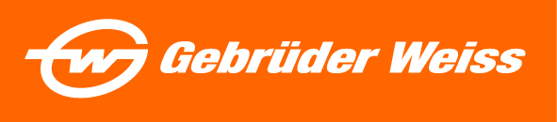
Press release
International Transport & Logistics Leader Gebrüder Weiss to Participate in
“Manifest Vegas”

The company will highlight its domestic transport and nearshoring services at an interactive booth featuring golf pro tips and “long drive” practice at the supply chain conference

Wood Dale, IL—(January 17, 2024) - Gebrüder Weiss, a 500-year-old international transport and logistics company, will be on-site for Manifest Vegas at Caesars Forum in Las Vegas, Nevada, from February 5-7, 2024. The conference is billed as the “premier gathering that unites the entire eco-system of Fortune 500 global supply chain executives, logistics service providers, innovators and investors at the forefront of logistics tech and end-to-end supply chain.” Key executives from the United States will attend networking events and conference sessions, and representatives will host an interactive booth with a golf simulator (visit them at booth 1601).

“Manifest is one of the top supply chain and logistics events in the nation, and we’re delighted to provide support and sponsorship,” says Mark McCullough, CEO of Gebrüder Weiss North America. “As a global logistics firm with European roots, we are keeping pace with post-pandemic trends and continue to anticipate and respond to customer needs around the world. In the past two years, our North American offices have expanded our domestic transport services and opened additional facilities in Laredo and El Paso, Texas, to support the North American cross-border trucking and nearshoring trend,” added McCullough.

The company’s booth theme is “The Long Drive,” a play on words for the logistics organization’s golf simulator activity that will allow attendees to practice their swings and compete in a daily contest for prizes in a “Long Drive” and “Closest to the Pin” challenge. The theme highlights full truckload (FTL), less-than-truckload (LTL), and partial truckload services offered by Gebrüder Weiss. Demand for LTL, in particular, has boomed during the post-pandemic trend toward nearshoring and cross-border shipping. Globally, the LTL market size is expected to grow at a compound annual growth rate (CAGR) of 7.3% from 2024-2028.

“The future of the global supply chain hinges on a combination of advanced technology and digitalization for peak efficiency, and the human element of white glove, high-quality customer service,” added McCullough. “We’re grateful to the conference organizers for bringing the top minds in the industry together to help spur the next evolution of the supply chain.”

Event registration is available at a discount through Gebrüder Weiss’ custom sponsor link. More than 3,000 people attended the 2023 Manifest event, and 2024 attendance is expected to surpass 4,500 people.

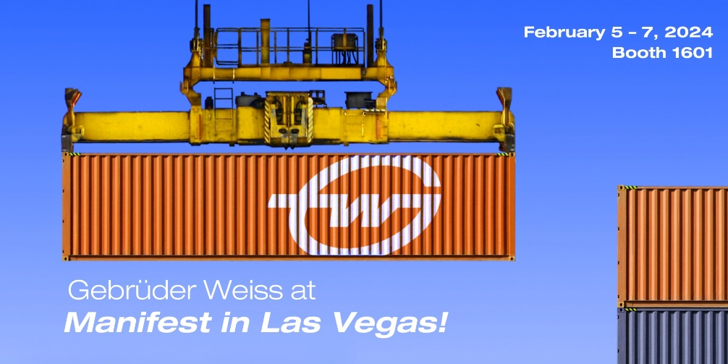

Photo Caption: Gebrüder Weiss will attend and host booth number 1601 at Manifest Vegas, February 5-7, 2024.

For more information, please visit www.gw-world.com.

##

About Gebrüder Weiss
Gebrüder Weiss, a global freight forwarder with a core business of overland transport, air, and sea freight and logistics, is the world's oldest transport company with a history that dates back more than 500 years. The family-owned company employs more than 8,400 people worldwide and boasts 180 company-owned locations. The business presence in North America includes headquarters in Chicago and offices in Atlanta, Boston, Dallas, El Paso, Houston, Laredo, Los Angeles, Miami, New York, San Francisco, Montreal, Toronto, and Vancouver. The company has implemented a wide variety of environmental, economic and social initiatives and is considered a pioneer in sustainable business practices. The company’s emphasis on superior customer service pairs customized solutions with a single point of contact to provide customers with focused, reliable, and economical solutions. www.gw-world.com/us
North American Contact:
Karolyn Raphael
Public Relations for Gebrüder Weiss
karolyn@wingermarketing.com
312-494-0422

