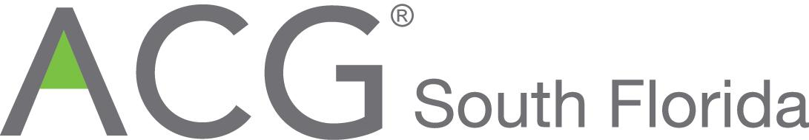
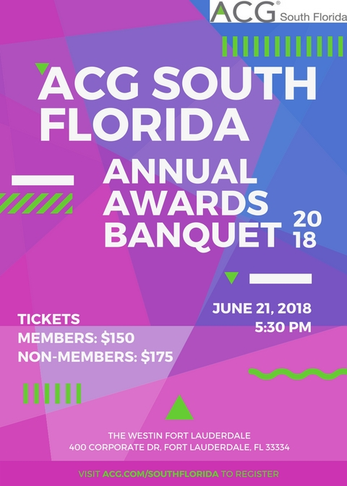

FOR IMMEDIATE RELEASE

ASSOCIATION FOR CORPORATE GROWTH SOUTH FLORIDA’S 26th ANNUAL AWARDS BANQUET

South Florida, March 26, 2018 The South Florida Chapter of the Association for Corporate Growth (ACG-South Florida) announced today that its 26th Annual Awards Banquet will be held June 21, 2018 at The Westin Fort Lauderdale located at 400 Corporate Drive, Fort Lauderdale, FL 33334 (tel 954 772 1331). Three major awards will be presented. The award descriptions/criteria and past winners are shown below. The Board is evaluating input of its directors, members and guests of possible award winners among South Florida’s leading businesses. The categories are Outstanding Growth Company of the Year, Emerging Growth Company of the Year and Deal/Transaction of the Year. A cocktail reception, awards dinner and post event reception will be held on June 21st beginning at 5:30pm – save the date. ACG South Florida offers a wide range of event sponsorship and advertising opportunities to businesses in Miami-Dade, Broward and Palm Beach Counties, that wish to join us in honoring the best in South Florida business. The journal ad and sponsorship menus follow below.

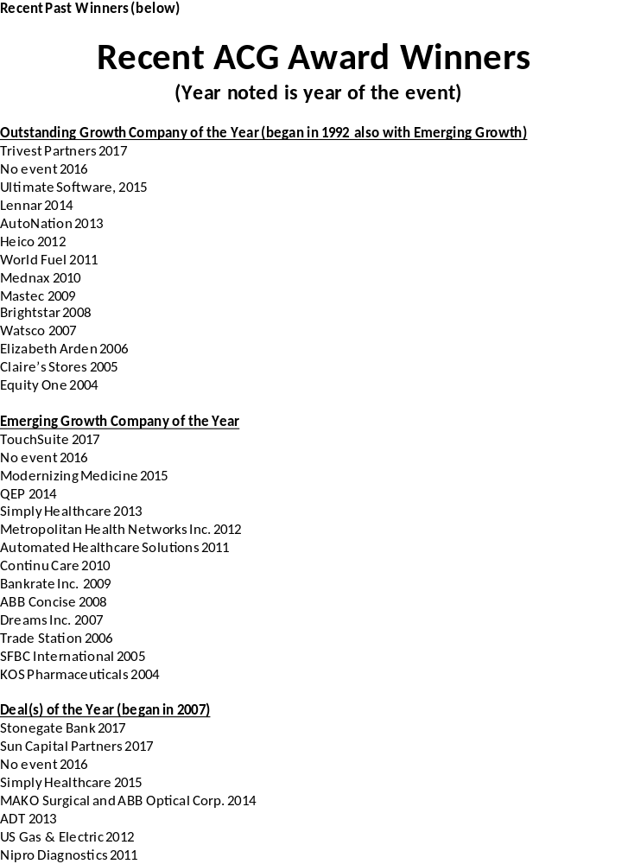

Sponsorship, Advertising, Tickets Menu


Annual Awards Banquet
Thursday, June 21, 2018 – 5:30pm at The Westin
400 Corporate Drive, Fort Lauderdale, FL 33334

26th Annual South Florida ACG Awards Sponsorships
All sold on first come, first served basis
Sponsor commitments must be received by not later than Monday May 28
Sponsors’ ad copy must be received no later than Friday June 1

Sponsorships
- Exclusive Names Event Sponsor - $10,000, includes signage, press releases, free table for 10, logo centerpiece, logo in ACG web, two paid ACG new memberships, logo tote bag to all attendees, emcee mentions, ad and story inside front cover of journal, name sponsor presents outstanding growth award
- Cocktail Party Sponsor - $7,000, includes pre-awards/dinner cocktail party networking title sponsor signage, cocktail glass with logo, logo napkins, full page 4-color ad in journal, six free tickets, one paid new ACG membership, emcee mentions, logo on ACG website and press releases, presents emerging growth award
- AV and Program Sponsor - $5,000, logo and name featured on awards video , one full page 4 color journal ad, four free tickets, logo on ACG web, emcee mentions, logo on press releases
- Post Awards Dinner Party Sponsor - $4,000, logo signage, logo napkins, four free tickets, full page 4 color journal ad, present deal of the year award, logo on press releases, ACG web and emcee mentions
- Supporter Sponsor - $2,000, includes two free tickets, half page 4-color journal ad, logo on ACG web and in press releases, emcee mentions
- Advertising Sponsor - $1,000, includes two free tickets, quarter page black/white journal ad, logo on ACG web, emcee mentions
Checks must be made payable to ACG South Florida at commitment
PO Box 5505, Ft. Lauderdale, FL 33310
Email: renparlc@gate.net Payment by credit card may be accomplished through the email above.

Name:_____________________________Company:_______________________________________
Address:___________________________City/State/Zip Code:_______________________________
Telephone:_________________________Email:__________________________________________
Sponsorship Description (as above):____________________________________________________
Thank you for your support!!!

Annual Awards Banquet
Thursday, June 21, 2018 – The Westin
400 Corporate Drive, Fort Lauderdale, FL 33334

26th Annual South Florida ACG Awards Journal/Program Ads
Back Cover 4-color $1,650
Inside Back Cover 4-color $1,500
Full Page 4-color $700
Half Page 4-color $400
Quarter Page black/white $200

Ads sold on first come, first served basis
Camera ready ads must be in jpg or pdf formats
Ad deadline for reserving space is Monday May 28
Ad copy must be received not later than Friday June 1

Checks must be made payable to ACG South Florida at time of commitment
PO Box 5505, Ft. Lauderdale, FL 33310
Email: renparlc@gate.net
Payment by credit card may be accomplished through the email above.

Name:____________________________Company:_________________________
Address:__________________________ City/State/Zip Code:_________________
Telephone:_______________________ Email:____________________________
Ad Size/Description (as above):__________________________________________

Thank you for your support!!!

Annual Awards Banquet
Thursday, June 21, 2018 – The Westin
400 Corporate Drive, Fort Lauderdale, FL 33334

26th Annual South Florida ACG Awards Tickets
All sold on first come, first served basis
Tickets shall be paid for at time of commitment

Tickets: $150 each (member); tables of 10 available; $175 each (non-ACG member)
Quantity: _________
Purchaser:__________________________________
Contact: ___________________________________
Contact Phone: _____________________________
Contact Email: ______________________________
Payment Method- circle one (Check to ACG) (Visa) (MasterCard) (Amex)
Credit Card Number: _________________________
Expiration (mm/yr): __________________________
Payment by check can be made at time of commitment, payable to ACG South Florida, PO Box 5505, Ft. Lauderdale, FL 33310; Contact: renparlc@gate.net

Names of attendees:
Name Company
__________________________ ______________________________
__________________________ ______________________________
__________________________ ______________________________
__________________________ ______________________________
__________________________ ______________________________
__________________________ ______________________________

Thank you for your support!!!

2018 Sponsors to date:
Advertising Sponsors: nPerspective, Renaissance Partners

