Aalto Bio Reagents Launches First Monoclonal Antibody Against SARS-CoV-2 Nucleocapsid Protein.

Dublin, Ireland – 6th November 2020 – Aalto Bio Reagents has just announced the availability of its first mouse monoclonal antibody against SARS-CoV-2 nucleocapsid protein (code CA 1360), which they expect will be a game changer globally. These 5 clones were developed for use in a variety of assays including Western blot, ELISA and lateral flow for the detection of SARS-CoV-2 in plasma, serum or saliva. To date, there have been over 48 million cases of COVID-19 worldwide, including over 1 million deaths. It is evident that early and accurate detection is necessary to help prevent the spread of this virus, and to reduce the rate of these ever-increasing numbers.
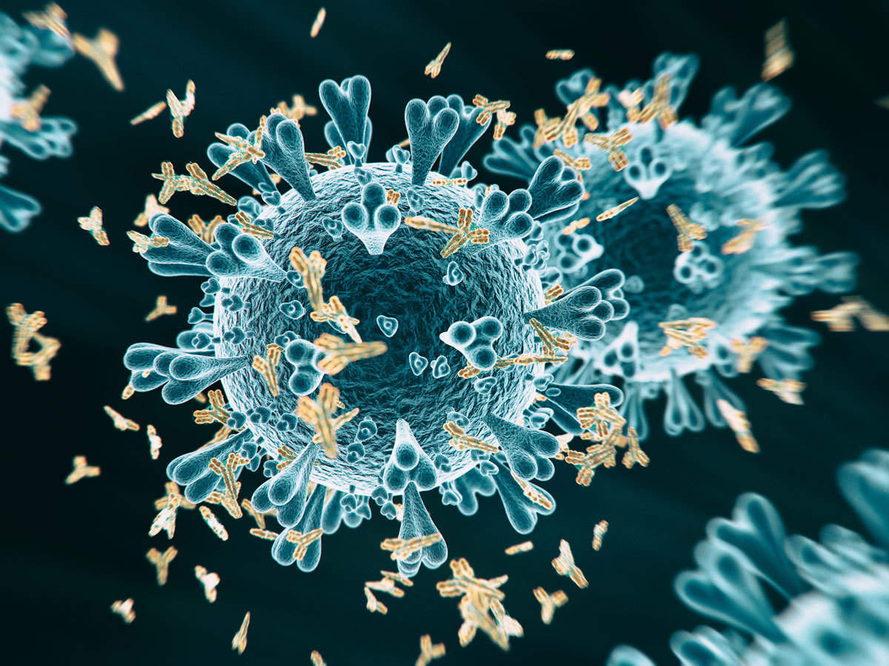
Nucleic acid (NA) testing by real-time reverse transcriptase-polymerase chain reaction (RT-PCR) remains the gold standard when it comes to the diagnosis of SARS-CoV-2 infection. However, this type of test requires a well-equipped laboratory and has a long turnaround time, which doesn’t suit the highly infectious nature of the virus. Rapid antigen tests are low cost and are the preferable method for high volume screening, particularly in the context of incoming travellers at airports. The nucleocapsid protein of SARS-CoV-2 is expressed abundantly during infection making it an ideal target for viral-antigen based detection. Our MAb to SARS-CoV-2 N protein (code CA 1360) demonstrated exceptional reactivity in ELISA when tested against our recombinant SARS-CoV-2 nucleocapsid protein (code CK 6404-b).
“There are a number of rapid tests on the market at the moment that are using the currently available monoclonal antibodies for COVID 19 antigen detection” says Philip Noone, CEO of Aalto Bio Reagents, “however, there seems to be concerns with the accuracy of these tests, specifically when testing asymptomatic people. To ensure the highest accuracy in these tests, it is essential to use highest -quality raw materials which we believe Aalto Bio have delivered with this new COVID19 mab”.
About Aalto Bio Reagents
Founded in 1978, Aalto Bio Reagents is a leading developer and provider of critical raw materials to the in-vitro diagnostics industry and to research laboratories globally. We serve the largest multinational companies in our industry with a broad range of purified human proteins; monoclonal and polyclonal antibodies; fungal, parasitic, bacterial and viral antigens; and disease state plasma for in-vitro diagnostic application.

Since the company's inception, we have built strong working relationships with our clients who trust us to provide them with the highest quality raw materials to meet the exacting standards of their own product development requirements. Headquartered in Dublin, Ireland, the company is rapidly expanding both its product portfolio and customer base. For further information please visit http://www.aaltobioreagents.com

Contact: Aalto Bio Tel: +353-1-4900685 Email: info@aaltobioreagents.com

