Looking for a Father’s Day Gift? Shop BLUETTI for The Best Deals & VIP Exclusives
The best dad in the world deserves the best off-grid power gears on the special day. Gift him the power independence and ultimate off-grid experience.


If your dad is anything like most dads, he has probably already told you he doesn’t want a fuss made for them on this upcoming Father’s Day. However, we still think he’ll be surprised with a gift in their need.
BLUETTI is offering massive markdowns across plenty of solar generators. This sale will start from June 12, 7 PM PDT to June 22, 7 PM PDT. Now you can express your love with a huge save.
(Spoiler Alert: the VIP exclusive discounts are even more jaw-dropping if you are already their customer).

For Your Handyman
AC300 & B300, Modular Solar Generator System
Starts at $3,599 (was $3,798)

For all our DIY-inclined dads out there owning some heavy-duty power tools thirst for electricity at the cabinet, they may worry about the electric bills and wonder how to use the tools when the wall outlets are far from reach. Then it’s time to gift him the BLUETTI AC300 & B300 solar generator system to cover all his needs.

AC300 is 100% modular, which can be configurated according to his needs. The 3000W pure sine wave AC inverter makes it possible to run almost 99% of the power tools without breaking a sweat.

As for the electric bills, he can totally rest assured since the AC300 can connect with two B300 battery modules (3072Wh per unit) to achieve up to 2400W solar input, and fully topped up in 4 hours by prime sunshine.

The AC300 + B300 system (3000W, 3072Wh) is now at $3599, $199 OFF the original price. And don’t forget that this modular system comes with a 4-year hassle-free warranty.

For Dad Works from Home
EP500Pro, All-in-one Home Backup Power
Starts at $4,999 (was $5,999)

Does your dad feel frustrating when there’s a sudden power cut during an important task? Then you might want to help him through this trouble with BLUETTI EP500Pro.

The EP500Pro was born a giant with stunning 5100Wh LiFePO4 batteries under the hood that dad can rely on. Thanks to the 24/7 UPS, the EP500Pro can be integrated into your home or RV circuit for constant power supply. Dad won’t have to stop working whenever the grid goes down, and the data within computer is well-protected from accidental loss.

The EP500Pro is also equipped with a 3000W inverter and 2400W solar input rate to run all dad’s power tools at ease without boosting the electric bills. The built-in LFP battery cells come with 3500+ life cycles which can last nearly 10 years for one cycle per day.

Most importantly, BLUETTI offers a 5-year hassle-free warranty to provide dad with more peace of mind.

For The Outdoorsy Dad
EB55 and EB70S, Portable Solar Generators
(EP55-original price $499, VIP limited deal $399;EB70S-original price $569, VIP limited deal $449.)

Remember the last time you went fishing with dad?
Now you can up your game with the portable power station: BLUETTI EB55 and EB70S.

The portability of the solar-powered generator makes it a perfect companion for traveling, camping, and outdoor events. Dad can pack, store, and move it without any fuss.

Traveling with 537Wh (EB55) to 716Wh (EB70) durable LiFePO4 and a 200W solar input rate to keep the lights on and drinks cold, your dad will immerse himself along the road knowing that he always has a solid power source no matter where he goes.

Jaw-dropping VIP Exclusives
$1,699 (was $1,899) for the AC200MAX, $1,699 (was $1,999) for the B300, and more.

Have ever heard about some “massive discounts” from BLUETTI? This time, they mean it, for VIP ONLY.
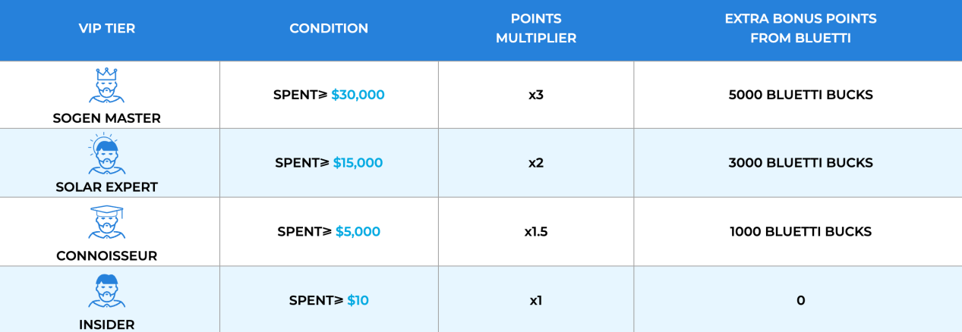
BLUETTI released the VIP loyalty program in March 2022. Anyone with a purchase over $10 can join the program. Once your history order spent on bluettipower.com reaches the $5000 threshold, there will be extra bonus bucks and a points multiplier.

If you already belong to any BLUETTI VIP tier, you’re in luck. In addition to discounts, BLUETTI’s planning limited VIP lightning deals on June 12 and June 19 (Father’s Day 2022) with unprecedented discounts. Come closer for the details:

VIP Deals on June 12:
Models | MSRP | VIP Offers On Jun. 12 | Saved | Availability
AC50S | $379 | $299 | $80 | Limited & Available For All VIP Tiers
EB55 | $499 | $399 | $100 | Limited & Available For All VIP Tiers
EB70 | $569 | $449 | $120 | Limited & Available For All VIP Tiers
AC200P | $1599 | $1399 | $200 | Limited & Available For All VIP Tiers
AC200MAX | $1899 | $1699 | $200 | Limited & Available For All VIP Tiers

VIP Deals on Father’s Day (June 19):
Models | MSRP | VIP Offers On June 19 | Saved | Availability
B230 | $1399 | $1199 | $200 | Limited & Available For Connoisseur, Solar Expert and Sogen Master Only
B300 | $1999 | $1699 | $300
AC300 | $1799 | $1599 | $200
EP500Pro | $5499 | $4699 | $800
PV200 | $499 | $399 | $100

Lucky Wheel

Every order over $2000 placed during the Father’s Day sale (PDT June 12 - June 22) will earn a spin on Lucky Wheel. A large sum of rewards are available, including multiple BLUETTI Bucks (virtual loyalty points issued by BLUETTI for redeeming discounts), even a FREE AC200MAX, and more.
Try your luck and win BIG!

About BLUETTI

From the very beginning, BLUETTI has tried to stay true to a sustainable future through green energy storage solutions for both indoor and outdoor use while delivering an exceptional eco-friendly experience for everyone and the world. BLUETTI is making its presence in 70+ countries and is trusted by millions of customers across the globe. For more information, please visit https://www.bluettipower.com/

Press Contact:
amada@bluetti.com

