Ryde Education Merit Awards (REMA) 2024: Honoring Singapore’s Future Leaders

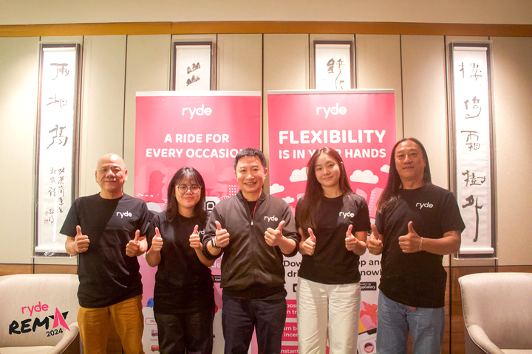
REMA 2024 Recipients – Hannah Yeo and Sasha Ng

SINGAPORE, February 25, 2024 – Ryde Group Ltd (NYSE American: RYDE) ("Ryde'' or the “Company"), is proud to announce the recipients of the Ryde Education Merit Awards (REMA) 2024 – Sasha Ng and Hannah Yeo – two outstanding individuals who exemplify academic excellence, leadership, and a strong commitment to societal impact.
Recognising Aspiration and Impact
The REMA selection process was highly competitive, with candidates undergoing multiple rounds of interviews and assessments to ensure that awardees truly reflect Ryde’s values of aspiration, leadership, and positive change.
Both Sasha Ng and Hannah Yeo demonstrated a clear vision for their future and a commitment to shaping Singapore’s society through their respective fields:
Sasha Ng is an exemplary student with 5 straight As at Dunman High School, excelling in GP, English Literature, History, Mathematics and Economics. She aspires to pursue Law and International Relations at Oxford University, driven by her deep interest in policymaking and diplomacy. Her active involvement in legal discussions, governance programs, and leadership roles in Dunman High’s Law Society and International and Strategic Affairs Society underscoring her commitment to shaping Singapore’s legal and policy landscape on a global stage.
Hannah Yeo has an outstanding academic record, achieving a 3.85 GPA at Ngee Ann Polytechnic, where she is pursuing a Diploma in Early Childhood Development and Education. Passionate about early childhood education and the arts, she plans to further her studies at the National Institute of Education (NIE) to become an art teacher. Her hands-on experience in curriculum development, student leadership, and creative education reflects her dedication to nurturing young minds and strengthening Singapore’s education system.
Beyond academics, both recipients have demonstrated remarkable leadership and community service:
- Sasha’s active participation in Model Parliament, legal internships, and governance research reinforces her drive for public service.
- Hannah’s leadership in FoodAid Club, student council, and education initiatives highlights her dedication to empowering the next generation through creativity and mentorship.

As REMA recipients, both Sasha and Hannah will receive mentorship opportunities with Founder, Chairman, and CEO of Ryde Group, Terence Zou. This will allow them to learn directly from an industry leader about leadership, innovation and making a lasting impact in their respective fields.
Rigorous Selection Process
The REMA 2024 selection was highly competitive, with many outstanding candidates. Among them was finalist Anson Koh, whose expertise in AI, cybersecurity, and financial literacy was highly impressive. Anson has been recognized with an Appreciation Award and encouraged to reapply with a clearer vision for his societal impact.
Parents Express Their Gratitude
Simon Ng, father of REMA 2024 recipient Sasha Ng and a dedicated taxi driver, shared: “I am incredibly thankful to Ryde for giving this opportunity to my daughter. She will certainly use the financial awards provided to her in her studies and for future work. I would like to express my gratitude towards Ryde for recognising the achievements of the children of their taxi driver-partners, and for their generosity in this project.”
Yeo Choon Chai, father of REMA 2024 recipient Hannah Yeo and a Ryde delivery partner, shared: “Our family was overjoyed to learn that Hannah had been selected as a recipient of the REMA Award 2024. The resources provided will undoubtedly play a significant role in supporting her academic success and future endeavours. I would also like to extend my sincere gratitude to Ryde for this meaningful initiative, as well as to everyone involved in making this project a reality.”
REMA 2024 Winners Reflect on Their Achievement
Sasha Ng, recipient of REMA 2024, shared “Winning the Ryde Education Merit Awards (REMA) 2024 is an incredible honor. It means so much to me because my father, a Ryde driver-partner, has worked tirelessly to support our family. This award is a testament to his hard work and the values he has instilled in me— resilience, perseverance, and a commitment to uplifting others.
Hannah Yeo, recipient of REMA 2024, shared “Receiving the Ryde Education Merit Awards (REMA) 2024 is an incredible honor, and I am deeply grateful for this opportunity. This award is not just a milestone— it is a stepping stone towards my dream of shaping the future of education and making learning more inclusive and engaging for the next generation."

Ryde’s Commitment to Education & Leadership
The Ryde Education Merit Awards (REMA) is part of Ryde’s broader mission to empower future leaders and changemakers. By recognizing exceptional individuals like Sasha and Hannah, Ryde aims to support young talents poised to shape Singapore’s future in governance, education, and beyond.
“We are incredibly proud of Sasha and Hannah for their well-defined aspirations and commitment to societal impact. They truly embody the values of Ryde Education Merit Awards (REMA), and we are excited to see them continue their journey towards making a meaningful difference in Singapore.” – Terence Zou, Founder, Chairman, and CEO of Ryde Group,

Looking Ahead
As we celebrate REMA 2024, we encourage future applicants to strive for excellence, leadership, and a clear vision for societal impact. The next REMA cycle will continue to uncover remarkable young minds dedicated to shaping Singapore’s future.
For more information on REMA and Ryde’s initiatives, please visit [https://rydesharing.com/].
About Ryde Group Ltd
Ryde, a homegrown super mobility app founded in Singapore, is the world's FIRST on-demand carpooling app since 2014! As a publicly listed company on the NYSE, we are reimagining the way people and goods move around. We offer a full suite of services, including carpooling, private hire, taxi, and delivery, but what truly sets us apart is our commitment to empower our private-hire and taxi partners. We take 0% commission, ensuring that more of every hard-earned dollar goes to drivers on our platform. For more information, please visit https://rydesharing.com/ to learn more.
Contacts

For Media Relations:
Media Team
Ryde Group Ltd
Email: media@rydesharing.com

For Investor Relations:
Investor Relations Team
Ryde Group Ltd
Email: investor@rydesharing.com

FORWARD-LOOKING STATEMENTS

Statements in this press release about future expectations, plans and prospects, as well as any other statements regarding matters that are not historical facts, may constitute "forward-looking statements" within the meaning of The Private Securities Litigation Reform Act of 1995. These statements include, but are not limited to, statements relating to the expected trading commencement and closing dates. The words "anticipate," "believe," "continue," "could," "estimate," "expect," "intend," "may," "plan," "potential," "predict," "project," "should," "target," "will," "would" and similar expressions are intended to identify forward-looking statements, although not all forward-looking statements contain these identifying words. Actual results may differ materially from those indicated by such forward-looking statements as a result of various important factors . Any forward-looking statements contained in this press release speak only as of the date hereof, and Ryde Group Ltd specifically disclaims any obligation to update any forward-looking statement, whether as a result of new information, future events or otherwise, except as required by law.

