

COPY

CLIENT: | Arkansas Surgical Hospital | DATE: | November 18, 2019
TITLE: | Press Ganey award press release |  | Version: 7

Arkansas Surgical Hospital Receives 2019 Press Ganey Guardian of Excellence Award®️ for Patient Experience

NORTH LITTLE ROCK - Arkansas Surgical Hospital has been named a 2019 Guardian of Excellence Award®️ winner by Press Ganey and is the only hospital in Arkansas to receive this recognition.

The nationally-recognized award honors top-performing health care organizations that have achieved the 95th percentile or above in performance in Patient Experience. Presented annually, the award names clients who consistently sustained performance in the top 5% of all Press Ganey clients for each reporting period during the course of one year.

The 2019 award recipients were honored at the Press Ganey National Client Conference in Orlando, Florida on November 18.

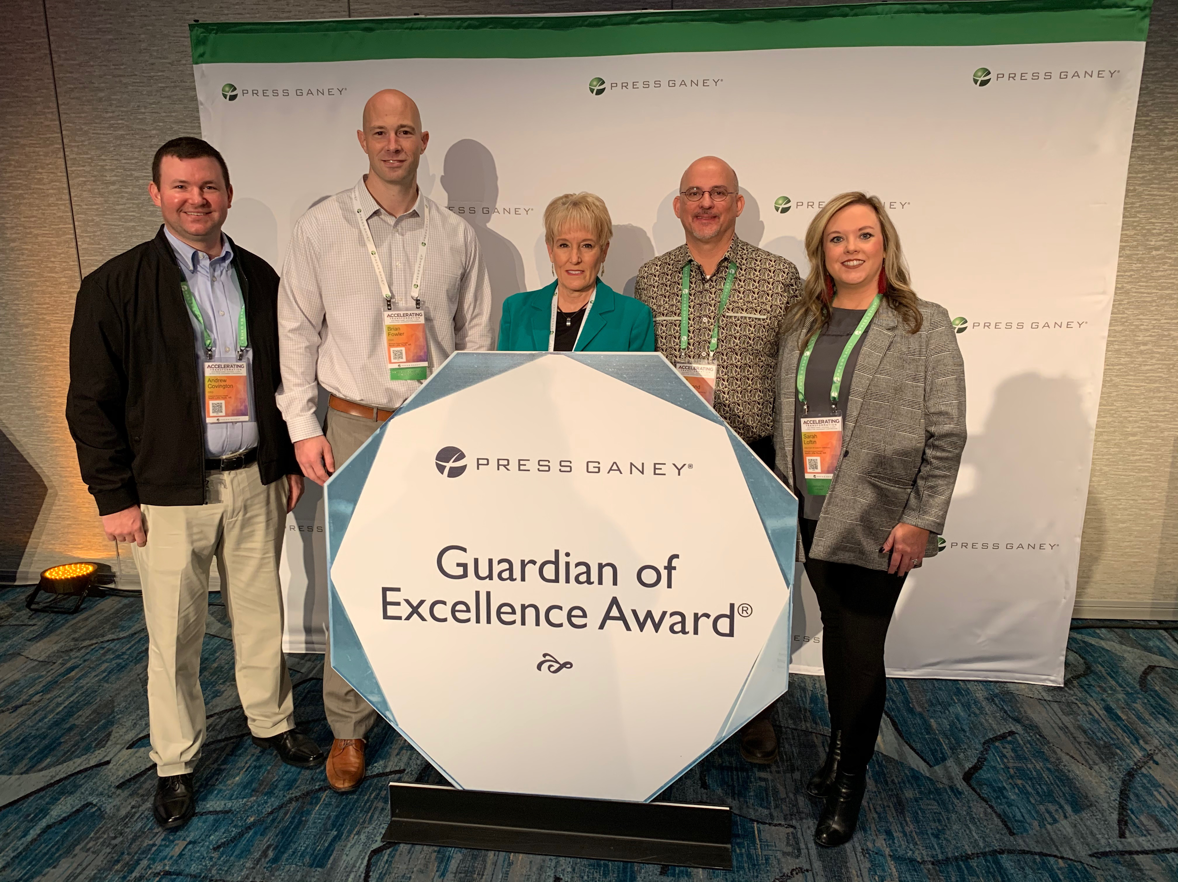
Representatives of Arkansas Surgical Hospital at the Press Ganey National Client Conference in Orlando, Florida. Left to right: Andrew Covington, CFO; Brian Fowler, COO; Carrie Helm, CEO; Kent Hammond, Director of Patient Care Services; Sarah Loftin, Director of Quality Services.

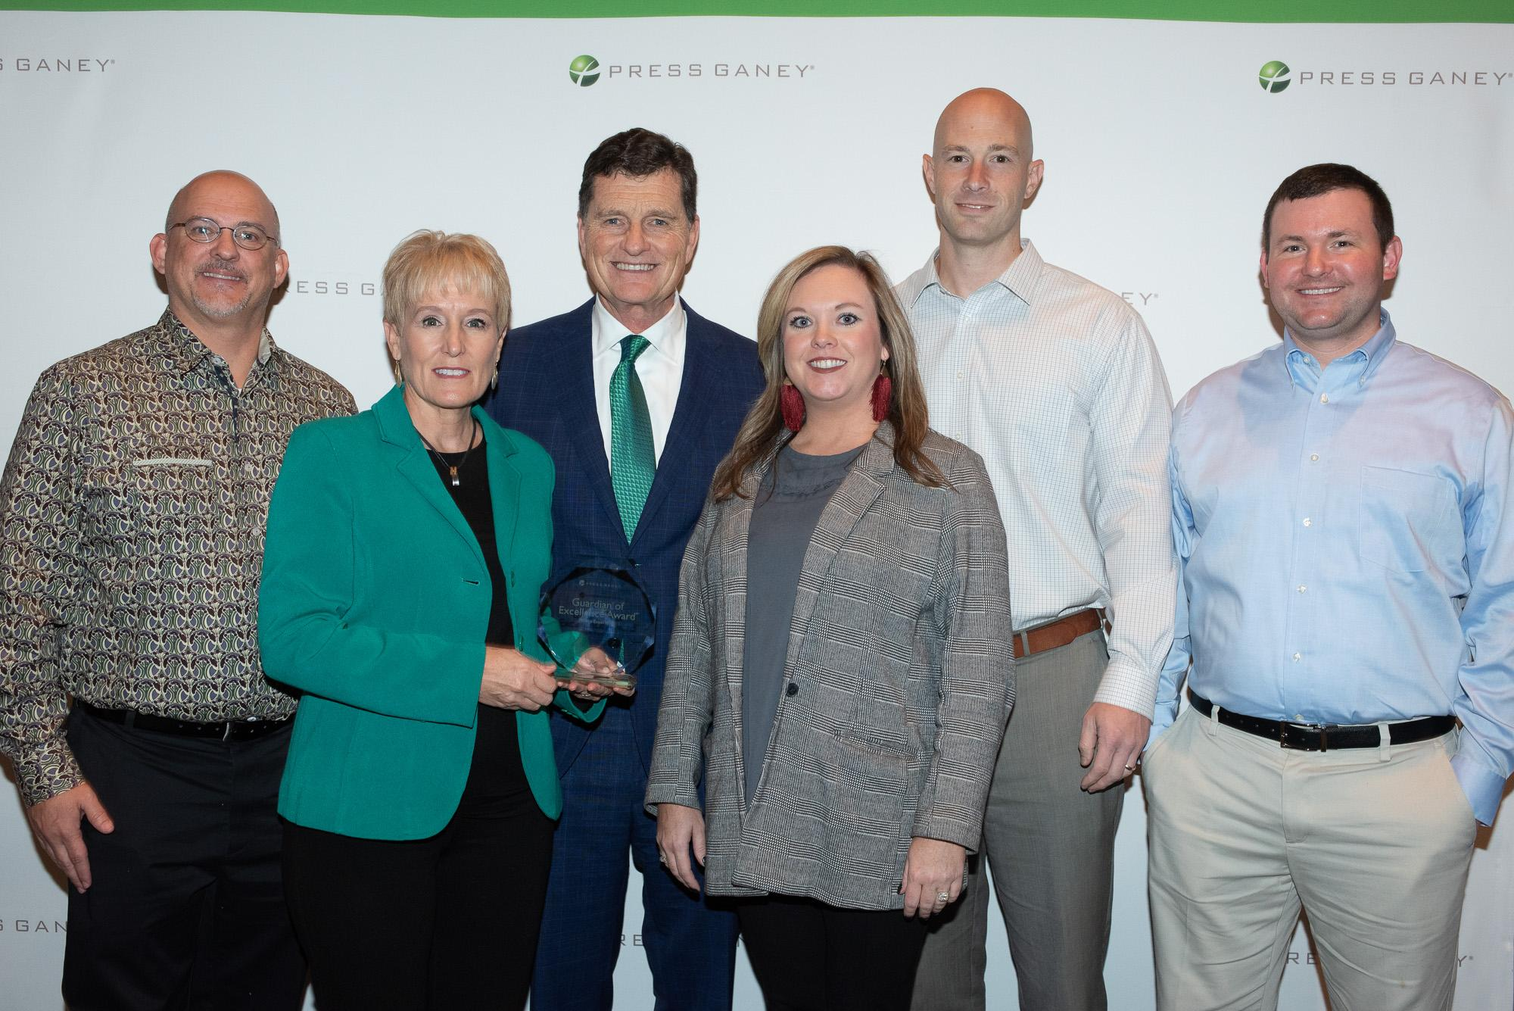
Representatives of Arkansas Surgical Hospital accepting the Guardian of Excellence Award from Patrick T. Ryan, Executive Chairman of Press Ganey Associates.

According to Carrie Helm, the chief executive officer of Arkansas Surgical Hospital, the award represents an important recognition from the industry’s leader in measuring, understanding, and improving the delivery of care.

“It is an honor for our hospital to be named a Guardian of Excellence for Patient Experience,” said Helm. “This prestigious award is further proof that our commitment to exceptional care is being recognized by those to whom it matters most: our patients.”

“Congratulations to Arkansas Surgical Hospital for receiving the Guardian of Excellence Award,” said Patrick T. Ryan, Executive Chairman of Press Ganey. “This honor reflects their unwavering commitment to improving the safety, quality, and experience of care. Their hard work and dedication are inspiring, and we are proud to partner with them on our shared mission to reduce patient suffering.”

About Arkansas Surgical Hospital: Arkansas Surgical Hospital, the leader in orthopedic and spine surgery in Arkansas, is located in North Little Rock. The physician owners at Arkansas Surgical Hospital are focused on exceptional outcomes for their patients. This includes a commitment to patient safety, care, and comfort for patients and their families. To learn more about Arkansas Surgical Hospital, visit ArkSurgicalHospital.com.

About Press Ganey: Press Ganey pioneered the health care performance improvement movement more than 30 years ago. Today, Press Ganey offers an integrated suite of solutions that enables enterprise transformation across the patient journey. Delivered through a cutting-edge digital platform built on a foundation of data security, Press Ganey solutions address safety, clinical excellence, patient experience, and workforce engagement. The company works with more than 41,000 health care facilities in its mission to reduce patient suffering and enhance caregiver resilience to improve the overall safety, quality, and experience of care.

