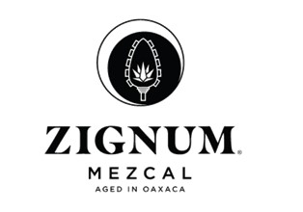
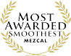
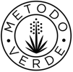
Media Contact:

Victoria Camargo
Deussen Global Communications, Inc.
vcamargo@deussenglobal.com
m.786-271-4641

Introducing ZIGNUM: The Most Awarded Mezcal
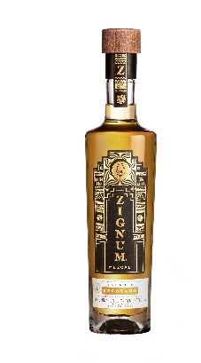
Oaxaca City, Oaxaca, Mexico / August 5, 2019: Rooted in Oaxaca, ZIGNUM is one of the leading Mezcals in Mexico and Mexican duty free and is the most awarded Mezcal in the world, often noted for being smooth and easy-to-drink. The METODO VERDE™ ZIGNUM distillery is cruelty-free, certified Clean Industry by Mexico’s Federal Attorney for Environmental Protection, and Kosher, among other designations. Socially, ZIGNUM’s pioneering agave nursery program is used as a model for agricultural curriculums in some of Mexico’s most respected universities. In addition, the company funds and operates two foundations – one promoting the arts, the other providing social services – and employs more women than any other Mezcal distillery. ZIGNUM ages its Reposado in medium charred white oak, and its Añejo in a combination of medium charred French and American oak. ZIGNUM Joven, Reposado, and Añejo are dressed in packaging inspired by pre-Hispanic Oaxacan temples and, can be enjoyed neat (traditionally with a slice of orange sprinkled with sal de gusano) or in cocktails.
Production: From Field to Bottle
From organic seed germination in the greenhouses to agave reforestation for sustainability, ZIGNUM thoughtfully monitors every step of production to create optimum quality Mezcal.
Organically managed nurseries cultivate espadín from seed
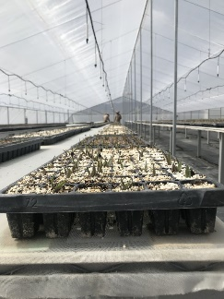
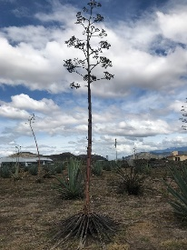
ZIGNUM is one of the few Mezcal distilleries with a greenhouse nursery program, in which they organically cultivate espadín from seed. This long, slow, expensive process protects against the over-harvesting wild agave, and it also promotes bio- and genetic diversity. Cultivating from seed is time-consuming because for seeds to exist, an agave plant must be allowed to flower. This only happens when the plant is a minimum of 7 years old, and after flowering, the plant dies. In addition, the effort of flowering exhausts the plant’s sugar stores, so its piña cannot be used for distillation. Many producers rely on the more common agave cloning method, but ZIGNUM invests in germinating from seed to maintain the species’ health and vigor by allowing bio- and genetic diversity, as pollination is a necessary step. As a result, the bird, bee, and bat populations in ZIGNUM’s agave field are busy and thriving.
ZIGNUM’s pioneering agave nursery program has garnered attention from several of Mexico’s most respected universities, who use the program as a model for their agricultural curriculums.
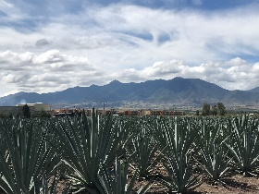
A 11-hectare agave field, and 26 partner growers
In addition to its greenhouses, ZIGNUM has a 11-hectare (27-acre) agave field. Any additional agave hearts needed are supplied by ZIGNUM’s partner growers, who – similar to partner growers in Champagne – are coached on and inspected for following ZIGNUM’s method. This communal work helps foster long-term relationships with the growers.
The Barrel Room
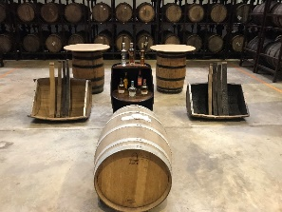
ZIGNUM’s spacious, cool, dark barrel room is currently aging hundreds of liters of ZIGNUM Mezcal. The Mezcal destined to become ZIGNUM Reposado is in charred, white American oak, while the spirit bound to become Añejo ages in a mix of half American and half French oak. ZIGNUM ages its Reposado for 8 months, well beyond the 2 months required by law. The Añejo is aged for 18 months, surpassing the law’s 12 month requirement.
Stewardship
Environmental
Mezcales Casa Armando, the Mexican, family-owned, parent company of ZIGNUM, is meticulously dedicated to their mission to produce the best quality Mezcal while protecting and nourishing the environment. Their eco-friendly policies include collecting rainwater for use in the distillery, using solar panels to heat the water used in the distilling process, re-foresting agaves, and building and using their own wastewater treatment facility to purify and re-oxygenate the water used during production so that it can be re-used for irrigation and other purposes. The ZIGNUM distillery team is extremely proud of their Clean Industry, ISO 9001, Kosher, and HACCP certifications.
Social
The parent company’s two community outreach programs, the Fundación Don Antonio Rivera Venegas and the Fundación el Agave y Nosotros, promote Oaxacan social welfare and fine arts, respectively. The distillery also employs more women than any other Mezcal distillery.

How to enjoy ZIGNUM Mezcals (NOM-070)
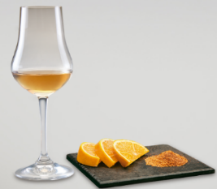
As an exceptionally smooth, easy-to-drink Mezcal, any ZIGNUM expression can best be enjoyed the traditional way: sipped neat, with or without the accompanying orange slice sprinkled with the unique Oaxacan chili and salt seasoning, sal de gusano.

More information, media samples, hi-res imagery, recipes, and interviews available upon request.
Please drink responsibly. ZIGNUM is imported exclusively by Winesource International, Hilton Head, SC

