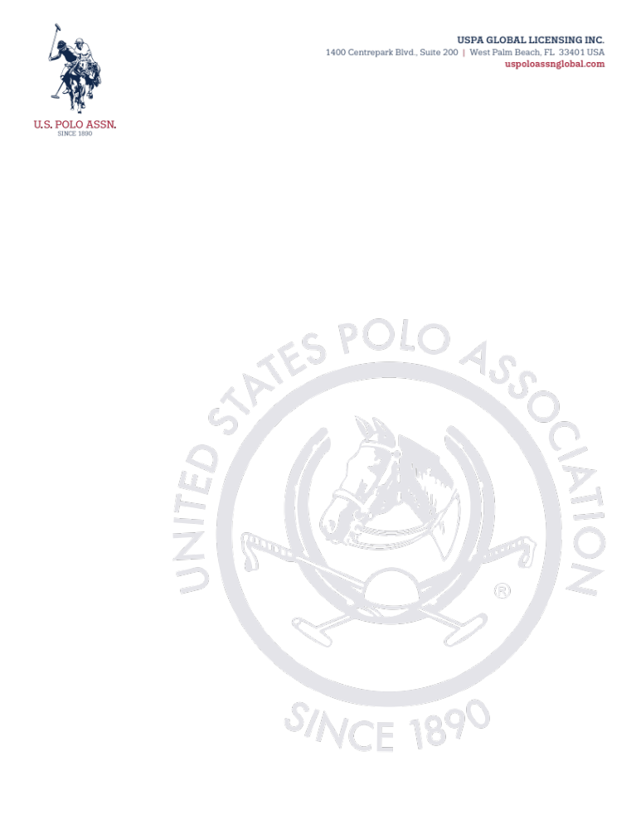

Authentic American Apparel Brand U.S. Polo Assn. Rides into
Sydney with International Polo Championship –
Opening New Licensing Opportunities in the Region

West Palm Beach Fla, USA – (January 31, 2017) USPA Global Licensing Inc., will introduce the U.S. Polo Assn., brand, the officially sanctioned by the United States Polo Association to sports fans, fashionistas and the horse crowd in Australia at the prestigious FIP World Polo Championship in Sydney this October.

Brand awareness and authenticity is a strong focus for U.S. Polo Assn. Both will be prominent in the upcoming partnership with the FIP World Polo Championship at the Sydney Polo Club October 17-31. Expecting nearly 10,000 spectators and broadcast on international sports channel Eurosport and domestically on Free to Air TV, the event will provide a great platform for U.S. Polo Assn. to outfit the polo professionals and officials’ jerseys, equipment bags, hats, jackets and pants.

Australia is one of the few markets still open for USPA licensing opportunities, and President, CEO and former polo player David Cummings thought the world games were the perfect venue to announce the brand to the Australia. He said, “It’s an approach that emphasizes our authenticity, who we are, connecting our passion for the sport with our passion for the brand. It embodies all that’s best about the game and the horses and the camaraderie. A fun and tailor-made way for us to stir up interest for both work and play.”

Recently ranked as #56 in the top 150 global licensors, U.S. Polo Assn. is known for its classic American style and authentic connection to the sport of polo. U.S. Polo Assn. branded products enjoy worldwide distribution through more than 800 mono-brand stores aside from additional retailers like department stores and e-commerce sites, selling apparel for men, women and children, as well as accessories, handbags, luggage, watches, footwear and more.

The U.S. Polo Assn. label is the intellectual property of the United States Polo Association, which is the governing body for polo in North America and recognized by the U.S. Olympic Committee, assigning official status to all branded merchandise. Royalties from sales help support the sport far beyond the USA.
###

ABOUT U.S. POLO ASSN.
U.S. Polo Assn. brand products are officially sanctioned by the U. S. Polo Association (USPA), the American governing body for the sport since 1890. USPA Global Licensing Inc. (USPAGL) manages the Association’s licensing program in more than 135 countries through independent retail, department, online and mono-brand stores, selling sportswear for men, women and children, as well as accessories, luggage, watches, footwear and more.

The USPAGL mission is to create a long-term source of revenue to promote the sport and educate fans. Results help fund efforts in intercollegiate/interscholastic play, Team USPA mentoring, equine welfare, membership, handicapping, clubs, clinics, tournaments and player safety. To learn more, visit uspoloassnglobal.com

CONTACTS:
For licensing inquiries -- Molly Robbins, USPA Global VP Licensing mrobbins@uspaproperties.com, +001.561.530.5747
For info on the broadcast or events Shannon Stilson, Director Global Broadcast and Events
sstilson@uspaproperties.com, +001.561.227.6994

