How many customer experience practitioners will survive 2017?

I don’t believe in coincidences. I told my mother I was booking business flights for the New Year and she emailed me this chart showing survival rates in airplane crashes, and told me to buy good insurance!
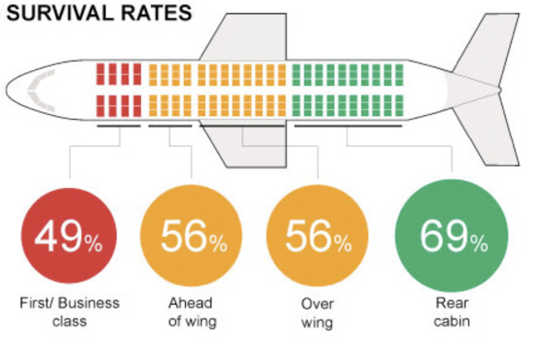
I was later reviewing the 2016 data from CX practitioners who had completed our CX capability assessment and the two sets of numbers struck me as being nearly identical.

Of those CX practitioners who convinced their companies to make large investments in CX, only 51% had survived in their role beyond year 2. Of those who described their focus as building proof-points for the benefits from CX, 72% survived in their role beyond year 2.

Two things are clear.
Firstly, survival rates for CX practitioners are worryingly low.
And secondly that a practical focus on building the evidence that CX is making a difference to your business, rather than large investments in CX. This means you and the customer agenda will survive longer in your company.

But this is more than just numbers. In Q4 2016 alone, I received on average, two emails a week from CX practitioners who had been let go and are “now in transition”. What’s striking is the similarity of reasons for their departure from their CX roles: “the company ran out of patience”, “the NPS numbers were not improving”, “the company had to cut costs and CX was an easy target”.

It doesn’t need to be like this. CX is now a well-travelled path. There are proven strategies to improve the likelihood of success and practitioners can learn from the mistakes of others.

It’s one of the key reasons a group of senior CX practitioners started TribeCX, with the goal of providing a trusted environment where practitioners can share what works (and what doesn’t). Our CX capability assessment provides a clear benchmark of where your CX program stands in comparison to other companies. Practitioners from 17 countries have already contributed to this in the past year. Monthly practitioner calls enable CX practitioners to learn from the mistakes of some of the world’s experienced CX leaders. We’ve also built practical, step by step toolkits to help practitioners expedite early-wins and build CX proof-points. And they have access CX experts providing 1:1 remote coaching, tailored to you and your company’s unique needs and capabilities. http://www.tribecx.com/tribes

Subscribers to TribeCX have access to these resources “built by practitioners, for practitioners”. The first step is to schedule a “virtual coffee” with one of our team of global CX experts, to build a “do now, do next, do later” roadmap with you to validate and drive your CX plans in 2017. Hello@Tribecx.com

Annual subscribers signing up to TribeCX in January receive a month for free. And if you find yourself let go from your CX role this year, we’ll give you a personal free subscription to TribeCX for the year so you can stay connected and be in the best shape to secure your next CX role.

It’s the best insurance you can buy for your CX journey and it will safeguard against you becoming a statistic in 2017!

