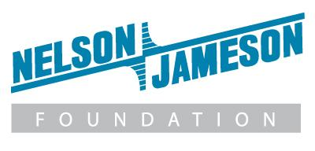

FOR IMMEDIATE RELEASE

Nelson-Jameson Announces Support for National Breast Cancer Awareness Month

Leading dairy distributor kicks off Breast Cancer Awareness Campaign with a charitable donation to National Breast Cancer Foundation and CFS pink-coded gift basket weekly giveaway.

Marshfield, WI, October 5, 2023 – Nelson-Jameson, a national dairy distributor dedicated to delivering the exceptional, is launching a new campaign in support of Breast Cancer Awareness Month. The company is kicking off this initiative with a $5,000 donation to National Breast Cancer Foundation (NBCF) that will allow NBCF to provide support, resources, and hope to women in need.

“By partnering with NBCF, Nelson-Jameson is contributing to a cause that is important to both our customers and our employees,” says Amanda Nelson-Sasse, fourth-generation owner of Nelson-Jameson. “Our company is built on a people-first culture, and making an impact in people’s lives when they need it the most is part of our DNA.”

To demonstrate the company’s commitment to breast cancer awareness, Nelson-Jameson is also partnering with CFS Brands to feature a pink color-coded line at its strategic distribution centers and an online product give-away this October. Color coding areas in food processing facilities is an effective way to improve food safety and prevent cross-contamination. Nelson-Jameson will give-away a total of five, CFS donated, pink-coded gift baskets containing pink products designed for cleaning in a color-coding system in a weekly drawing during the month of October. Additionally, Nelson-Jameson Foundation’s matching gift program will match donations employees make to 501(c)(3) charities like NBCF up to $2,500 per employee per year.

"NBCF is grateful to partner with the team at Nelson-Jameson in our mission of ‘Helping Women Now,’" says Emily Millender, Manager of Strategic Partnerships at NBCF. “Donations create a huge impact in screening and diagnostics, patient navigation, education and outreach, and support services that wouldn’t be possible without the generosity from our supporters.”

If you are interested in entering to win CFS’ pink color-coded items gift basket, visit https://m.shortstack.page/d40JJW or click on the promotion when you visit the home page at NeslonJameson.com.

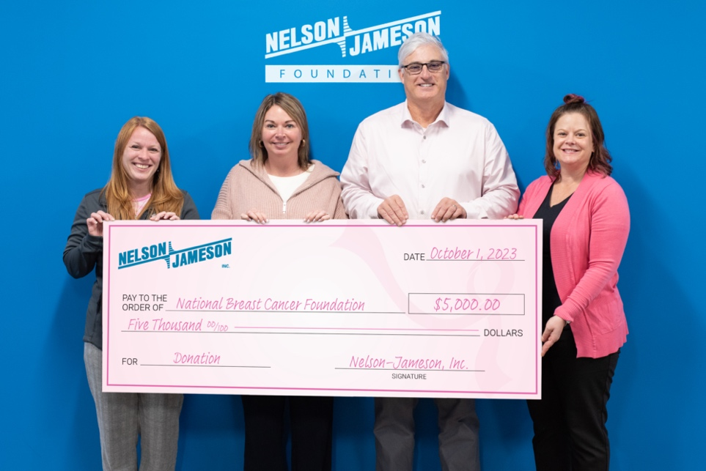
Photo Caption: Nelson-Jameson employees Kara Lineal, VP of Marketing; Heather Simcakowski, VP of Employee Experience; Mike Rindy, President; and Melissa Pasciak, Director of Event Marketing, hold up their company donation to the National Breast Cancer Fund to help raise breast cancer awareness.

###

About Nelson-Jameson
Nelson-Jameson is a fourth-generation, family-owned distributor to the dairy industry. From the company’s roots in dairy production supplies, it has expanded to offer a broad range of food processing products and services that help food and beverage organizations operate efficiently with the highest quality, safety, and compliance standards. The company represents more than 850 vendors, distributes more than 60,000 curated products, and employs more than 260 people nationwide. The dairy industry leader also operates NEXT Logistics, a transportation arm that provides delivery services from its Wisconsin, California, Idaho, Pennsylvania, and Texas strategic distribution centers.

For more than 75 years, Nelson-Jameson has supported food, beverage, and dairy processors with innovative products and a comprehensive set of solutions that keep pace with changing consumer tastes, manufacturing processes, and distribution channels. The company values delivering the exceptional for its customers by leading with the guiding principles of kindness and mutual respect. Nelson-Jameson is a supplier of choice for customers in all 50 states and international markets.

For more information, please visit: https://nelsonjameson.com

About National Breast Cancer Foundation, Inc.®
Recognized as one of the leading breast cancer organizations in the world, National Breast Cancer Foundation (NBCF) is Helping Women Now® by providing early detection, education, and support services to those affected by breast cancer. A recipient of Charity Navigator’s highest 4-star rating for 16 years, NBCF provides support through their National Mammography Program, Patient Navigation, breast health education, and patient support programs. For more information, please visit https://www.nationalbreastcancer.org/

Media Contact:
Karolyn Raphael
karolyn@wingermarketing.com
(312) 494-0422

