 FOR IMMEDIATE RELEASE:
December 8, 2015

NATIRAR, NEW JERSEY’S EMERGING WORLD-CLASS RETREAT,
LAUNCHES EXCLUSIVE RESIDENTIAL DEVELOPMENT

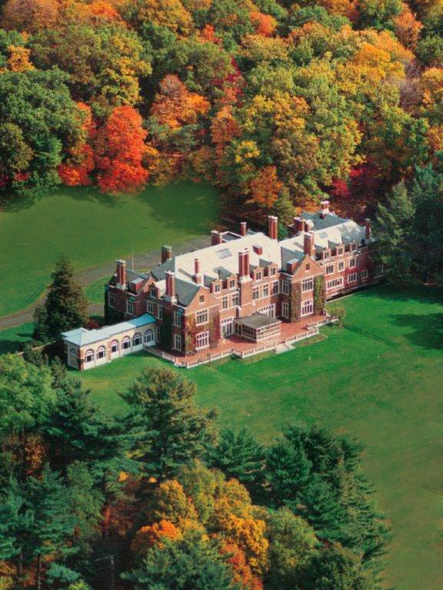
Natirar, New Jersey’s timeless 500-acre historic estate that embodies rustic refinement, has announced its plans to construct an exclusive on-site residential development on a portion of the estate comprised of 24 luxury homes. This will be the second phase initiated by Bob Wojtowicz, founder of Natirar, which will transform this pristine property, located in Somerset County—one of the country’s most affluent counties, into an all-encompassing world-class retreat.

The development will grant residents the rare opportunity to completely immerse themselves in the luxurious lifestyle Natirar offers including extreme privacy, breathtaking views of the Somerset Hills and around-the-clock access to premier amenities. These include close walking access to Ninety Acres Culinary Center, comprised of a highly accredited restaurant and culinary school, the Natirar Farm & Gardens, exclusive access to on-site events such as wine tastings, sunrise yoga classes, tennis, on-site pools and year-round property maintenance, just to name a few.

“What I love about Natirar is that it is a 500-acre active outdoor-pursuit lifestyle,” says Wojtowicz. “We have an organic farm and garden, a table-at-the-farm restaurant, cooking school, swimming pools, tennis courts, fitness and miles of hiking, biking and horseback riding trails, as well as fly fishing and a diverse social calendar of events. All of this adds to our lifestyle.”

Wojtowicz has engaged Stephen Perkins, a notable architect whose resume includes the Fairmont in Boston, the Jefferson Hotel in Washington D.C., and other international projects, to help him carry out his vision for the residential community. Perkins’ extensive knowledge in architecture has earned him the design industry’s highest honor: an induction into the Platinum Circle. He also has 35+ years of international and design management experience, making him one of the key components to the success of the Residences at Natirar.

The serenity and amenities can be yours. Let Natirar help you…

‘Make It Your Lifestyle.’

For more information, please contact us at Residences@Natirar.com

MEDIA CONTACT:
Shannon.steitz@modpr.com OR 973-249-6157

About Natirar:
Tucked away in the rolling hills of Somerset County, New Jersey, Natirar is a timeless 500-acre historic estate that truly embodies rustic refinement. Located less than an hour away from New York City, Natirar’s vision is simple: to provide guests with an escape from the routine and predictability of daily life. Offering a multitude of elite amenities including spa & fitness activities, exclusive events, premier membership access and an all-encompassing culinary center equipped with a comprehensive cooking school and Ninety Acres, a highly accredited table-at-the-farm restaurant, Natirar immerses all its guests in a tranquil and luxurious experience. Natirar has been featured in the New York Times, Travel + Leisure, Vanity Fair, Departures and many more. For more information, visit www.natirar.com.

* The purpose of this correspondence is to solicit nonbinding reservations. A nonbinding reservation is not a contract and may be cancelled by the prospective buyer at any time, without cause. Any money paid to the developer shall be refunded to the prospective purchaser upon request and cancellation of the nonbinding reservation. The developer expressly disclaims any warranty, express or implied with regard to the accuracy of these verbal and graphic approximations of the community herein. These approximations are subject to change without notice. A Master Deed will be recorded in the Somerset County Clerk’s Office, setting forth the model types, areas, dimension and amenities available within the community.

