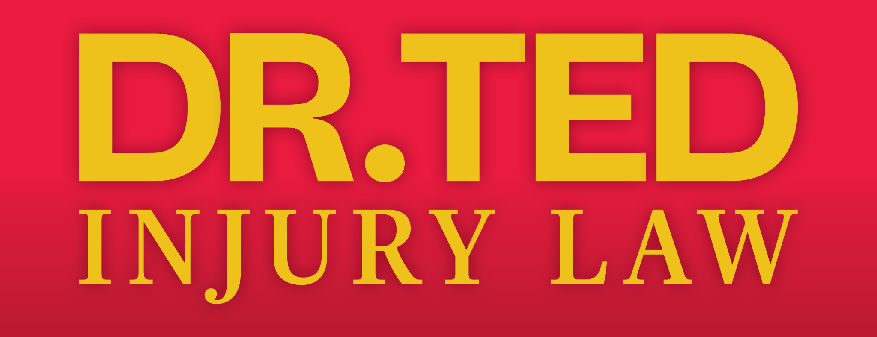
FOR IMMEDIATE RELEASE

TED A. GREVE & ASSOCIATES REBRANDS AS DR. TED INJURY LAW
New brand reflects founder’s unique dual expertise.


CHARLOTTE, NC – [Date] – Ted A. Greve & Associates, a personal injury law firm based in Charlotte, NC, has announced a new name: Dr. Ted Injury Law. This rebrand highlights the founder’s, Dr. Ted A. Greve, rare dual credentials as both a Doctor of Chiropractic and an attorney, a distinction the firm has promoted for years with “Call the lawyer who is also a doctor.”
Dr. Ted Greve commented,
“We’ve long branded ourselves as ‘the lawyer who’s also a doctor.’ Changing our name to Dr. Ted Injury Law makes it easier for injured people to find us; and after years of emphasizing that unique combination, the new name helps cut through the clutter of all the personal injury lawyers out there. While I do maintain my chiropractic license, I only practice law; but my expertise is extremely beneficial to guiding my clients who have been injured in an accident.”
Dr. Ted

Dr. Ted Injury Law serves clients across the Southeast with strategically located offices in North Carolina, South Carolina and Georgia. In addition to the convenient locations, the firm is also available for a free in-home/hospital or remote consultations as well.

As both a Doctor of Chiropractic and attorney, Dr. Ted offers unmatched insight into the medical complexities of injury cases. This dual expertise allows him to:
- Accurately interpret medical records and injury reports
- Anticipate defense arguments related to health and treatment
- Communicate effectively with medical experts and juries alike

This unique perspective has helped Dr. Ted secure significant verdicts and settlements for thousands of clients throughout his 40+ years of service.

The name may be transitioning, but the leadership, staff, and dedication to client success remain exactly the same. The firm continues to offer free consultations and clients pay nothing unless their case is won.
The Law Office of Ted A. Greve and Associates, P.A., is highly qualified in handling automobile accidents, workers’ compensation, social security disability, and slip & fall. The firm was established in 1993 with North Carolina locations in Charlotte, Concord, Gastonia, Hickory, Raleigh, Shelby, Rock Hill in South Carolina, and Atlanta; and Augusta in Georgia. For more information call 1-800-MYDRTED, or visit DrTedInjuryLaw.com

Media Contact:
Jacque Sumner
President/ Sumner Group
704 747 5498
jacque@sumnergroup.com

