AWARD PRESS RELEASE

CONTACT INFORMATION:
Advanced Fertility Center of Texas
Lisa Benjamini
713-275-8534
Lisa@AllonHealthCenter.com


FOR IMMEDIATE RELEASE

Headline: Advanced Fertility Center of Texas has been awarded on the Newsweek list of America’s Best Fertility Clinics 2024; Awarded #1 in Texas and #7 Nationwide.

Advanced Fertility Center of Texas (AFCT) is proud to announce that it has been recognized on Newsweek's and Statista Inc., list of America's Best Fertility Clinics 2024

Newsweek and Statista Inc., the world-leading statistics portal and industry ranking provider, presents this prestigious award. The evaluation of fertility clinics was based on four pillars:
- Nationwide Online Survey:
Reproductive endocrinologists, infertility specialists, obstetricians/gynecologists working in and referring patients to fertility clinics, medical professionals (e.g., registered nurses, laboratory assistants), and fertility clinic administrators/managers working in fertility clinics were invited to participate in the survey.
- Quality metrics: Assisted Reproductive Technology metrics with a focus on indicators relevant to fertility clinics published by CDC were analyzed.
- Accreditation Data: Provided by The Joint Commission, College of American Pathologists, Clinical Laboratory Improvement Amendments, and American Institute of Ultrasound in Medicine.
- Patient satisfaction: Data based on Google reviews.

Based on the results The Advanced Fertility Center of Texas is proud to be recognized on Newsweek’s list of America’s Best Fertility Clinics 2024 as #1 in Texas and #7 Nationwide. This is a testament to our unwavering commitment to comprehensive patient care and excellence in reproductive medicine.

AFCT's remarkable success stems from its unique combination of individualized treatments, state-of-the-art reproductive laboratory technologies, Omni Med-Lab, and partnership with Lisanne Wellness Center. AFCT was founded and led by Dr. Michael Allon since 2005, and the approach is distinct. Dr. Allon's meticulous attention to underlying medical factors that may be contributing to patients' infertility and his crafting of personalized treatment plans tailored to each patient make AFCT's practices stand out from the standardized ones.

Dr. Allon works alongside scientific director, Dr. Dmitri Dozortsev, Ph.D., President of the American College of Embryology, who has been practicing reproductive embryology since 1991. Dr. Dimitri Dozortsev has directed AFCT's cutting-edge reproductive technology, Omni Med-Laboratory. Omni-Med Laboratory is equipped with the latest technology and employs the most sophisticated protocols for IVF, cryopreservation, and embryo biopsy, including Minimal Impact Biopsy for embryo screening for chromosomal errors.

Additionally, AFCT believes in the importance of preparing the body and mind for pregnancy
before undergoing any fertility treatment. That is why we have partnered with Lisanne Wellness Center, renowned for its expertise in holistic wellness, to offer comprehensive pre-conception programs and the Fertile Mind Body Experience, offering support and fertility coaching.

By integrating clinical, laboratory, and wellness approaches, we ensure that our patients receive comprehensive and personalized care. This approach is not just about treating the condition, but about optimizing their physical and emotional well-being and enhancing their chances of success on their fertility journey. We want our patients to feel reassured and cared for every step of the way.

"We are honored to be recognized as a top fertility center in Texas," says Dr. Michael Allon, M.D. "Our clinic provides a range of specialized fertility treatments, including Platelet-Rich Plasma (PRP) therapy and Ovarian Rejuvenation procedures, and the most advanced ovarian stimulation techniques, improving egg quality – Term Stimulation and Mini Stim. These innovative options are designed to enhance fertility potential and achieve the birth of a healthy child."

As we celebrate this achievement, we extend our heartfelt gratitude to our dedicated team of fertility specialists, nurses, and support staff. Their tireless work upholds our standards of excellence, and we deeply appreciate them. We also thank our patients for entrusting us with their care and allowing us to be a part of their fertility journey. Their trust and faith in us drive us to do better every day.

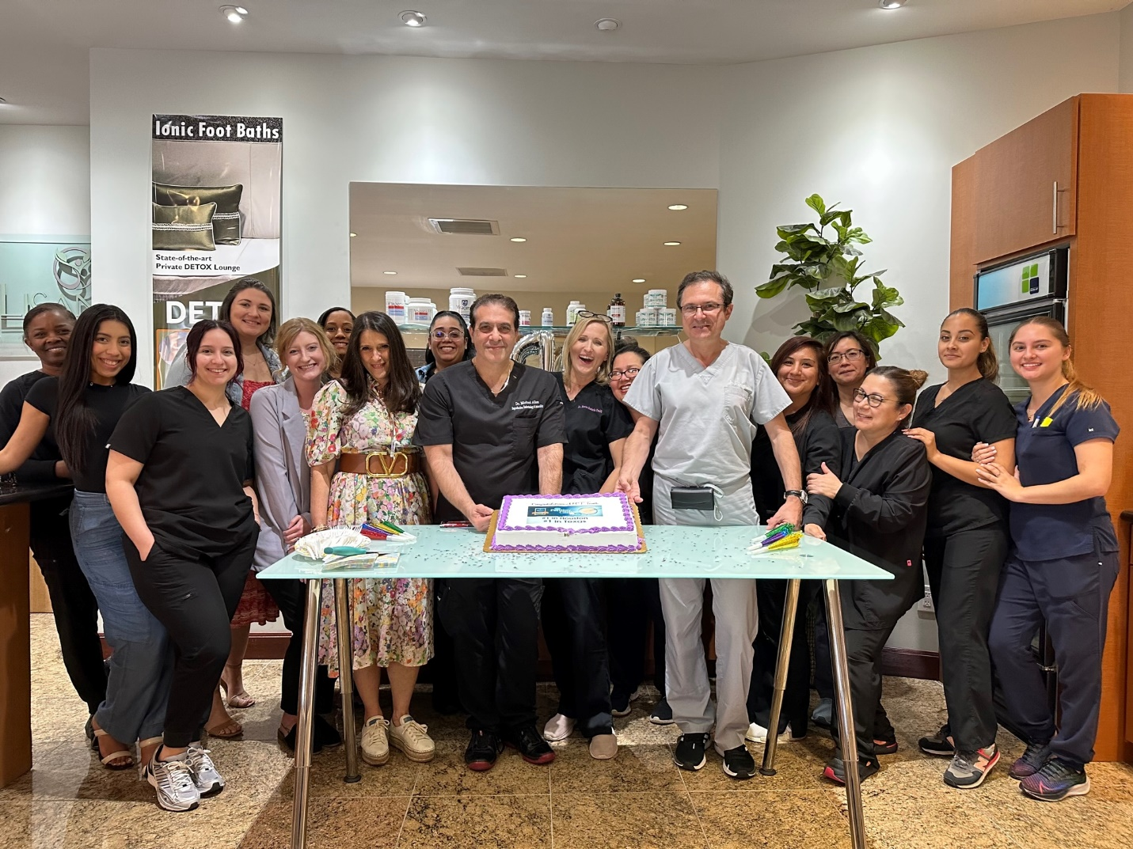

Advanced Fertility Center of Texas remains steadfast in its mission to provide compassionate, personalized fertility care to individuals and couples nationwide. We look forward to continuing to serve our community and helping more families grow.

