
2018 Smart Kitchen Summit Overall Winner to Attend FoodTech Live @ CES 2019
Innovative Patch That Keeps Delivery Food Fresh is Ready for Pre-Orders
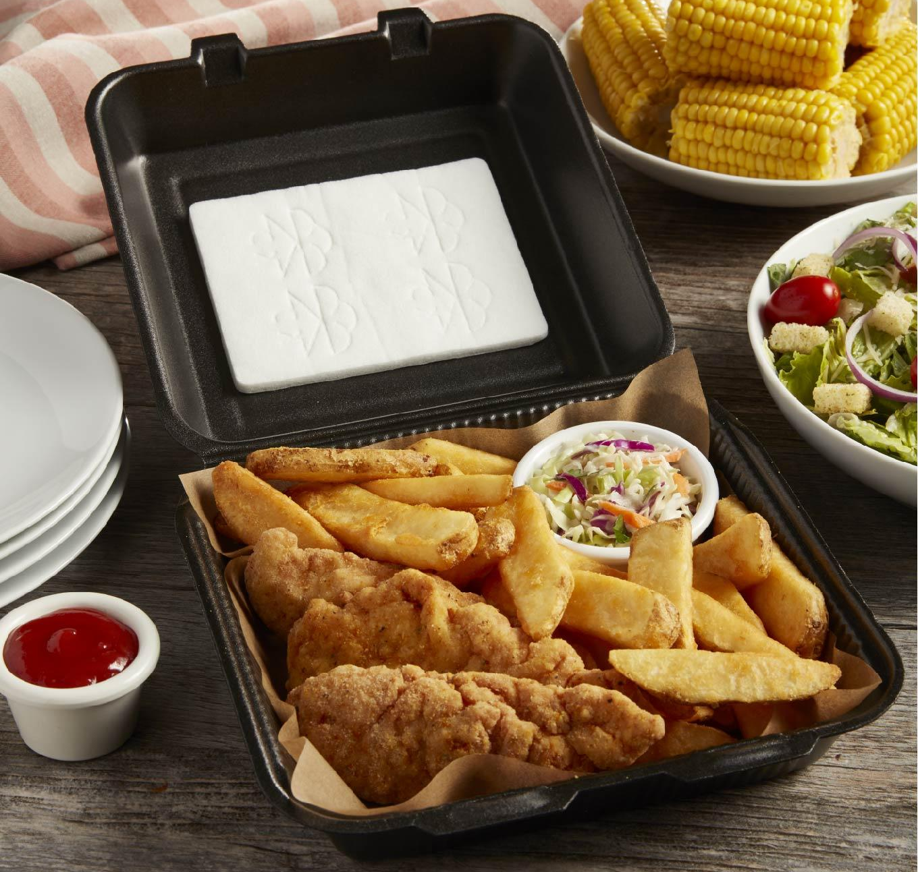
Las Vegas, NV (January 8, 2019) - Soggy Food Sucks, creator of the patented, award-winning “Crunch Patch” for takeout and delivery food makes its Consumer Electronics Show debut at FoodTech Live @ CES 2019.

Soggy Food Sucks is a simple, scientifically based USDA and FDA approved product that helps the restaurant and food service industry provide higher quality cuisine to-go. This disruptive new technology made from renewable materials recently received the overall winner prize at the 2018 Smart Kitchen Summit Startup Showcase.

Designed by a rocket scientist, this solution keeps food fresh much longer without requiring a restaurant to change the design of their existing disposable food container. Just stick the frozen patch to the top of your take out packaging and it forcefully traps condensation, pulling it away from the food. Keeping condensation at bay prevents sogginess and maintains the quality, texture, and taste of your food after its left the restaurant.

“Food taken home from a restaurant is often ruined by condensation. This patented product stops this, with the first of its kind, high performance, non-chemical desiccant,” said Founder Bill Birgen. “I’m excited about our momentum as we approach CES 2019. Series A funding has been finalized and we will soon be ready for global distribution.”

Soggy Food Sucks will take pre-orders at the show and continues to look for new restaurant partnerships. It is currently being tested by UberEats, Domino’s pizza, Ordermark, and a few dozen local restaurants in Arizona.

For more about this product as well as the science behind it, visit www.soggyfoodsucks.com, and follow updates on Twitter, Facebook or Instagram.

Media Kit - www.soggyfoodsucks.com/mediakit

About Soggy Food Sucks
Aerospace engineer Bill Birgen founded Soggy Food Sucks because of the simple fact that he hated eating soggy salads. After trying many different reusable and disposable salad containers to ward off condensation and sogginess, he created his own eco-friendly, plant-based, and compostable solution. Soggy Food Sucks makes the peel and stick “Crunch Patch” that easily fits in carry out containers and keeps food crisp, fresh, and tasting like it just came out of the restaurant kitchen.
###

