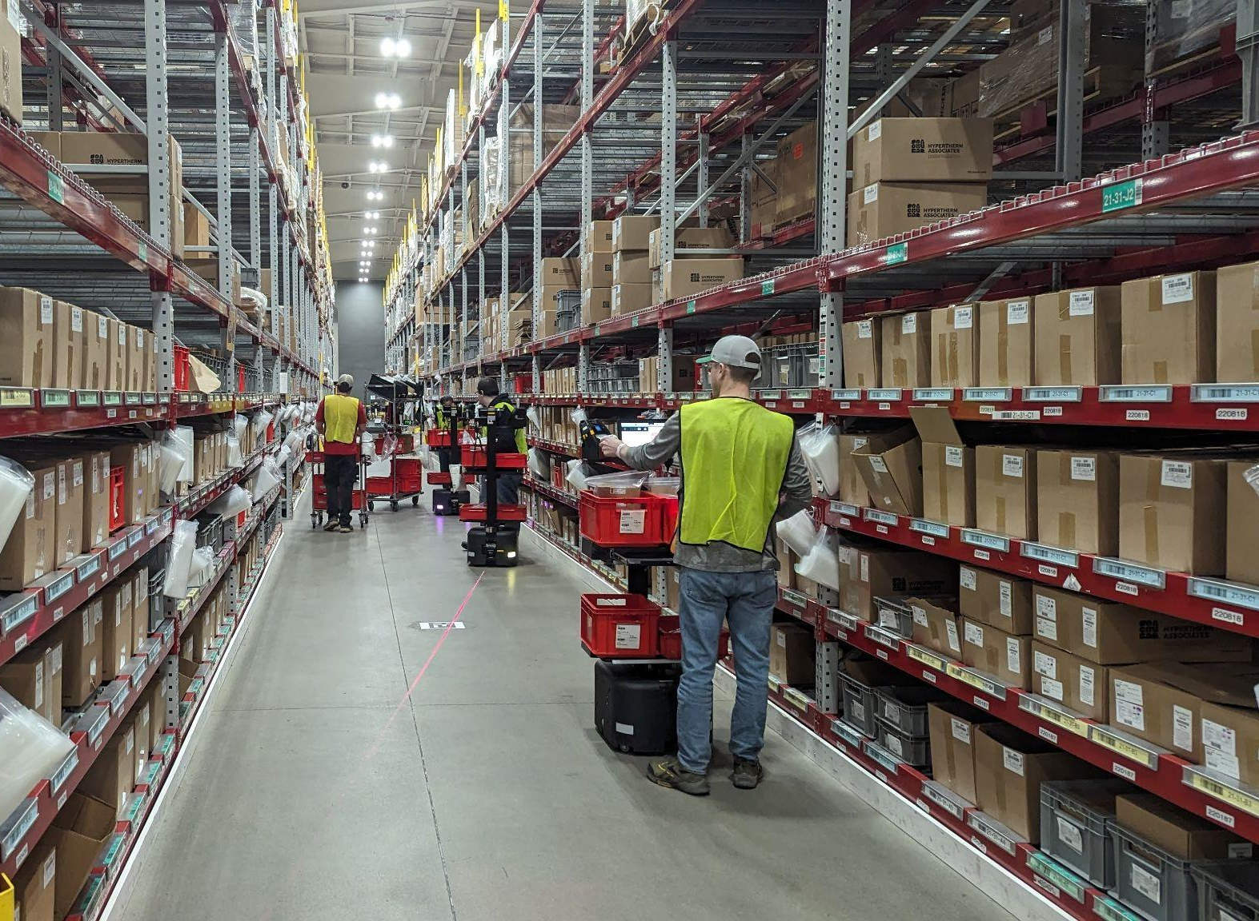

Hypertherm Associates Becomes Rapyuta Robotics' First US Customer for Pick Assist Autonomous Mobile Robots

New Hampshire, United States – April 02, 2024 - Rapyuta Robotics, a leading provider of autonomous mobile robot solutions, proudly announces Hypertherm Associates as its first customer in the United States for the revolutionary Pick Assist Autonomous Mobile Robots (AMRs).

Hypertherm Associates, an associate-owned, multi-technology manufacturer of industrial cutting systems for customers worldwide, has been looking for a way to automate warehousing to empower associates in a sustainable manner. The collaboration with Rapyuta Robotics marks a significant milestone in the adoption of cutting-edge automation technology within the US manufacturing and warehousing landscape and puts them ahead of competition.

Rapyuta Robotics' Pick Assist AMRs combine technologies such as optimal route planning with multi robot coordination AI, picker guidance system and fleet management. These autonomous robots are designed to navigate dynamic environments, pick and transport materials safely, and integrate seamlessly with existing infrastructure.

"Our collaborative robot is a perfect fit with Hypertherm Associates’ corporate culture to make the company a safe and efficient place to work. By leveraging our Pick Assist AMRs, Hypertherm Associates will increase throughput/productivity and gain the opportunity to identify the new way of structuring its operation with robots." said Ryo Mori, Executive Director at Rapyuta Robotics.

“We are continuously looking for ways to create a safer, more efficient and streamlined operation and Rapyuta team worked with us to create a solution for us to do that.” said Frank Cook, Hypertherm Associates warehouse operations leader. “They took the time to understand our needs and helped us every step of the way to implement the solution that worked for us.”

About Rapyuta Robotics:
Rapyuta Robotics, an ETH Zurich spinoff, stands at the forefront of cloud robotics and is recognized as the market leader in Pick Assist Autonomous Mobile Robots (AMRs) in Japan.
With a rich heritage of innovation and with a comprehensive solution line-up that pushes the boundaries of flexibility and performance, Rapyuta Robotics is dedicated to making robots more accessible to everyone in the logistics industry.

For media inquiries, please contact:
PR Division
Rapyuta Robotics
Email: pr.us@rapyuta-robotics.com
Phone: 773-236-2401

About Hypertherm Associates:
Hypertherm Associates is a U.S. based manufacturer of industrial cutting products and software. Its products, including Hypertherm plasma and OMAX waterjet systems, are used by companies around the world to build ships, airplanes, and railcars; construct steel buildings, fabricate heavy equipment, erect wind turbines, and more. In addition to cutting systems, the company creates CNCs, and software trusted for performance and reliability that results in increased productivity and profitability for hundreds of thousands of businesses. Founded in 1968, Hypertherm Associates is a 100 percent Associate-owned company, employing approximately 2,000 Associates, with operations and partner representation worldwide. Learn more at www.HyperthermAssociates.com.

For media inquiries, please contact:
Denise Champagne
Designation: Director of Corporate Communications and Brand Strategy
Hypertherm Associates
Email: denise.champagne@hypertherm.com
Phone: 603-475-3921

