DOOGEE introduces the N20 Pro Android 10 smartphone with 16MP quad rear camera
With a 16MP AI quad rear camera, 16MP Samsung front camera and advanced performance, the N20 Pro is great value
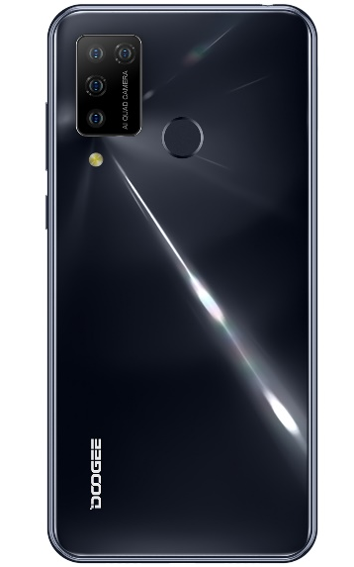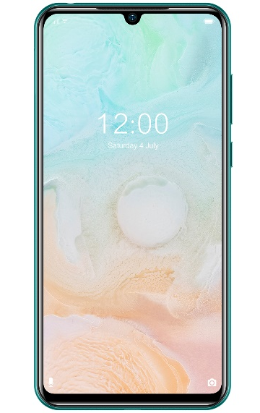
London, 1st August 2020: Innovative technology company, DOOGEE Hengtong Technology Co. Ltd, is pleased to announce the launch of its latest phone, the DOOGEE N20 Pro. The N20 Pro is a great value hero product from DOOGEE featuring a 16MP AI quad rear camera, an impressive 6.3” Waterdrop screen and a Helio P60 Octa-Core processor. The N20 Pro is available from the DOOGEE online store globally for $119.99 and from AliExpress for $119.99（$10 coupon on 10th-11st, 2000 limited, code: N20PRO10）.
The N20 Pro brings an advanced performance and is equipped with a 12-nanometer processing technology Helio P60 Octa-Core processor so whether gaming, streaming music or taking pictures, the phone provides a fast, effortless and enjoyable experience. The 4400mAh high-capacity battery also uses power optimization to give a longer lasting charge and supports a 10W quick charge.
The N20 Pro has a 6GB large memory so that the phone will remain smooth and stable even with multiple programs running simultaneously. Also, with up to 128GB and a maximum expansion of 256GB, there is a large capacity for storage and the potential to download large-scale games and high-definition videos without the need to sacrifice other applications. The device runs on the newest Android 10 with the system-wide dark theme, privacy controls and many more features. With Bluetooth 5.0, it is a faster and easier experience for the user.
With an impressive screen through an upgraded double coating glass process, the N20 Pro features a 6.3” FHD+ IPS Waterdrop screen with an aspect ratio of 19:9 to bring a movie-level visual experience. Not only ideal for watching videos or viewing images, the screen and phone provide a superior gaming experience. Weighing just 175g and the thinnest part of the DOOGEE N20 Pro’s body being just 8.8mm, the smartphone is incredibly portable and with a comfortable feel. The ideal travel phone, it also supports Dual Nano SIM cards to make it easier when travelling regularly or on business.

Camera
The N20 Pro boasts a 16MP AI quad rear camera with an F.20, 6 element lens which provides superior photos for capturing memories, experiences and adventures. The high-resolution 16MP main camera provides real clarity with images and gives impressive results. With a 130° ultra-wide camera lens, it is also possible to photograph larger areas as well as a 3x optical zoom making it an ideal everyday camera. Using the AI portrait mode allows for background blur adjustment so that all photos taken with the N20 Pro will have the desired look and quality. The Samsung front camera retains the high resolution 16MP quality so that selfies can be just as impressive as landscape pictures and keeps all images are clear and natural.

Security
To ensure safety and that the phone is secure, the N20 Pro has a fingerprint sensor embedded at the back of the phone and uses Fingerprint Scanning technology to accurately identify the user with just a single touch making it simple, easy to use and fast to unlock. In addition, the phone also includes face recognition as another biometric technology to enhance security.

The DOOGEE N20 Pro is available from the DOOGEE online store globally for $119.99 and from AliExpress for $119.99($10 coupon on 10th-11st, 2000 limited, code: N20PRO10)
To access full details, including specifications for the N20 Pro, click HERE
（https://promotion.doogee.cc/doogee-n20pro/）

High resolution imagery is available here

Now the DOOGEE AliExpress has the activities which you can get free phone: https://shopnews.aliexpress.com/shopnews/postDetail.htm?postId=50457589649750&appType=11&albslr=238328750&albbt=5

Network Bands
2G Bands GSM: B2/B3/B5/B8
3G Bands WCDMA: B1/5/8
4G Bands: FDD-LTE: 1/3/5/7/8/19/20/28A/28B. TDD: 38/39/40/41

Features

- CPU – Octa-Core (4 x 2.0GHz ARM Cortex-A73, 4 x 2.0GHz ARM Cortex-A53) Clock Speed
- Chipset – MediaTek Helio P60 (MT6771), 64-bit Processor
- GPU – ARM Mali-G72 MP3, 800MHz, 3 Cores
- Camera – 16 Megapixels + 8 MP + 2 MP + 2 MP with Dual-LED and AF Rear Camera | 16 Megapixels Front Camera
- Memory – RAM- 6GB LPDDR4X, 1600MHz | ROM 128GB External Memory Supports Up to 512GB
- Display – Screen size 6.3-inches IPS FHD+ Display (1080 x 2280 Pixels), 20:9 Aspect Ratio
- Battery – Non-Removable 4,400 mAh Lithium-Polymer with Fast Charging
- SIM – Dual SIM (Nano-SIM + Nano-SIM/microSD)
- Sensors – Proximity Sensor, Accelerometer, Ambient Light, Gyroscope, Compass, Fingerprint Rear Mounted
- Colour – Black, Purple, Fantasy Forest Gray
- Operating System – Android 10 OS
- I/O Interface – 1 x Nano SIM Card, 1 x Nano SIM Card or microSD Card Slot, micro USB Port, Audio Out Port, Power Button, Volume Button, Microphone, Speaker
- Dimensions – 159 mm x 77.1 mm x 8.8 mm
- Weight – 175 Grams (With Battery)

- ENDS-

About DOOGEE Hengtong Technology Co., Ltd:
DOOGEE is a technology company that was set up in Spain in March 2013. This contributes to the high performance of its products as well as their beautiful design and features, smart operation, and “micro-innovation”.
DOOGEE’s new slogan is “Live Your Life,” delivering fashionable products with new technology, with the aim of becoming the most popular smartphone supplier in the world.
For more information or to discuss a review sample, please contact Kristy or Ceniza at px-xie@doogee.cc or ceniza@doogee.cc.
Skype: live:ba68ef9ce067f6b3

