
Commercial Finance Association Florida Chapter
Presents
Wednesday March 16, 2016 (registration 11:30am)
Ft. Lauderdale Yacht Club; CFA members $45, non-members $60
Early registration ends March 9 close of business. Late registration fee is plus $15
All ACG and TMA members and guests are cordially invited
Event sponsorship $175 (includes two admissions)
Registration at http://cfa.connectedcommunity.org/floridachapter
The Retail Industry - Change, Technology, Marketing and Consolidation

Learn how the dynamics have changed, the strategies have changed, the technology (including mobile) has changed and so too have winners and losers. What’s next?

Panelists:
Paula Rosenblum, Retail Systems Research
Andy Moser, Co-head Retail and Consumer Products ABL, Monroe Capital LLC
Derek McDowell, Managing Partner, Boyne Capital
Steven Zuckerman, Managing Director, Farlie Turner & Co.
Moderator: Thomas H. Hicks, Renaissance Partners

Paula Rosenblum, Retail Systems Research
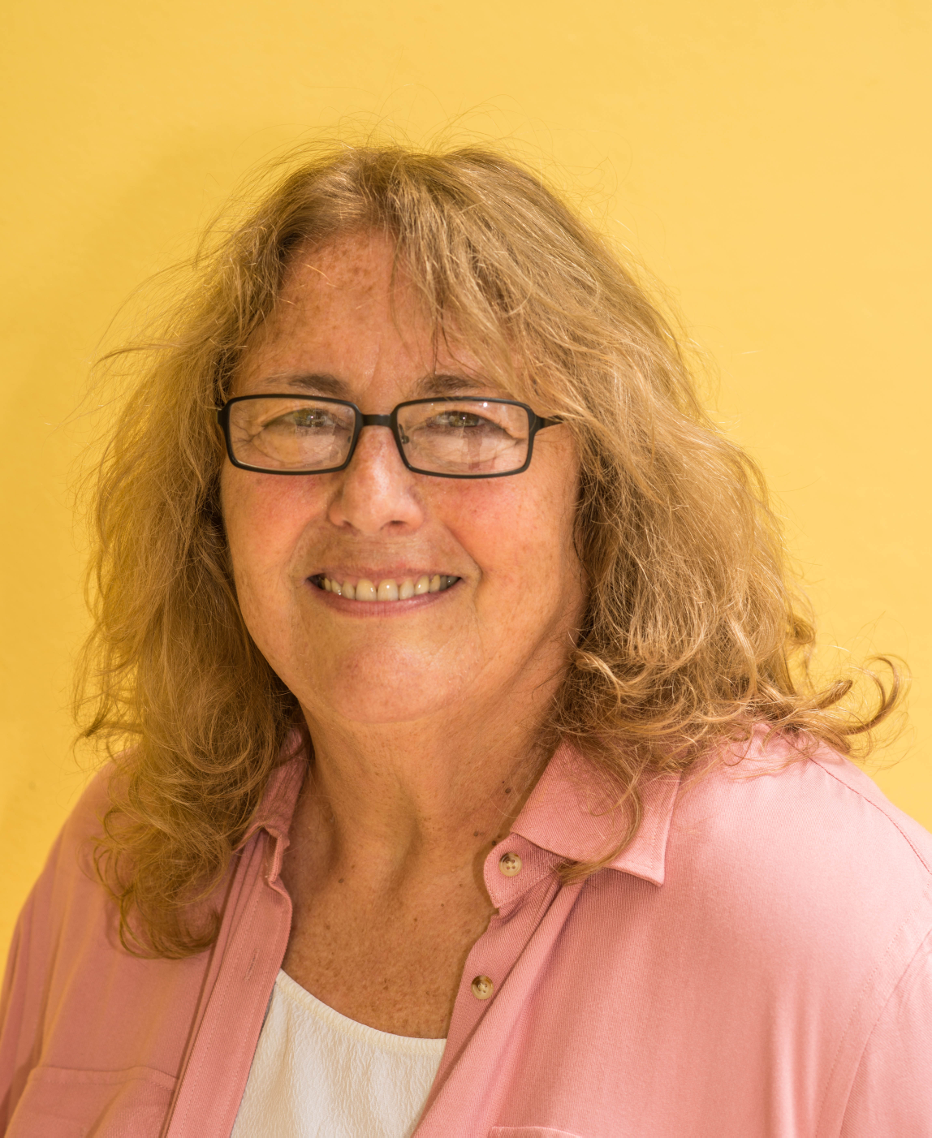
Paula Rosenblum is co-founder and Managing Partner at RSR Research and is widely recognized as one of the industry’s top retail technology analysts. She has been selected as one of the “Top 50 Retail Technology Influencers” from 2014 -2016. She also writes a weekly blog for Forbes and is frequently quoted in other major media outlets including the Wall Street Journal, Washington Post, LA Times, NPR Marketplace and many others. She serves on the advisory board of three consumer goods importers companies.

Previous to her years as an analyst, she spent over 20 years as a retail technology executive and CIO at companies including iParty, Hit or Miss, Morse Shoe, Domain Home Fashions and others.

Paula received her MBA in 1991 from Northeastern University, with a major in management of High Technology firms and was nominated to the Beta Gamma Sigma honor society. She’s active in a variety of organizations supporting human growth and development, and in particular has been involved with the RetailROI charity since its earliest days.

Andrew H. Moser, Monroe Capital LLC
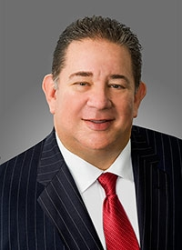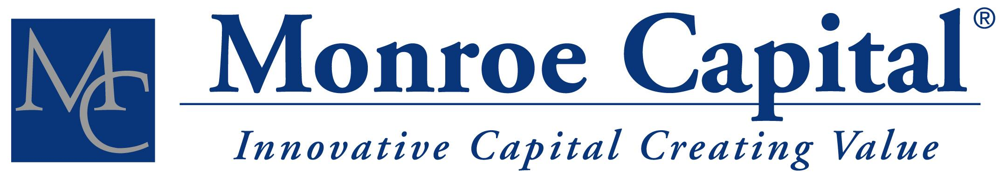
Mr. Moser co-heads the Retail and Consumer Products Asset Based Lending Group. He is actively involved in originating new investments in the business vertical and responsible for due diligence, structuring and execution. Mr. Moser has over 25 years of commercial finance, asset based lending, and retail industry experience. Prior to Monroe, Mr. Moser was President and CEO of Salus Capital Partners, LLC, Senior Vice President and Head of Asset Based Lending at First Niagara Bank, and Senior Vice President and Head of Asset Based Lending at NewAlliance Bank. In addition, he has held senior level positions with GMAC Asset Based Finance and Wells Fargo Foothill Capital Finance. He earned his Bachelor of Science degree in Finance from Bryant College. Mr. Moser is a member of the Commercial Finance Association, New York Institute of Credit, Turnaround Management Association Northeast and the Association for Corporate Growth.

Derek A. Mc Dowell, Boyne Capital LLC
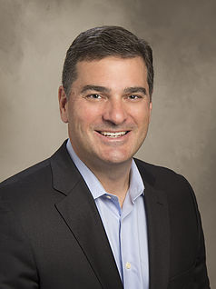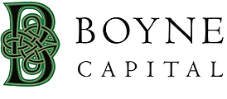
Mr. McDowell, Managing Partner of Boyne Capital LLC, is involved in all phases of the investment process and portfolio management at Boyne. He has a deep understanding of the needs of owners and managers of mid-sized companies. He invests for the long-term and believes in maximizing value by focusing on business fundamentals.

Prior to founding Boyne, Mr. McDowell served as a Partner with Trivest Partners, where he was involved in all aspects of capital raising, transaction execution and portfolio development. With nearly twenty years of private equity investing experience, Mr. McDowell began his career working with private equity and management consulting firms, including: HIG Capital Management, Continental Illinois Venture Corporation and Corporate Value Associates.

Mr. McDowell has significant experience in structuring and leading recapitalizations of privately held businesses, corporate divestitures and restructurings. His industry expertise includes financial services, business and consumer services, healthcare, building products, consumer products and aerospace. Mr. McDowell received his AB from Dartmouth College and MBA from the University of Chicago, Graduate School of Business.

Portfolio: Crispers LLC (fast casual restaurants), Evolution LLC (Catalina), KPB Foods (KFC franchisee)

Steven B. Zuckerman, Farlie Turner & Co.
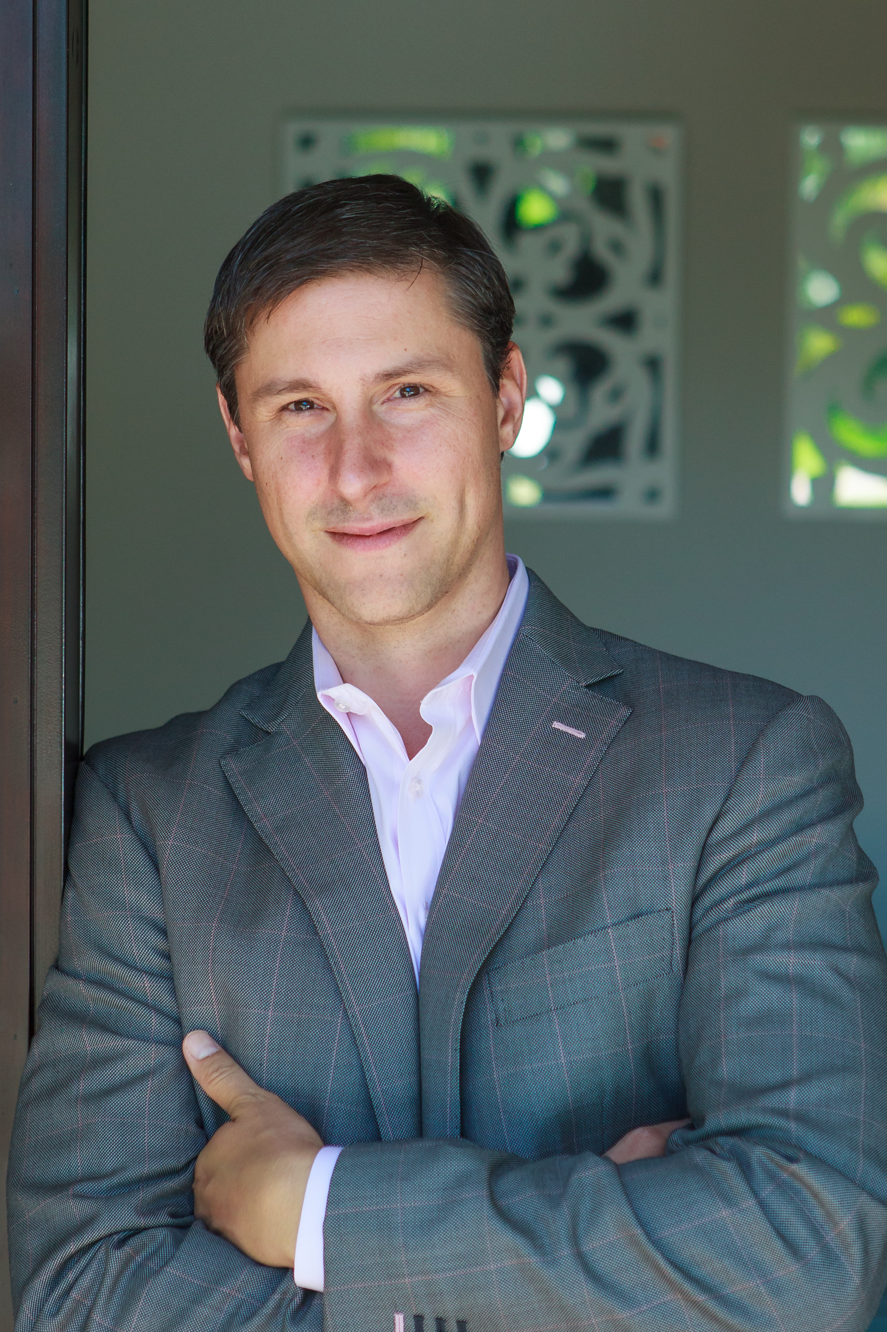
Mr. Zuckerman is a Managing Director and Head of Special Situations Group of Farlie Turner & Co. His diverse background as an investment banker, entrepreneur, and attorney enable him to develop creative and effective strategies to help clients achieve their objectives. In 2013, he was recognized as one of the top 40 dealmakers under 40 years old in the United States. Steve has worked on many consumer product, technology and retail restructurings.

Prior to joining Farlie Turner in 2007, Mr. Zuckerman invested in and advised middle-market companies. Prior to that, he practiced corporate restructuring law at Berger Singerman. Mr. Zuckerman is also the co-founder of a venture-backed healthcare technology company.

Mr. Zuckerman earned a B.A. from Boston University and a J.D. from the University of Miami School of Law, both with honors, and also holds a Series 79 license. Steve is also a published author. His book, Rain Power, sets forth an innovative strategy designed to help young professionals achieve their professional and personal goals.

