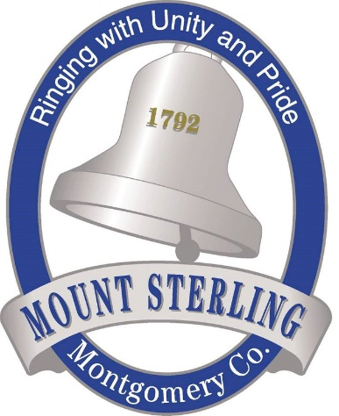
Press Release

Mt. Sterling – Montgomery County
Industrial Authority
Jason Rainey
(859)498-5400
jason@mtsterlingchamber.com

For Immediate Release

MT. STERLING – MONTGOMERY COUNTY GIVING FAMILIES HOPE & OPPORTUNITY
MT. STERLING, Ky. (March 7, 2022) — The Mt. Sterling – Montgomery County Industrial Authority has partnered with the Kentucky Career Center and the Montgomery County School system to hold two job fairs scheduled for this month. The Kentucky Career Center/Industrial Authority Job Fair will be held from 11 a.m. to 2 p.m. on March 11 at the Kentucky Career Center, 200 Oak Grove Drive. The MCHS/Industrial Authority Career Fair from 10 a.m. to 4 p.m. on Mar. 23 at the MCHS Arena, 724 Woodford Drive.
The Mt. Sterling – Montgomery County Industrial Authority is happy to partner with the Kentucky Career Center and Montgomery County Schools to provide our community with great opportunities. Providing our community with these great career opportunities allow our community to grow and individuals to build families and live the American dream.
Executive Director Jason Rainey states, “Mt. Sterling continues to serve as a lighthouse to the region for jobs and economic opportunities. We have great paying jobs for wherever someone is along the career path. Along with strong support in our school system and Maysville Community and Technical College Mt. Sterling campus, we are continuing to address workforce opportunities in innovative ways.”
Kentucky Career Center, Director of Business Services Jeremy Faulkner said, “We are excited to partner with the Mt Sterling Industrial Authority on the March 11th job fair. Events like these help us accomplish our mission to connect people with jobs, and to connect our regional business community with the resources they need that they need to be successful.”
Montgomery County Schools Superintendent Matthew Thompson said, “Montgomery County Schools is very happy to be a partner with the Industrial Authority/Chamber and our local business and industry in working to develop our local work force. We cannot have a strong community without a strong school system and we cannot have a strong school system without a strong community. Events like this job fair help strengthen both and show how attractive Montgomery County is as a destination for potential new businesses.”

