Dixie Black Pepper Recipes

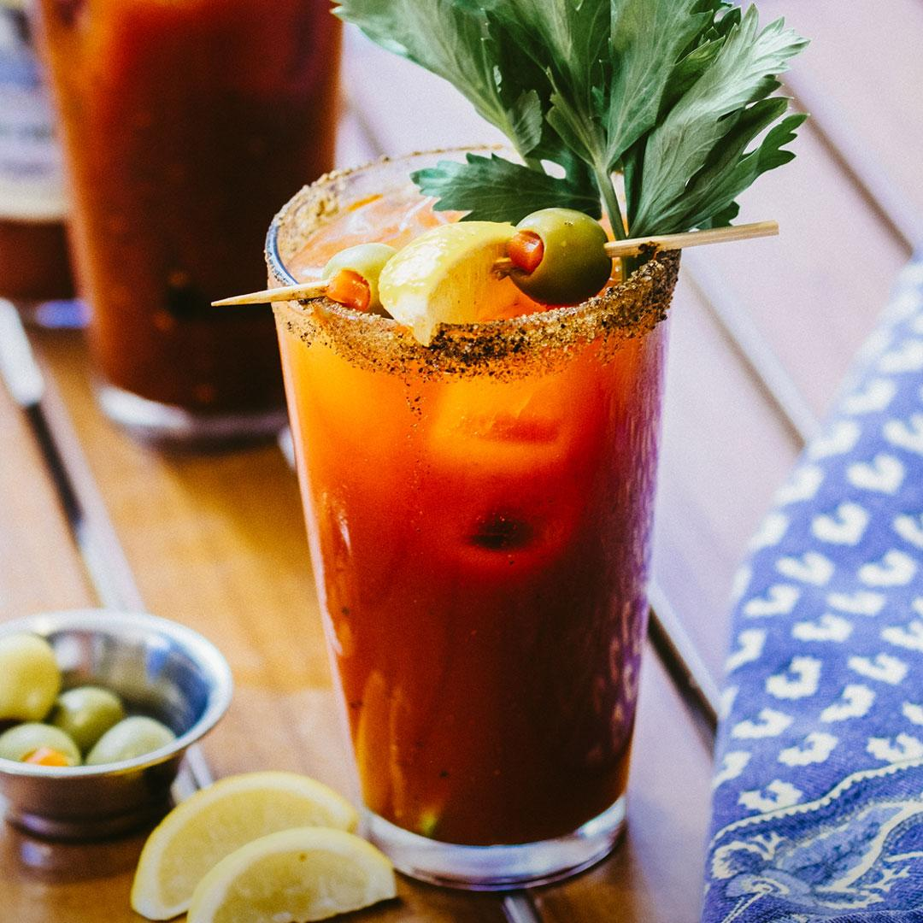
The South’s Best Bloody Mary

2 oz. Dixie Black Pepper Vodka
6 oz. Bloody Mary mix
Juice of 1/4 lemon
Celery stalk
Olives
Lemon wedge

Rim glass with celery salt and black pepper. Combine first 3 ingredients over ice and stir. Garnish with stalk of celery and a spear of olives and lemon.

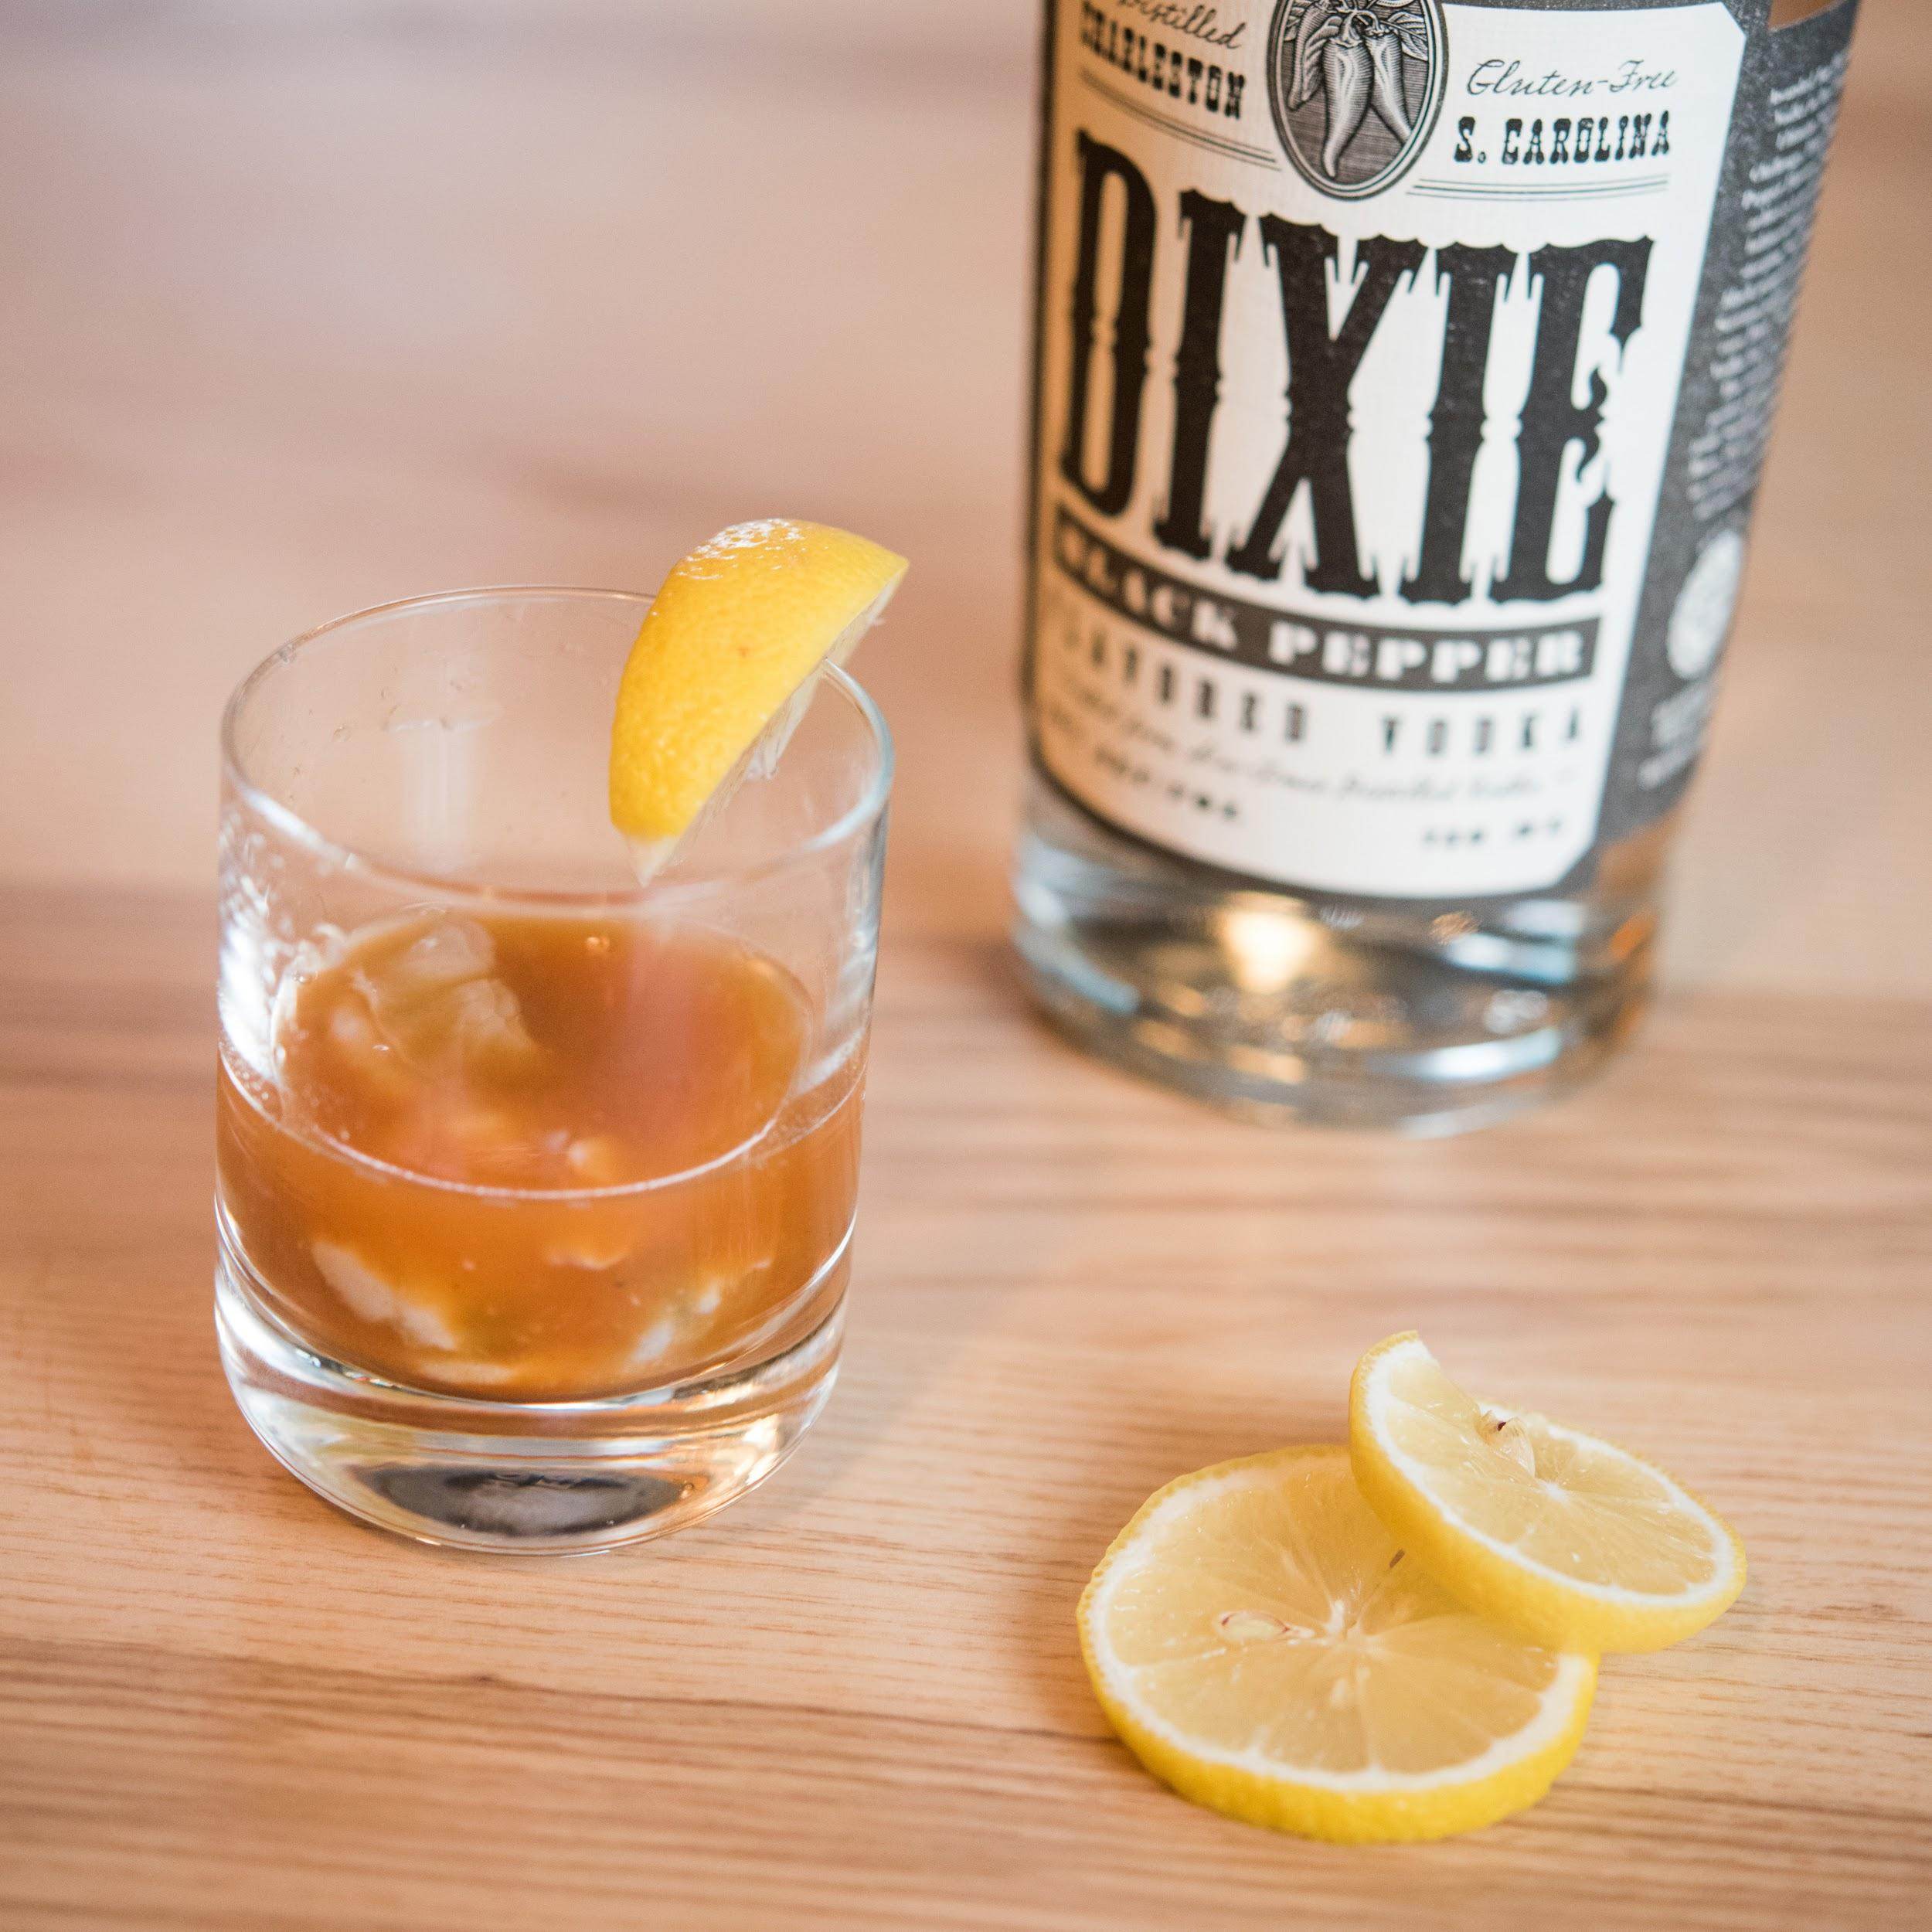
Oyster Shooter
1 oz. Dixie Black Pepper Vodka
1 tsp. cocktail sauce
Fresh oyster, shucked
Lemon wedge for garnish

Place oyster in shot glass. Top with cocktail sauce and vodka; garnish with lemon.

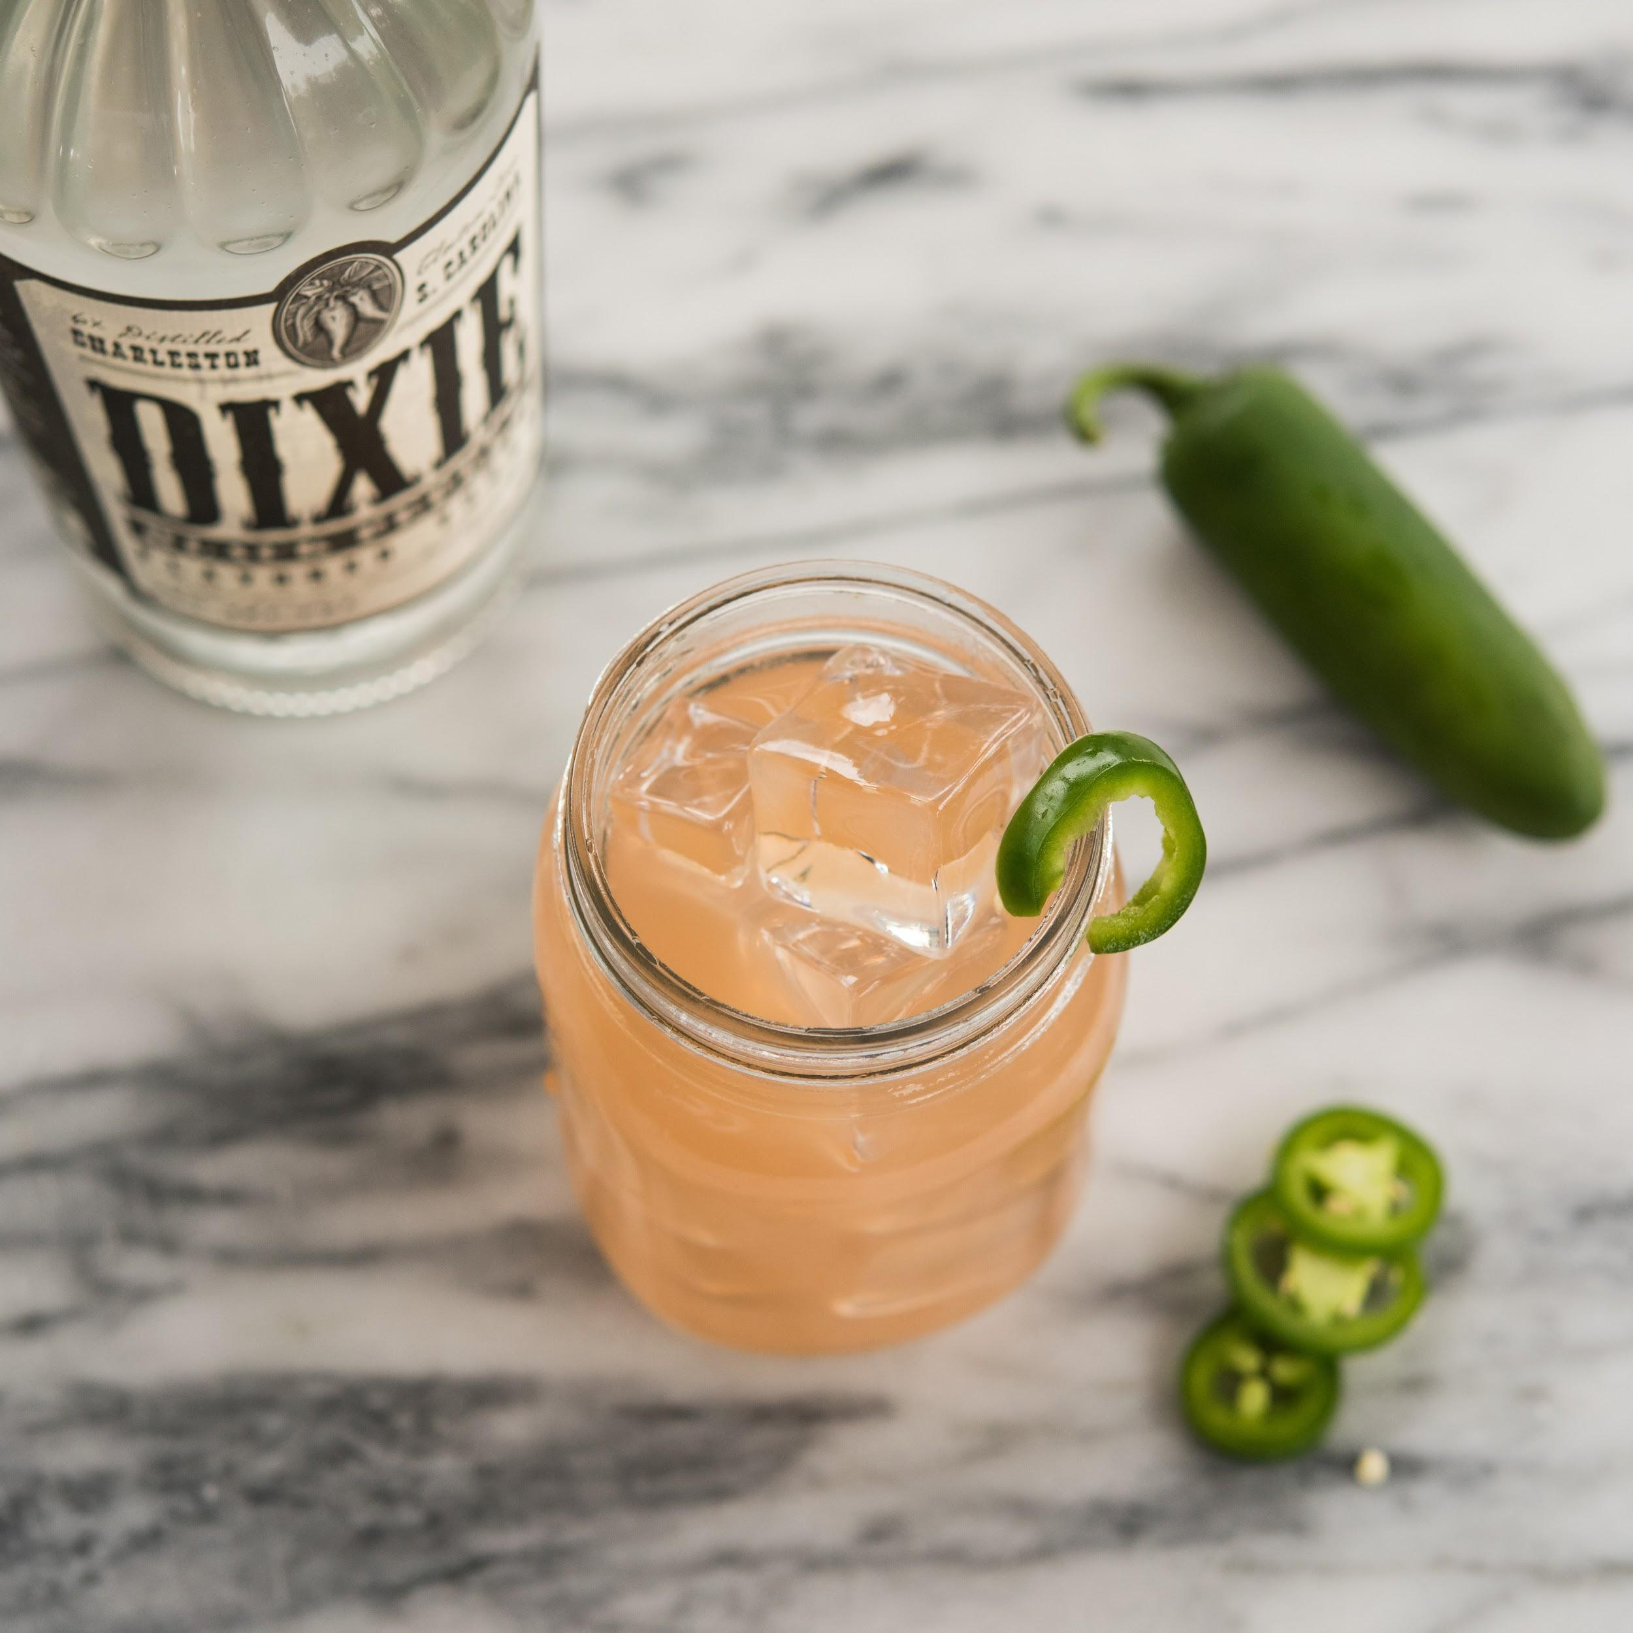
Spicy Southern Mule

1.25 oz. Dixie Black Pepper Vodka
4 to 6 oz. ginger beer
0.5 oz. lime juice
Pineapple
Fresh jalapeño for garnish
Sprig of mint

Muddle jalapeño, pineapple, and lime juice in a mixing glass. Add Dixie Black Pepper Vodka and shake with ice. Strain into a glass (or copper mug) filled with ice and add ginger beer. Garnish with jalapeño slice.
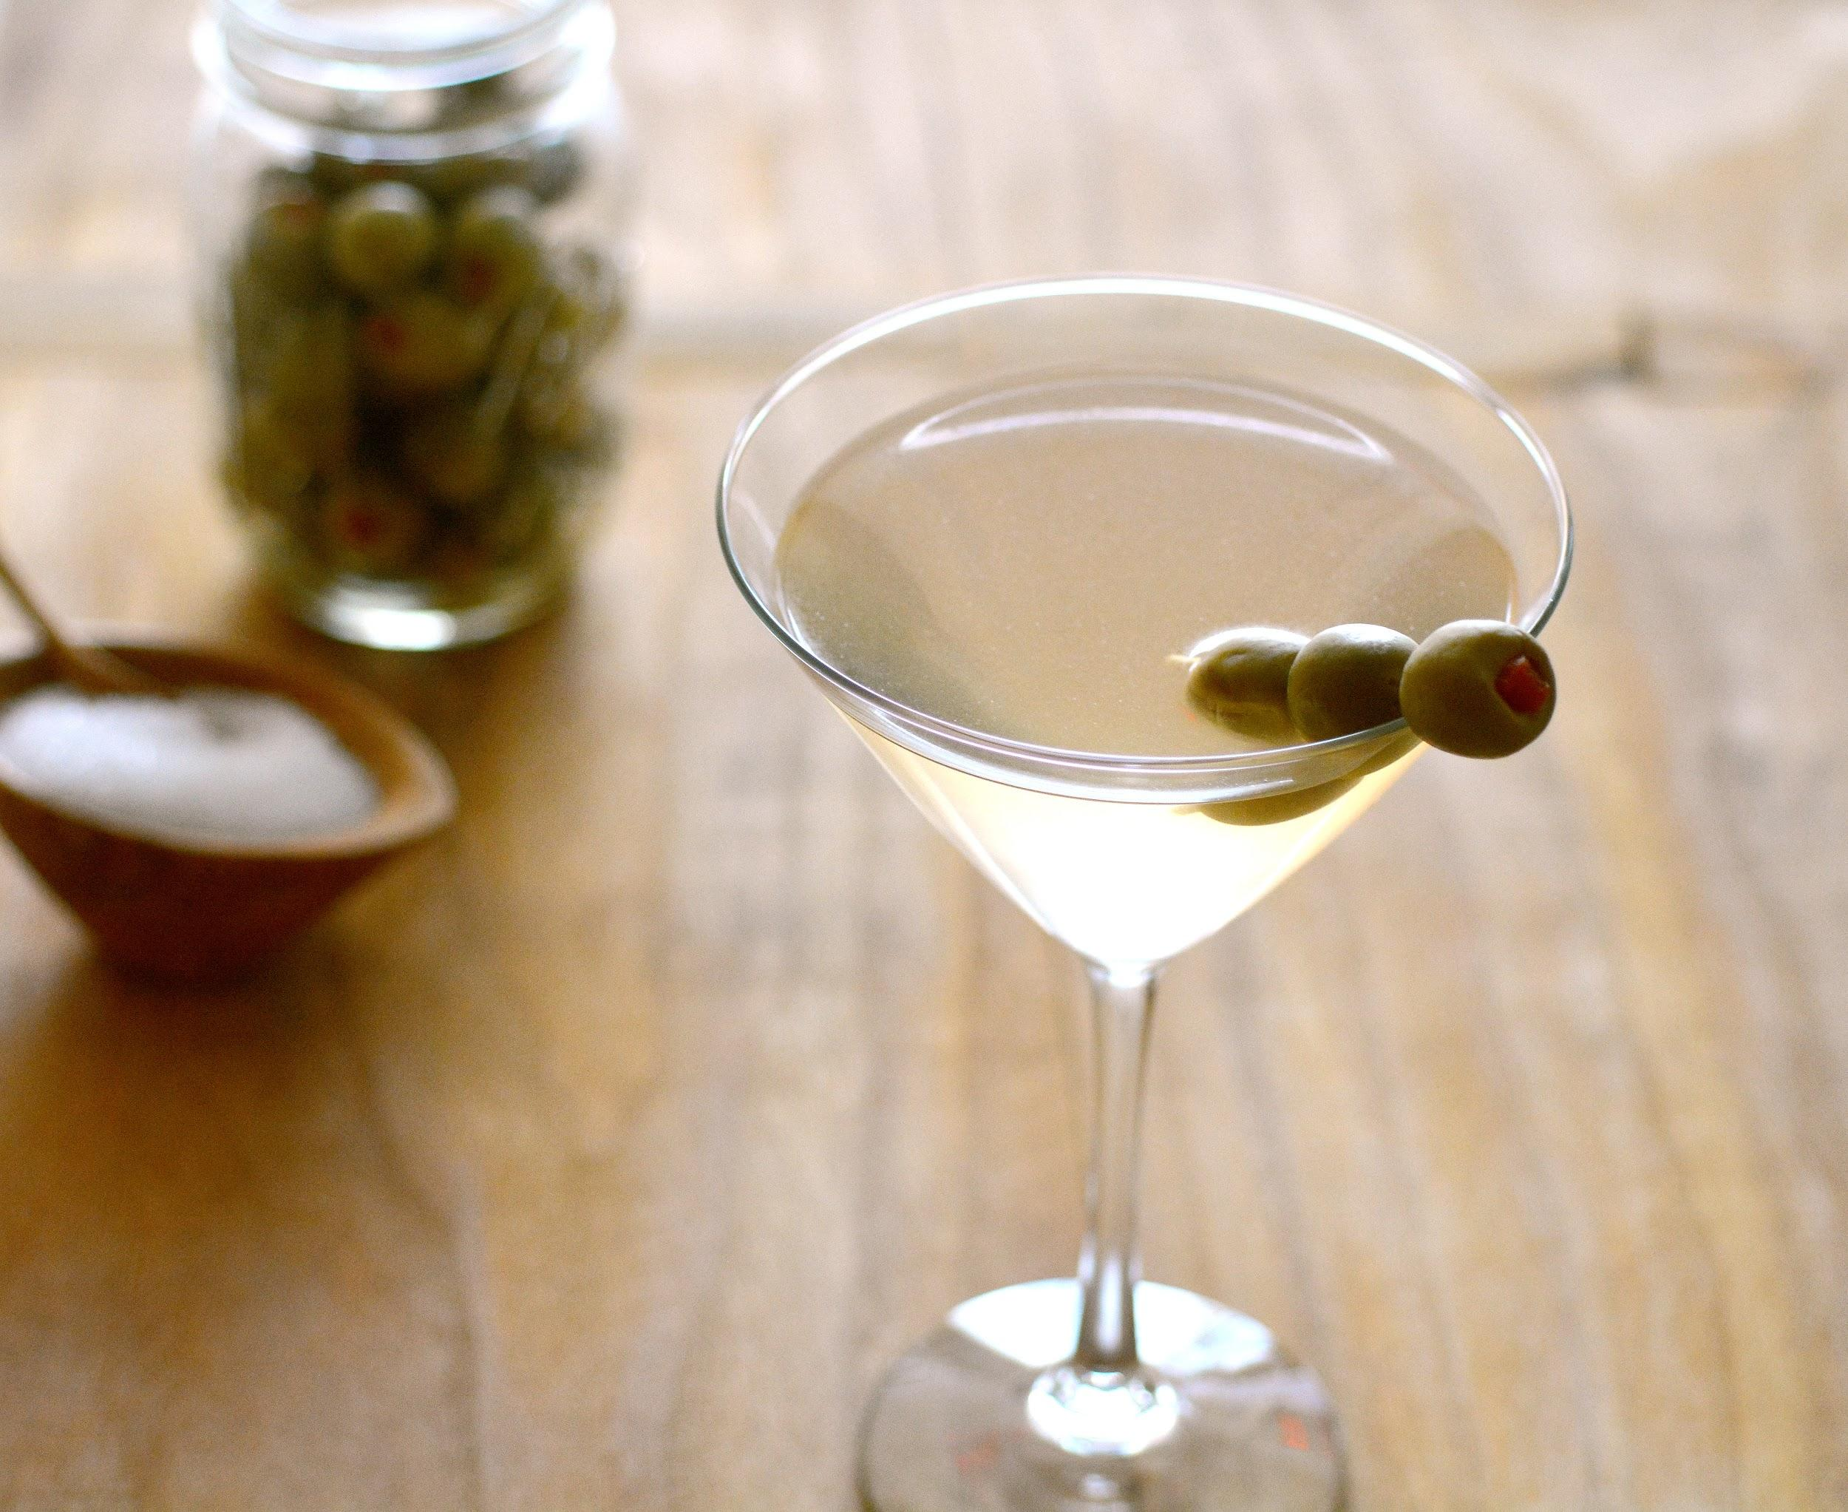
Salt & Pepper Martini

2 oz. Dixie Southern Vodka
2 oz. Dixie Black Pepper Vodka
2 oz. brine from olive jar
Olives

Combine Dixie Southern Vodka, Dixie Black Pepper Vodka, and brine in a shaker with ice. Vigorously shake all ingredients together until shaker is cold, and pour into a martini glass. Garnish with one or three olives — two is bad luck!

