Press release
Prof. Dr Herbert Kohler, Ex Tesla Board Member & Daimler VP, Joins Advisory Board of Elaphe
With this new appointment, Elaphe adds to its board a person instrumental to the rise of modern e-mobility. Dr. Kohler will be joining Elaphe's advisory board to focus on Elaphe's business development, market positioning, and supporting activities with the growing OEM business.
Ljubljana, Slovenia, EU, June 8, 2021 - Elaphe is commercializing its paradigm-changing distributed drive architecture. With Prof. Dr. Kohler as a member of their advisory board, Elaphe has made an additional step towards solidifying its leading position in distributed-drive technology. »Elaphe is honored to welcome to our team such a revolutionary contributor to the global e-mobility movement« stated Gorazd Lampic, Elaphe CEO.
Prof. Herbert Kohler started his career at Daimler as a Ph.D. student, worked his way up the ranks through production, engineering, and marketing and sales to senior management of the Daimler group. In 2000, Dr. Kohler took over Body and Powertrain Research as Vice President of the division.
In 2006 he was appointed as head of Daimler's Group Research & Advanced Engineering - Vehicle and Powertrain. For 5 years, starting May 2009, Prof. Kohler served as a Director of Tesla Motors, Inc., helping to bring electric propulsion to the mass market. At the pinnacle of his active career at Daimler, he was responsible for Research and Advanced Engineering of the entire Daimler group. Today, prof. dr. Kohler works for several national and international think tanks in the field of mobility and devotes his time to the students of Stuttgart University as a professor and mentor.
With Elaphe's in-house development and manufacturing capability, Elaphe supports ambitious projects with enabling technology that helps these companies transform the perception of e-mobility and the role personal transportation plays in our everyday lives. Their team works on an innovative performance-driven architecture, consisting of direct-drive motors, power electronics, and multiple-motor propulsion control. With their in-house development and manufacturing capabilities, Elaphe now works with many OEMs and startups.
To Elaphe, vehicles are not just a means of transportation for getting from location A to location B but serve as ecosystems that primarily cater to the user's needs and offer new mobility possibilities true to their mission. As Dr. Kohler stated in the past: »The vehicles have to give something back to society and offer added value for the world at large. An essential part of innovation is to make humans, with their needs and desires, the central focus of our considerations and developments.«
Elaphe's philosophy focuses on the creation of cutting-edge technology and using it to drive benefits, real-added-value for vehicle-makers, their users, and the planet. Their architecture empowers vehicle developers with design freedom to build the simplest and the most responsive platforms for the electric vehicles of tomorrow.

Press kit
Dear Sir or Madam, you are invited to use the materials below in support of the press release.
For interviews and additional data, please contact the Media contact at:
tjasa.hribar@elaphe-ev.com ; press@elaphe-ev.com

MEDIA MATERIAL
Interview with Elaphe CSO on Elaphe mission, vision and strategy
The distributed propulsion architecture gives vehicle designers complete freedom to maximize customer experience and vehicle efficiency, while reducing vehicle production cost.
Using the vehicle corners as propulsion leaves vehicle-makers with much more space for additional vehicle functionalities and, therefore, higher market differentiation.
- Source Interview: https://www.trendingtopics.eu/elaphe-the-company-that-aims-to-enable-a-better-design-at-a-lower-cost-for-electric-vehicles/
Interview with Elaphe's CTO, named Autonews Rising Star in Automotive for Electrification 2018
Elaphe’s CTO, PhD Gorazd Gotovac was named the Rising Star in Automotive in Electrification, named by Automotive News Europe (2018).
In this regard, he was acknowledged as an automotive executive that has and continues to drive change, fosters innovation, and makes courageous decisions in the e-mobility field.
- Source interview: https://europe.autonews.com/awards/2018-rising-stars-europe-gorazd-gotovac
Interview with Elaphe CEO's view on the present and future of electric mobility
Electromobility is inevitably a rapid growing global trend that not even a global pandemic can put to an end. As Gorazd Lampič, Elaphe's CEO stated, the Covid-19 pandemic has slightly surpassed the e-mobility movement which has only made it more manageable.
To name a current focus, Elaphe's extensive public projects of 2021 are powering Aptera Motors »Never Charge« and Lordstown Motor's »Endurance«.
- Source interview: https://www.energetika.net/eu/novice/envision/gorazd-lampic-elaphe-elaphe-is-developing-new-ev-architect
Details on Elaphe technology and in-wheel hub motor design philosophy
Elaphe in-wheel technology is covering the segments where it makes sense and adds real benefits.
In this regard, Elaphe high-performance distributed drives are part of electric CUVs and SUVs, sedans, pick-up trucks, people-movers and extremely low energy demand vehicles.
- Source: https://www.emobility-engineering.com/dossier-elaphe-l1500-in-wheel-motor/

IMAGE MATERIAL
You can access all images HERE.
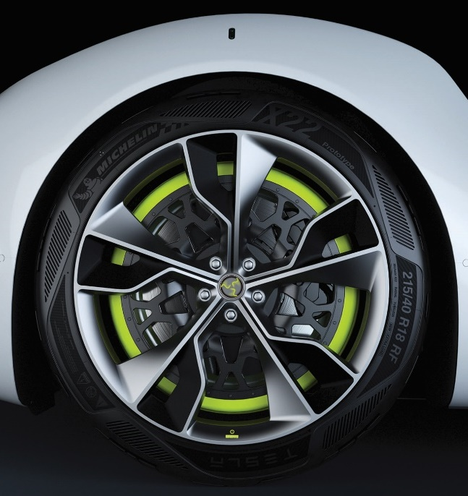 | Elaphe powertrain and philosophy behind it are changing the perception of what an electric powertrain can be and how it can make a vehicle and user experience better.  Despite the fact that motors are integrated into the rims next to original disc brakes and hub bearings, Elaphe in-wheel hub motors also provide exceptional torque density (~500 Nm/litre) and torque-to-weight ratio of active part in the range of 100 Nm/kg.
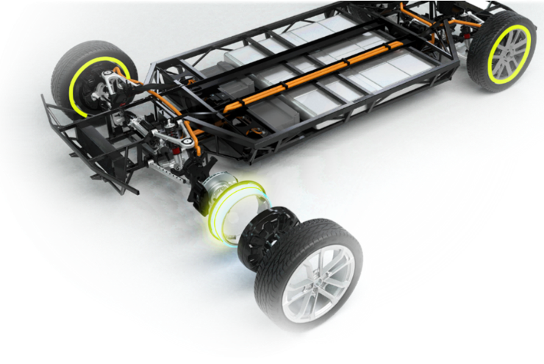 | Elaphe is a developer and manufacturer of distributed drive architecture powertrains.  The system consists of highly efficient direct-drive and in-wheel or near-wheel high-torque motors, motor controllers and powertrain control software with advanced algorithms, benefiting vehicle's intelligence and control for improved vehicle safety and dynamic handling.
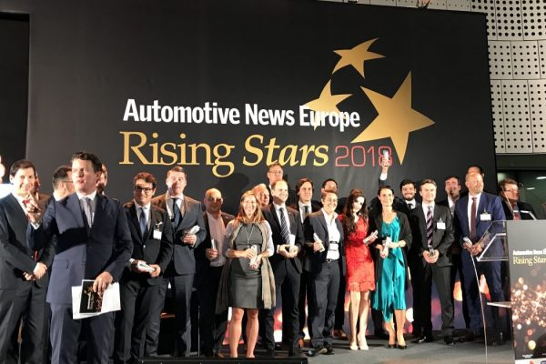 | Elaphe’s CTO, PhD Gorazd Gotovac was named the Rising Star in Automotive in Electrification by Automotive News Europe (2018).  He was awarded at the award ceremony at the Museo dell'automobile di Torino, Italy, where the who's who of the automotive realm gathered to celebrate the 2018 Rising Stars in Automotive – young extraordinary professionals, with a clear view and ambition to unleash their vision onto the world.

VIDEO MATERIAL
- Winter testing video highlighting Elaphe’s vehicle testing in rough winter conditions of Sweden. Testing was mostly focused on controls and advanced torque-vectoring algorithms.
  - Youtube video

- Elaphe’s In-Wheel Drive Audi R8 Boasts Faster 0-60mph acceleration Than Audi’s Own R8 E-Tron At 3.5 Seconds
  - Youtube video

- In-wheel powered BMW X6 SUV performing a Tank turn
  - Youtube video

- Elaphe's 360-degree all-wheel steering concept for optimum manoeuvrability and versatility in urban environments, a concept designed for urban mobility vehicles.
  - Youtube video

Media contact:
For interviews and additional data, please contact the Media contact at:
tjasa.hribar@elaphe-ev.com
OR
press@elaphe-ev.com

