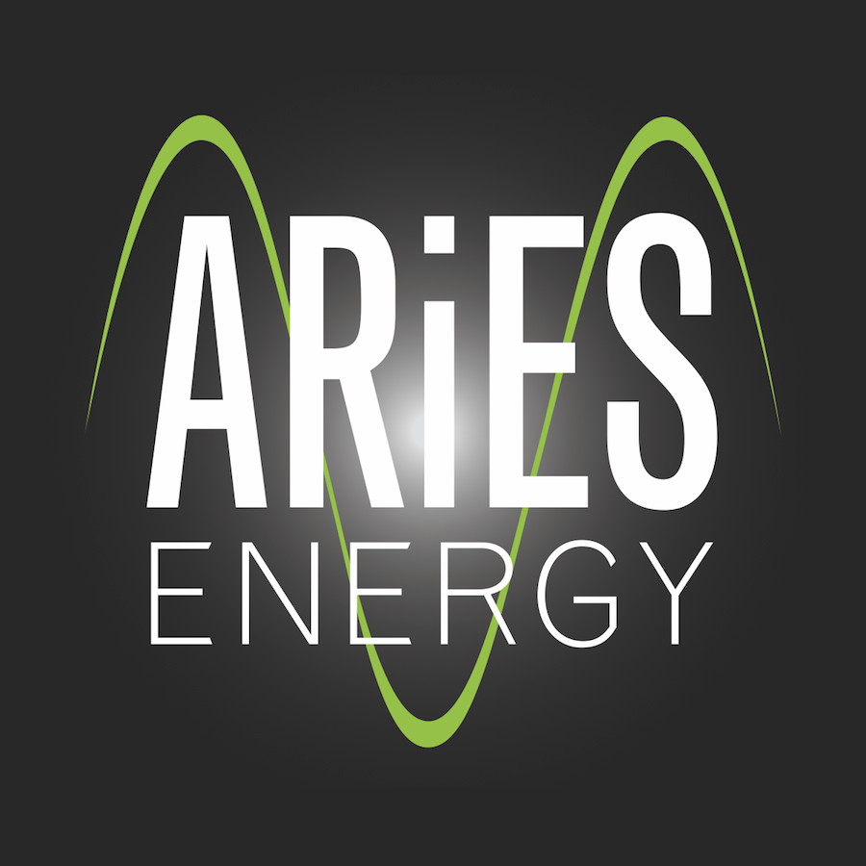

ARiES Energy, LLC

www.ARiESenergy.com

Contact:
Sarah Eastburn: Marketing: 262-468-1599, sarah@ariesenergy.com
Matt Ellison: Lead Design and Engineer: 865-742-4684, matt@ariesenergy.com

Photo of Matt Ellison: Photo Credit ARiES Energy


Partial Photo of Dry Ridge Farm’s Solar Array: Project designed by Ellison: Photo Credit ARiES Energy
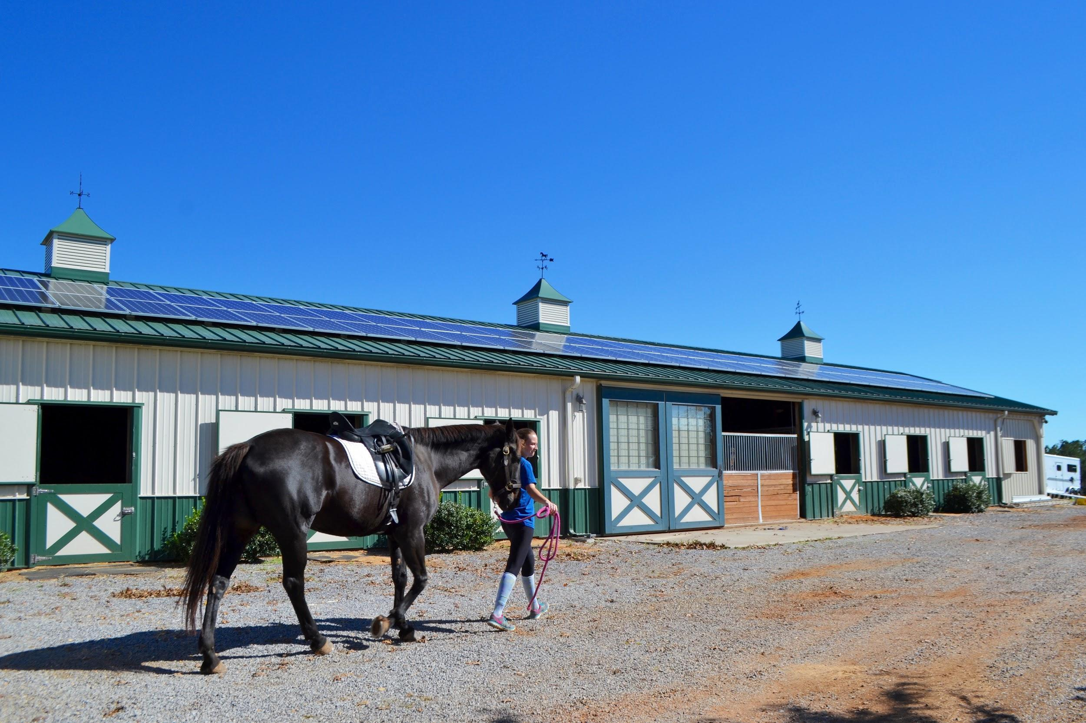

About ARiES Energy
ARiES Energy is for people and businesses who want to gain control of their energy costs. ARiES reduces or eliminates customers’ vulnerability to rising energy costs, offer an environmentally-friendly source of electricity generation, and provide affordable, turnkey clean energy solutions. ARiES Energy was started in 2011 and is wholly-owned by renewable energy company PHG Energy of Nashville, TN.

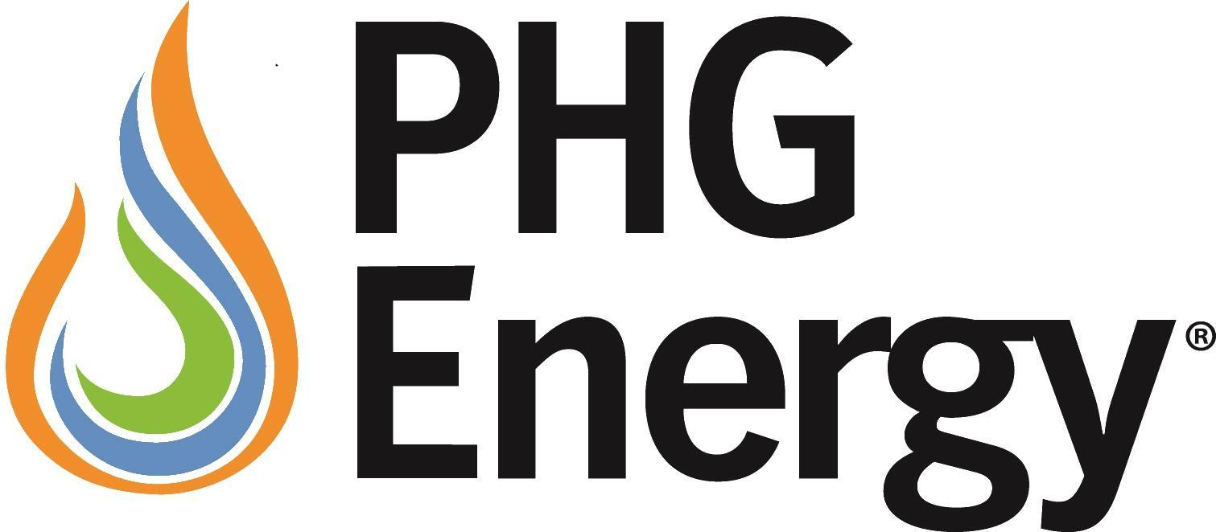

PHG Energy, LLC

www.phgenergy.com

Contact:
Nancy Cooper: Administrative Services & Business Development:615-471-9093, Nancy.Cooper@phgenergy.com

About PHG Energy
PHG Energy’s commercially proven waste-to-energy technology is employed by customers to convert industrial and municipal waste, or renewable biomass, to a clean-burning fuel gas through an environmentally friendly thermo-chemical process. That synthetic gas can be utilized like natural gas to produce economical electric or thermal power.

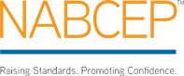

NABCEP: North American Board of Certified Energy Practitioners

http://www.nabcep.org/

About NABCEP
NABCEP is a non‐profit organization governed by a board of directors consisting of volunteer representatives of the solar industry, NABCEP certificants, renewable energy organizations, state policy makers, educational institutions, and the trades. NABCEP’s mission is to develop and implement quality credentialing and certification programs for practitioners by supporting and working closely with stakeholders in the renewable energy and energy efficiency industries. To learn more visit www.nabcep.org.

