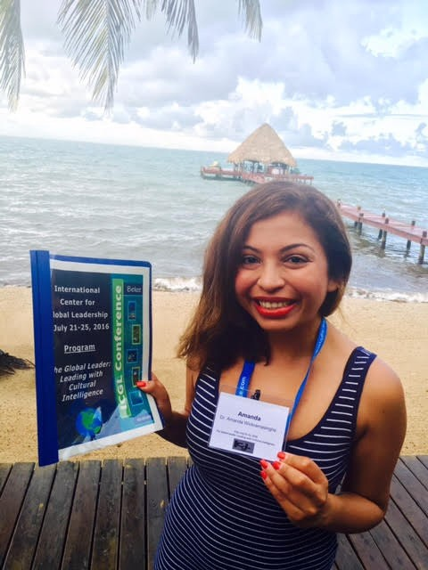

ICGL BELIZE

The International Center for Global Leadership is an organization based in Menifee, CA. Its primary purpose of the Global Leadership Conference is to cultivate leaders from around the world to advance organizations in their own countries. The center hosts an annual conference in Belize as a forum for those interested in obtaining leadership skills in the conceptual, interpersonal and technical areas. The Center has a campus under construction in Placencia, Belize, maintains an office in California, and has an international network of organizational and individual partners.

THE CONFERENCE

At the core of our mission is a deep desire to serve as partners in fostering sustainable solutions. Rather than impose, we seek to empower and support others through collaboration. We take on global issues but we help those around us. Currently we are raising funds for an ambulance for the town of Placencia. We give very publicly and support “Pack for a Purpose,” and, during our Saturday dinner at the conclusion of the annual conference present, local students who have scored highest on school exams, tablets in an effort to support their education. ICGL believes in direct giving, and the registration fee goes towards the purchase of those tablets as well as conference expenses.

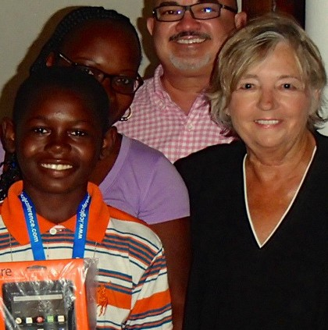SERVICES OFFERED

Sponsorship Conference Program Ads Social Media Promotions Strategic Partnerships

AUDIENCE REACH

30-50 Conference Attendees 450 Follower Facebook Reach
Over 700 unique web site visitors per month

CONTACT US

June Schmeider-Ramirez juneschmieder@icglconferences.com icglconferences.com rbertin@icglconferences.com
International Center for Global Leadership 30141 Antelope Rd #D780
Menifee CA 92584

