
SPIDEY TEK MAKES WORLD’S STRONGEST GLUE

May 23, 2018, Los Angeles, California Spidey Tek, LLC announces the test results of its ground breaking multi-purpose, all-natural adhesive, Spidey Glue.
Spidey Glue is the initial consumer and commercial product for the company. This amazing, non-toxic, biodegradable, super strong glue is 10 times stronger than the most widely advertised brand of glue, across many applications. Spidey Glue bonds any surface to any other surface, wood to wood, wood to metal, metal to metal, plastic to metal and wood, it even glues to Teflon.
In a recent interview Prof. Randy Lewis PhD. and Chief Science Officer for Spidey Tek was asked, ‘with all of the incredible things spider silk does, why make a glue first’. Dr. Lewis replied, “for several reasons, the world needs a non-acidic, natural, super strong glue for everything from paper-crafting, to assembling furniture, to bonding various elements of automobiles together. If you stop and think about all the uses of glues and adhesives in modern life, it is staggering”, he stated.
Spidey Glue underwent side-by-side analysis with the two major brands of glue readily available to consumer and commercial uses alike. Using their top of the line glues to compare with Spidey Glue, the results are reflected in the following charts. The tests were conducted using a variety of materials to be bonded. The Spidey Glue was tested in two forms, a regular liquid and as a spray. The two Spidey Tek columns are denoted by the spider-web imprint on the column.

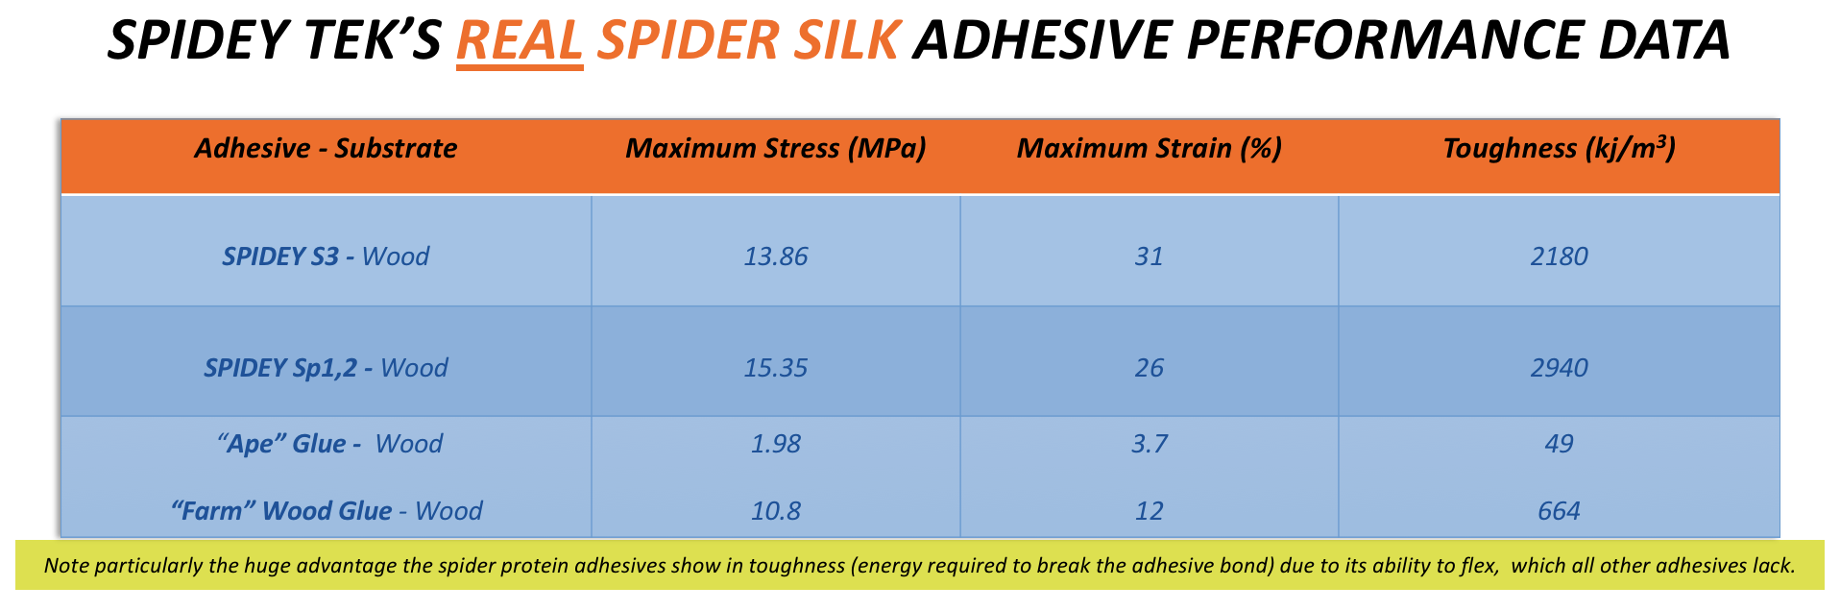
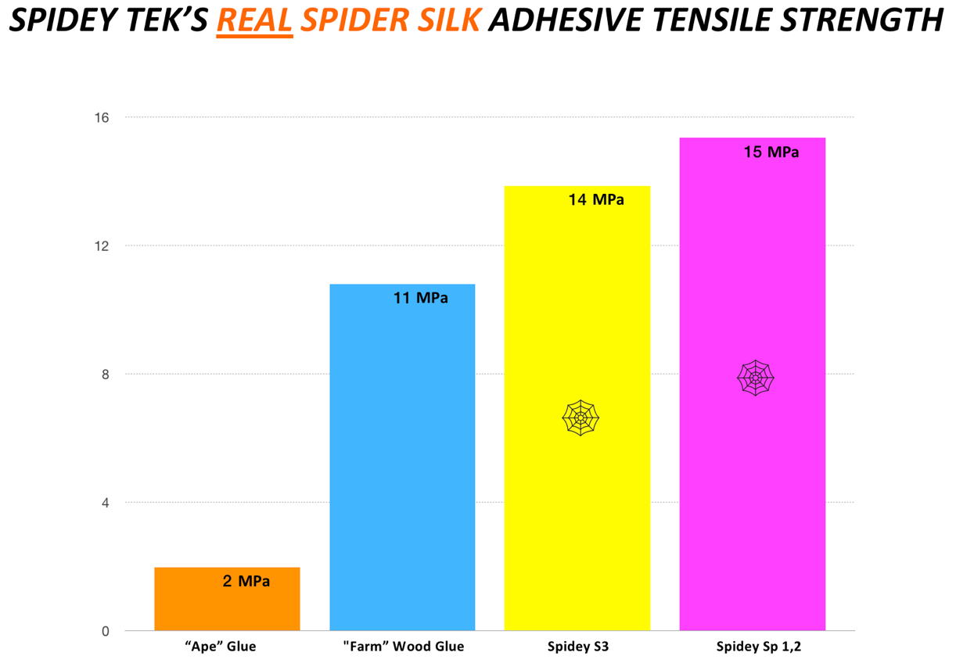

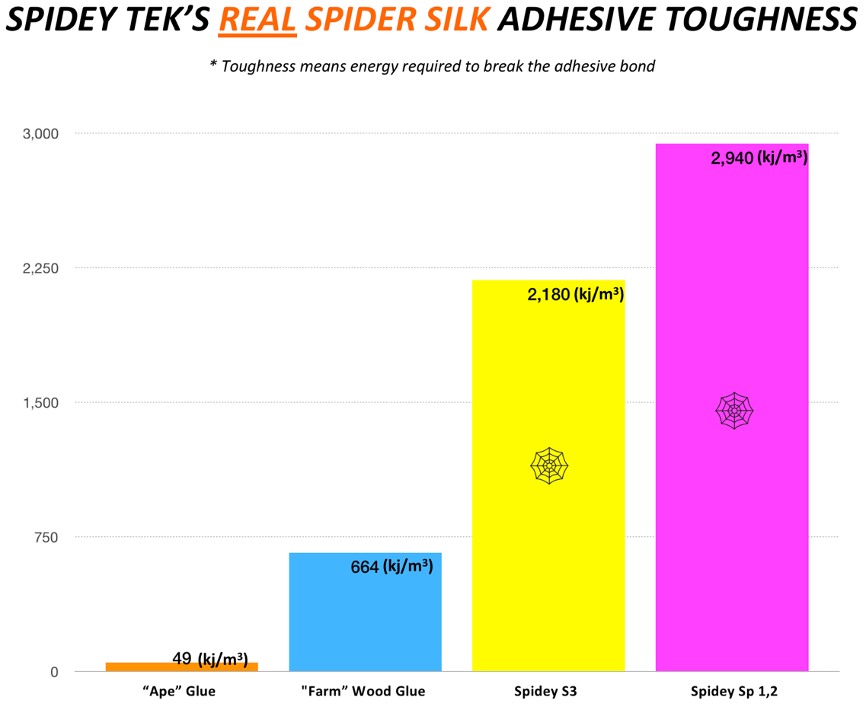
“Adhesives, such as super glue and other leading adhesive brands, have very little give or strain when bonded. The result is very tightly bound substrates (the pieces that are glued together) but, substrates that fail quickly and catastrophically. The bonded materials and the adhesive cannot sustain, or absorb, forces up to or beyond their adhesive ability. What makes our Spidey adhesives unique is not only their green composition (water solvated spider silk proteins) but, the Spidey adhesive can absorb energy by stretching before failing. This is a tremendous advantage for an adhesive in any dynamic environment.” Stated Spidey Tek CTO, Dr. Justin Jones, PhD.
Spidey Glue’s flexibility is unique to this technology and cannot be duplicated by chemical or man-made components. In addition, Spidey Glue is optically clear.
“As a designer, engineer, scientist and inventor I have often been confronted with the problem of ‘how are we going to hold these parts together under the stress they will be subjected to’, in some cases, we could not complete the project for want of a workable adhesive”, said Spidey Tek CEO Roberto Velozzi. “The worldwide market for glues and adhesives will be over $50 Billion by 2020. We feel that this is an excellent market for the company to make significant changes to. As an executive with a major international materials company recently said, ‘This technology changes everything’ Velozzi concluded.
For additional information on spider silk technology and Spidey Tek company developments, visit the Spidey Tek web site at: www.spideytek.com or submit comments and questions to: www.info@spideytek.com

