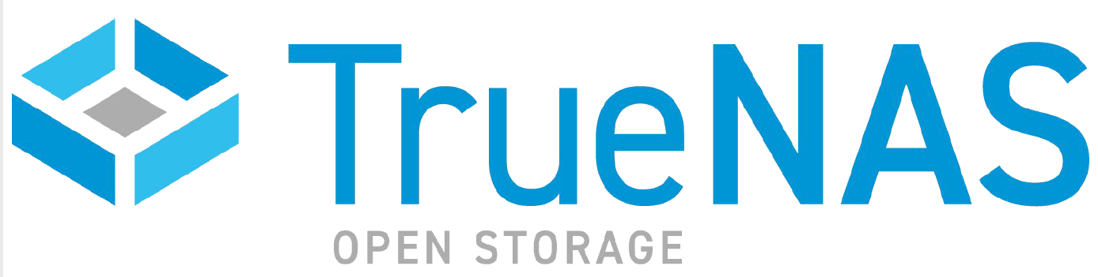

PRESS RELEASE
FOR IMMEDIATE RELEASE

iXsystems Launches Professional-Grade
Storage for the Edge with TrueNAS Mini X

Compact office storage system provides up to 85TB of
whisper-quiet HDD and flash via 10 Gigabit Networking

SAN JOSE, CA – August 20, 2020 -- The TrueNAS Open Storage portfolio expanded today with the TrueNAS Mini X storage appliance – optimized for storage at the edge. Designed for remote, branch, and other office environments, the new appliance utilizes TrueNAS CORE 12.0, the latest generation Open Storage software featuring OpenZFS, business-class security and management with compelling features and performance.

"The volume of data stored globally continues to rise, driven by data generation at endpoints and processing at the edge, putting pressure on IT professionals who manage this data," said Tom Coughlin, President, Coughlin Associates. "Even with the tightened economic situation, businesses need to enable cost-effective storage solutions that can help them meet this challenge. The TrueNAS Mini X is a good option for storage in these edge environments."

All TrueNAS Minis are built with professional-grade capabilities including error correcting (ECC) memory, IPMI remote management, and the OpenZFS file system. These features are not found in consumer-grade systems whose designs typically favor minimum cost over data integrity. By contrast, the entire Mini line’s primary focus is keeping data intact and protected from corruption and bitrot.

The two new storage systems (Mini X+ and Mini X) provide up to 85TB of storage in a compact (13.5L) chassis with seven hot swap drive bays (5 x 3.5” and 2 x 2.5”), which allow for a variety of RAID layout choices and caching configurations. The Mini X and X+ are designed to address a broad range of office/edge requirements for block, file, video, and unstructured data storage. Hard Disk Drives (HDDs) and Solid-State Drives (SSDs) can be mixed into fusion pools, which provide the performance of flash and the economics of disk drives.

The TrueNAS Mini X+ includes 2 x RJ45 10GbE ports, 8 cores, between 32-64GB of DDR4 ECC memory, USB 3.1 connectivity, and 1 x RJ45 IPMI remote management interface. With high bandwidth networking and optional flash capacity, this system is capable of supporting video editing, data backup, and file sharing applications with up to 2GB/s of bandwidth at less than 100W per unit, fully-loaded with drives.

The TrueNAS Mini X includes 4 x RJ45 GbE ports, 4 cores, between 16-32GB of DDR4 ECC memory, USB 3.1 connectivity, and 1 x RJ45 IPMI remote management interface. The system uses less than 80W of power.

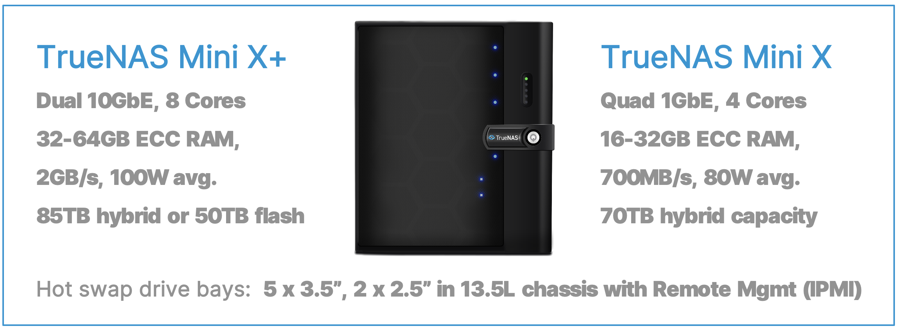

For offices or remote storage at the edge, the TrueNAS Mini family supports a wide range of unique operating environments with a compact, quiet, and flexible system. The ready-to-deploy TrueNAS Mini includes enclosure management that provides visual management of all drives from the UI, and applications such as Plex, NextCloud, Asigra, Iconik, and many others are deployable as either plugins or VMs.

Additionally, organizations managing multiple systems spread across multiple sites can utilize TrueCommand single-pane-of-glass management to simplify 24x7 operations. TrueCommand management offers performance monitoring, custom reports, predictive analytics for capacity/health, and system audits for businesses of any size.

“The TrueNAS Mini X provides a fast, high capacity, and easily manageable option for today’s more distributed workgroups,” said Tim Neary, Founder, Strategic Storage Solutions, an iXsystems partner focusing on media and entertainment. “Another important feature for us was the ability to protect against data loss caused by human error or hardware failures. With built-in ZFS RAID and snapshots, the Mini X maintains access to data even in the event of drive failure, disk corruption, file deletion, and even malware attacks, offering high levels of resiliency for a more productive work environment.”

"Powered by TrueNAS, the world's most popular Open Storage software, the Mini X is the next generation of TrueNAS systems for storage at the edge," said Morgan Littlewood, SVP, Products for iXsystems. "Supporting a growing demand for storage and faster access to data with management ease and affordability, the Mini X is ideally suited to office storage needs today.”

The TrueNAS Mini family starts at $699 and can be purchased in fixed configurations at Amazon, custom configured at truenas.com, or via any TrueNAS partner. iXsystems chose the highly reliable Western Digital Red Plus drives, ranging from 1TB to 14TB, to be used in the TrueNAS Minis. A 70TB TrueNAS Mini X+ retails for under $3500 and SSDs can be added for extra performance. All-flash configurations up to 50TB are also available at affordable prices.

"TrueNAS Minis are highly innovative, professional-grade NAS systems and we are delighted that iXsystems chose our WD Red Plus drives,” said Ziv Paz, Senior Director, Compute Segment Marketing, Western Digital.

To learn more about how TrueNAS can help your organization, contact us at https://www.ixsystems.com/contact-us/, or give us a call at 1-855-GREP-4-IX.

Tweet This: @iXsystems Launches Professional-Grade Storage for the Edge with TrueNAS Mini X - https://www.ixsystems.com/press-releases/

Additional Resources:
- To learn more about TrueNAS Open Storage, visit: https://www.truenas.com/
- Follow TrueNAS News on Twitter at: http://twitter.com/iXsystems

About iXsystems and TrueNAS
Through decades of expertise in system design and development of Open Source software (FreeNAS, FreeBSD, OpenZFS, and TrueNAS), iXsystems has become an innovation leader in high availability storage and servers powered by Open Source solutions. With over one million deployments and backed by the legendary ZFS file system, TrueNAS systems offer the stability and reliability required for Backup, Multimedia, Cloud Hosting, Virtualization, Hyper-converged Infrastructure, and much more. Since the founding of iXsystems in 2002, thousands of companies, universities, and government organizations have come to rely on the company’s enterprise servers, TrueNAS Open Storage, and consultative approach to building IT infrastructure and Private Clouds with Open Source economics.

- END -

