, 2024

Dear Valued Shareholders,

I am thrilled to share with you some of the remarkable progress and exciting developments we are making at Preferred Commerce, “your company.” Even though our revenue has not caught up to our progress, in our opinion we have everything in place to grow 10x or more over the next 12-18 months. In fact, we are working on several situations that are close, and if completed as agreed by myself and the other principals of the companies, we would be joining forces with companies that would be directly marketing our products to nearly 1,000,000 customers. There’s still a lot to do, but we’re getting closer every day and week.

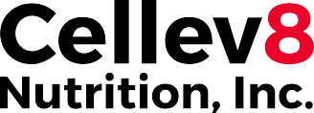
Name Change and Corporate Updates

First, let’s start with the name change: we are now officially Cellev8 Nutrition Inc. This will be updated on the wires very soon. We have successfully completed our transition to our new corporate identity, which better reflects our innovative approach to cellular health. I’m pleased to announce that we have applied to FINRA to update our stock listing to reflect this change, aligning our market presence with our cutting-edge brand. We have hired an additional law firm, Fox Rothschild, to assist in all needs of capital markets, patents, and trademarks, and business contracts. Along with Fox Rothschild, we have hired a CPA firm, Salberg and Co., to do our audits needed for listings and offerings. Salberg is very well versed in public markets and SEC rules and regulations.

Product Technology and Achievements

Our patent-pending technology has enabled us to create truly unique products that address one of the most critical aspects of cellular health: mitochondrial function. So far, only successfully delivering approximately 140 units or more daily of SOD2 and other high output antioxidants and ingredients through our proprietary Fibersol-enhanced gummies, we have achieved what no other company has been able to do: provide near-complete delivery and absorption of this vital enzyme to and in the small intestine. We now have the data to support our products, 100%. We also know we can supply people with even more of this superpower, enzyme/antioxidant, and when combined with additional ingredients could make Cellev8 one of the most powerful supplements ever.

We have completed formulation and testing on gummies now with more than 700 units of SOD per serving, which means an even bigger impact on people. This breakthrough into production of higher-level products to help people feel and look better, assist any athlete whether weekend warrior, professional, collegiate or youth, will help their bodies recover better and faster, and feel better every day. SOD2 and Cellev8 products for cellular health cannot be overstated. Numerous studies have demonstrated that raising SOD2 levels in chronically inflamed cells can revert mitochondria back to a healthy state. This has profound implications for overall health, energy levels, and even athletic performance.
Speaking of athletic performance, I am proud to announce that our product is now being used by 40 professional and collegiate sports teams. This is a huge gain for us considering the year started with just 2. This level of adoption by elite athletes is a testament to the quality of our supplement. I’m excited to share some compelling data from clinical studies on the key ingredients we use in our products, from our suppliers. It’s important to note that our patent-pending delivery system significantly improves upon the already impressive results achieved by our suppliers’ ingredients by enhancing and protecting their existing, clinically-tested, bioavailability.

Partnerships for Sales, Marketing and Branding

Over the last 30 months, we have embarked on a number of relationships with people with great backgrounds and companies with big promises, and you never know what your company is in store for until you try. Some have been great when others have been a complete flop, but the path is forever forward, so just learn and move on for every shareholder reading this and every customer that feels better because of our product, whether an athlete or a person with health conditions. The relationships we have in place have brought us initial sales and entry into the NFL, NBA, MLB, NHL, MLS, and NCAA in the US and Canada. These relationships start small, but we are already starting to see teams reorder with us for entire upcoming seasons. They are talking about us now and we are starting to grow wings.
Amazon has been a great place for us, our products, and has had its challenges too, but all-in-all a solid venue for sales. Amazon is a good example of a learning curve, and once it smooths out, that platform can bring strong revenue to the company, and we feel we are just about there. Vitacost (a subsidiary of Kroger) has been a slow starter for us, but the plans for 2025 are strong, and we feel the same as Amazon regarding growth because of the size of their supplement business online, I believe second in the world right now. Walmart online has just started, and we have already seen some good light ahead and look forward to updating you more on that progress.

Social media channels such as Instagram, Facebook, TikTok, and others are also starting to grow. We’ve had some great success with influencers so far and are continuing to grow there. We had a very successful

launch with one woman in particular, @thedowntownaly on Instagram, and completely sold out of our products twice with her. Ally has over 500,000 followers and is a shining light on Instagram. Her first two postings generated over $80,000 in sales over a 3-day period. She will be a point of interest moving forward for sure.

We are positioning ourselves for a nationwide rollout with retailers. While this will require significant capital investment for inventory, marketing, and advertising, we believe the potential returns are enormous. We have started to push harder with influencers and social media to enhance brand awareness in the retail sectors. To support this effort, we have contracted with several individuals and organizations that will help grow our network and ambassador program. Our leadership has been busy establishing these relationships, and we feel great about future results.
Bob Beaudine, the number one placement agent for coaches, front office and leadership roles in college and professional sports, has us currently in conversations and testing with over 30 universities across the US. Bob’s participation in the company has been awesome. He was introduced by Rowland Hanson, a longtime friend and Board Member. There are many more relationships in the pipeline right now, but that could take up pages of writing.

Nick Kray, the founder of KrayMode.com, a former NFL operations coach now branding ambassador for Cellev8 and others. Nick has strong ties to the NFL, NBA, WNBA, NHL, Olympic Teams, NCAA,
UFC, PGA, MLB, and more. Nick’s performance agreement has already opened doors to dozens of professional teams in the NBA and NFL.
Most recently, we have gone into a marketing agreement for 3 years with a company called Zyppah, that produces an FDA-cleared anti-snoring mouthpiece. Zyppah has been around for many years and has over 500,000 customers, millions of people in their database, and over 175,000 subscribers to their monthly newsletter. This agreement puts us in direct contact with those people and is a revenue-sharing agreement that is very advantageous to both sides. Dr. Jonathan Greenburg, the founder, has an amazing background, and when he was introduced to us, he immediately took action to align himself with us because of our products.

We are in final signatures with Vivos right now, a company that produces and sells non-surgical FDA- cleared devices to stop sleep apnea. This agreement is very similar to Zyppah, and although they do not have as many customers, the customers and network of medical professionals they have is very strong. Between both companies, we gain access to over a million direct relationships to market Cellev8 to.
Good Eye Kid is a digital marketing agency that specializes in retail velocity... converting exposure into sales! Their focus is anything from paid searches to retail media. They have already started to convert eyeballs into sales and increase our exposure in just a couple of months. Their creativity and drive are crystal clear to us, and we feel this could be a long sought-after relationship for us. Brought to us by Sandy Blumberg who has been working with us for over a year now.

There are several more relationships we are working on right now that could directly expose Cellev8 to nearly 10 million more customers, and we look forward to the next update having a few more of those relationships in force!

SlimCell™
New Products

Elev8™

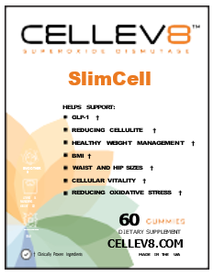
Packed with 50 mg of Dimpless™ ingredient, we incorporate into our formulations has shown remarkable efficacy in reducing and eliminating cellulite and reduction in BMI or assistance in weight management. In gold-standard clinical trials conducted by our supplier, Dimpless™ successfully demonstrated:
Î A significant 10% reduction in cellulite after just one month of supplementation.
Î Reduction in gluteal and femoral skin folds by 23% and 28% respectively after three months.
Î Accelerated reduction in waist and hip circumference, down 40% and 46% respectively, after three months.
Î Over 50% reduction in both fat cell size and fibrosis compared to the control group.

These results highlight the potent effects of this ingredient on subcutaneous fatty tissue and overall body composition. Additionally, we incorporate Morosil™ into the SlimCell™ product, further differentiating our offerings and potentially amplifying their benefits. Morosil™ has clinically been proven to assist in weight loss, while reducing your waistline and hip lines. The combination of SOD2, Dimpless™, and Morosil™ in SlimCell™ will be the first of its kind for post GLP1 or people looking to lose or maintain their weight. This new formulation is designed for complementary use with GLP-1 and GLP-1 agonists, tapping into the rapidly growing market for weight management solutions.
In the area of sports nutrition, we will be releasing another product that will use the powerful SOD product, Melorun®, which has been validated through clinical studies and real-world testing, hopeful name pending trademark “Elev8.”
Î Efficacy proven in a clinical trial on recreational users and a consumer study on a professional volleyball team, after two months of supplementation at 40 mg/day.
Î Four preclinical studies have elucidated the mechanisms behind its efficacy.
Î Melorun has been shown to promote physical and mental wellbeing, protect magnesium levels, prevent oxidative stress and inflammation, and support muscle and joint integrity.

Dr. Marc Saramito, the co-engineer of Melorun™, who has worked with top athletes including the French Olympic team, has been recommending melon SOD formulations to athletes for 20 years, noting their reliable and significant effects. The additional ingredients include high levels of Tart Cherry, D-Ribose, ATP, Vitamin D3, ROC (Red Orange Complex), and more... Our innovative approach involves encapsulating these proven ingredients in our proprietary delivery system, which significantly enhances their bioavailability.

Market Outlook

The global dietary supplements market, valued at $90.03 billion in 2023, is projected to reach $248.4 billion by 2036, growing at a CAGR of 8.8%. Cellev8 Nutrition Inc. is well-positioned to capture a significant share of this expanding market, particularly in the protein and amino acids segment, which is expected to dominate with a 38% market share by 2036. The North American region, which is predicted to account for more than 34% of the dietary supplements market revenue share by 2036, remains our primary focus. With approximately 1 in 3 American consumers interested in using botanicals to improve their mood and mental health, our natural, science-backed approach resonates strongly with our target market.

Our commitment to delivering high-quality, effective supplements at reasonable prices sets us apart in a crowded marketplace. The soft-gel segment, which our gummies fall under, is projected to grow at over 6.3% between 2024 and 2036, highlighting the increasing consumer preference for easy-to-consume supplement formats.
Our proprietary encapsulation system further enhances these effects by improving bioavailability and slowing the digestive process to enhance absorption even more than our initial products. This patent-pending system holds the potential to enable even large pharmaceutical companies to utilize the benefits of our enhanced delivery process. This represents an exciting new revenue stream for Cellev8 Nutrition Inc., further enhancing our growth potential and shareholder value.

We have had the honor of working with great people like Hal Kravitz from Coca Cola and Gerry David from Celsius help get us down the right path even though they have moved on. Their expertise and guidance have been invaluable. As we look to the future, we remain dedicated to innovation, scientific research, and expanding our market presence. With our unique delivery system, strong adoption among professional athletes, upcoming product launches, potential major distribution deals, and the promising licensing opportunities, we are attracting the right people to support our formulation, results, and credibility behind our products.

New Experts in Functional Medicine and Functional Nutrition

We are proud to have some new experts in the fields of functional medicine and functional nutrition:

Kylene Bodgen - Advisory Board:
Kylene is currently the Head of Nutrition for the Cleveland Cavaliers. Kylene is the first board- certified Sports Dietitian in the United States to

have completed the Institute for Functional Medicine’s 5-day intensive course, Applying Functional Medicine in Clinical Practice (AFMCP). Kylene is also a board-certified Integrative and Functional Nutritionist. She is also a certified LEAP therapist specializing in nutrition for performance while considering food sensitivities, gut health, and nutrients. In addition to her private practices and her work with the Cavaliers, Kylene has worked with a wide array of athletes from high school to Olympic, NFL, NBA, and more.

Danielle LaFata - Advisory Board:
Danielle has spent nearly two decades as a Sports Dietitian working with high school, college, and professional athletes throughout the world. She is a Board-Certified Specialist in Sports Dietetics (CSSD), and she too is a Certified LEAP Therapist. She has worked with World Series Champions San Francisco Giants for 6 years through two titles in 2012 and 2014. Danielle, recently, was the Director of Nutrition for the Phoenix Suns. Danielle has worked with the US Men’s National Soccer Team for 3 years and one World Cup, the Arizona Coyotes NHL team, and the Arizona Cardinals Football.

Kelsee Gomes - Advisory Board:
Kelsee is an MS, RD, CSSD, LD/LN, and CLT. Kelsee is currently the dietitian for the NY Yankees organization. Kelsee is a Registered Dietitian, Certified Specialist in Sports Dietetics, a certified LEAP Therapist, and has been elected to the board of directors of Collegiate and Professional Sports Dietitians Association. She is also active in the Collegiate and Professional Sport Dietitians Association. Kelsee is also a Board Member of the American Sports and Performance Dietitians Association. Kelsee was the Director of Sports Nutrition for the Florida Gators football team for 4 years, after her 7-year tenure with North Carolina Tarheels where she oversaw the nutrition department for baseball, men’s basketball, field hockey, football, gymnastics, women’s lacrosse, and volleyball. She was part of 5 national championships - lacrosse (2015), basketball (2017), and field hockey (2018-2020).
Kelsee, Danielle, and Kylene represent our commitment to excellence to produce products with the finest ingredients that have the backing of doctors, dentists, scientists, professional nutritionists, and dietitians.

Dr. Eric Serrano MD:
Dr. Serrano has joined our Board of Directors and is very engaged. He has helped me with formulation and concept design around future Cellev8 products that are truly amazing. He has made Cellev8 a poster product in his offices encouraging all his patients to use the Cellev8 brand. The results have been staggering to say the least. I only wish we could use them in advertising! Dr. Serrano is world renown in the fitness and supplements industry holding approximately a dozen patents on supplement products, developing innovative workout equipment, and working with some of the most recognized athletes in the world. He is a trainer, a rehabilitation specialist, a life coach and a world record holder in powerlifting. I could go on and on about him, but the list is way too long. His clientele come from all over the world to be treated and range from young kids to elderly adults. “Eric” is a true partner here at Cellev8 and his efforts in helping our brand grow are top notch.

Mario Medri:
Mario has recently joined our Board of Directors along with being our Chief Scientist. For the past 40 years, Mario Medri has been principal and Managing Partner of Consumer Products Corp. (CPC), a New York Corporation specializing in product development, process engineering, and providing turnkey operations for OTC pharmaceutical, food, and cosmetic products. Mario has developed, reformulated, and patented pharmaceutical and nutraceutical products including:

Î Antacid, fast melt tablet and gum
Î Calcium supplement in candy, gum and chewy nougat delivery form
Î Chew nougat (sugar/sugar-free) hot and cold process as delivery system for OTC
Î Chloraseptic, Branded and NBE for private label
Î Cough drops, NBE for private label
Î Chewable aspirin tablet and in chewing gum
Î Fiber bar, with dietary fiber
Î Generic Nicotine gum (Mint and fruity flavor)
Î Anti emetic chewable tablets for pediatric use (motion sickness)
Î Halls Cough drops, sugarless
Î Halls regular, honey lemon and ice blue cough drops
Î Hot and cold cough tablet. Two-layer cough tablet (Patented)
Î Medicated chewing gum with functional actives
Î Reversed engineered – Nicorette gum NBE
Î Medicated hard candy with actives – sugar & sugar-free – branded and PL
Î Medicated tablets with actives; cough / cold.
Vapor action. Chewable analgesic.
Î Remegel, chewy antacid – Mediquel chewy cough suppressant with DM.
Î Rolaids, new formulation
Î Slim mint, diet tablet and gum
Î Sugar and sugar free medicated lollipops with actives
Î Pre-ops lollipops with Fentanil Opiate (pediatric)
Î Sugarless Cough drops and lozenges, NBE for private label
Î Travel gum and Chewable tablet with Dimenhydrinate
Î Medicated Gummies for drug delivery.

Only to name a few. He holds over 15 patents and several patent pending statuses with “Big Pharma.” Mario has built his company CPC (Consumer Products Corp) and others from the ground up assisting in everything from business plan to facility setup, right down to establishing the production lines and teaching people how to make successful products for consumers health and wellness. We are proud to have him to assist us in developing more Cellev8 products.

Mike Hagan Board of Directors:
Mike served as the CEO of Cheribundi, a leading tart cherry juice brand, from 2015 to 2021 and a competitor of ours in the sports nutrition space.

Mike’s Leadership Positions:
Î CEO of Cheribundi (2015-2021) Î COO of ginnybakes (2014-2015) Î COO of SM Jaleel (2012-2013)
Î COO of Shasta Beverages, Inc.
at National Beverage Corp (2011-2012)
Î President of Pepsi Americas, Puerto Rico (2006-2009)

Î Senior Vice President of Sales & Marketing at The Philadelphia Coca-Cola
Î Bottling Company (1998-2005)
Î Division Vice President & General Manager at Coca-Cola Enterprises, Inc. (1992-1998)

Achievements at Cheribundi
During his tenure as CEO, Hagan:
Î Built a robust distribution network of over 20,000 retail partners across multiple channels
Î Drove over 540% revenue growth in less than three years
Î Focused on supply chain optimization and building out the company’s direct-to-consumer business

Mike’s Expertise include:
Î Sales And Marketing
Î Operations And Supply Chain Management
Î Finance And P&L Performance
Î Strategic Planning
Î Acquisition Due Diligence

After his time at Cheribundi, Hagan went on to serve as CEO of the Emerging Brands Portfolio at KEEN Growth Capital from 2021 to 2023. As of October 2023, he has taken on the role of Chief Executive Officer at Snaxsational Brands, LLC.

Last but not least, we have engaged with some expert advisors that are experienced in business development and growth as well as capital markets. They have introduced us to many potential relationships already for business opportunities and are working closely with our attorney’s firm to help
structure our uplisting to the OTC Markets and possibly getting the company listed on the Chicago Exchange. They also have a proven track record of helping companies achieve market recognition and have already started to bring other investment groups forward, exposing them to Cellev8.

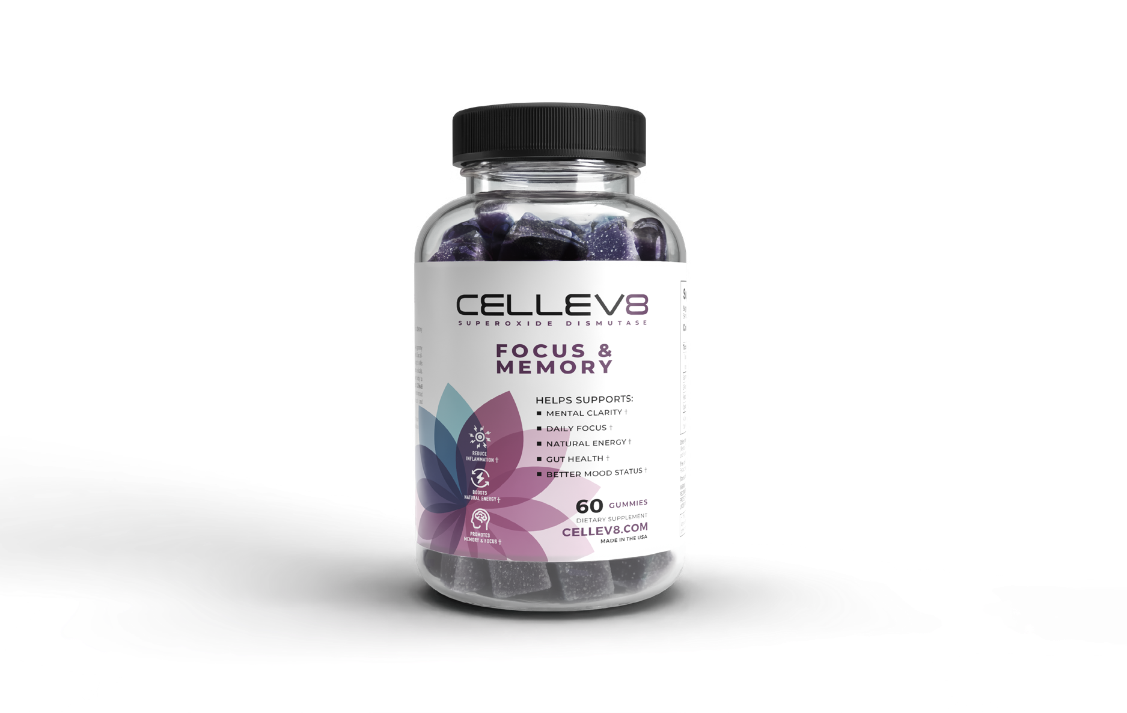
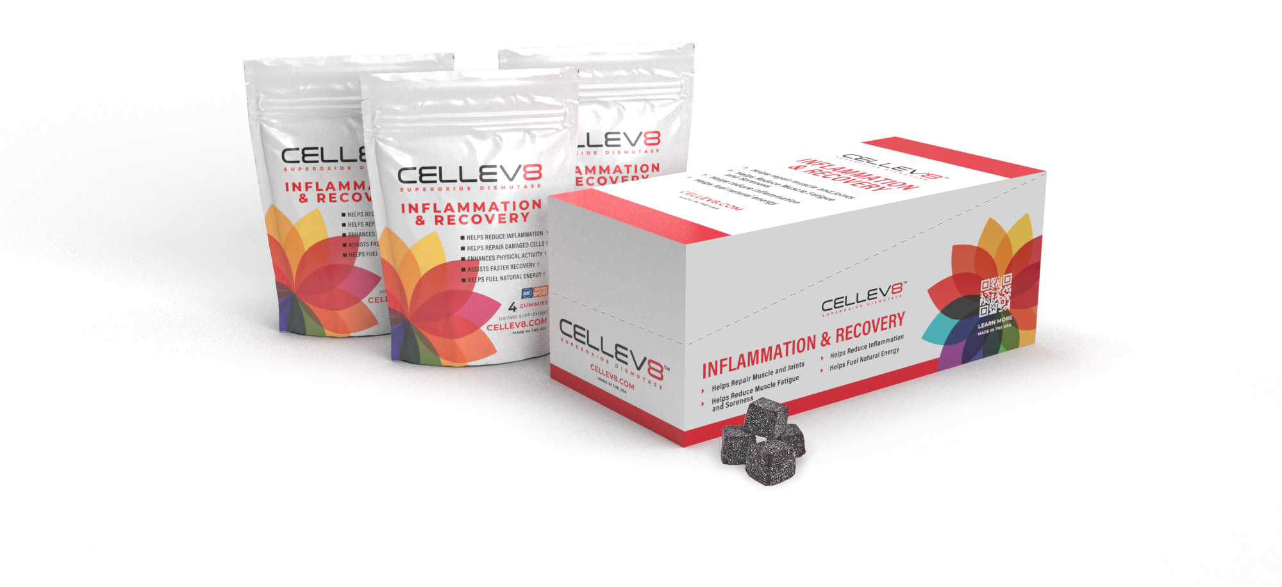
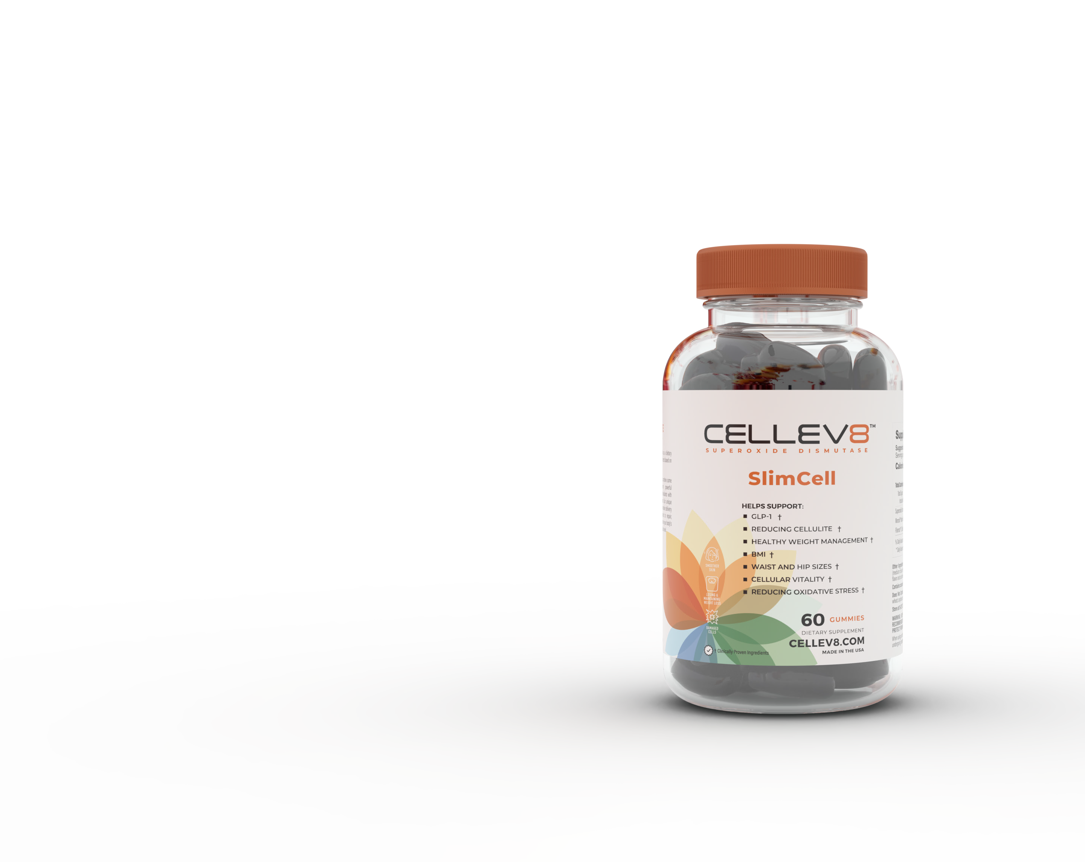
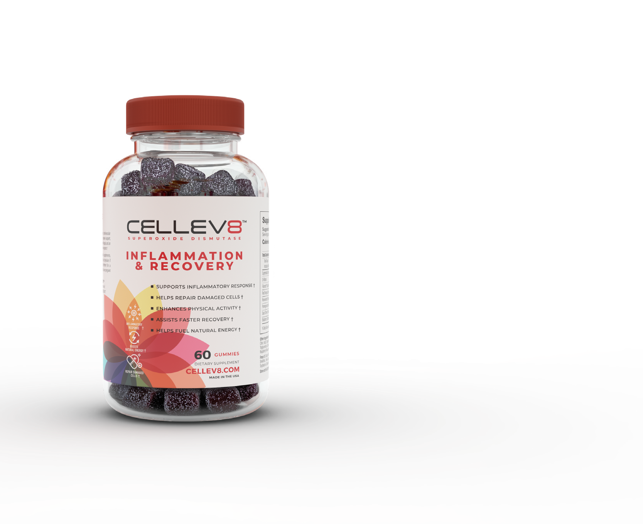


Thank you for your continued support and trust in our vision. As Cellev8 Nutrition Inc., we are not just building a successful company, but also contributing to improved health and well-being for millions of people while potentially revolutionizing drug free delivery of ingredients that will enhance the body from a cellular position.
Sincerely,
Michael Ferraro
CEO | Cellev8 Nutrition Inc.

