Press Release
FOR IMMEDIATE RELEASE
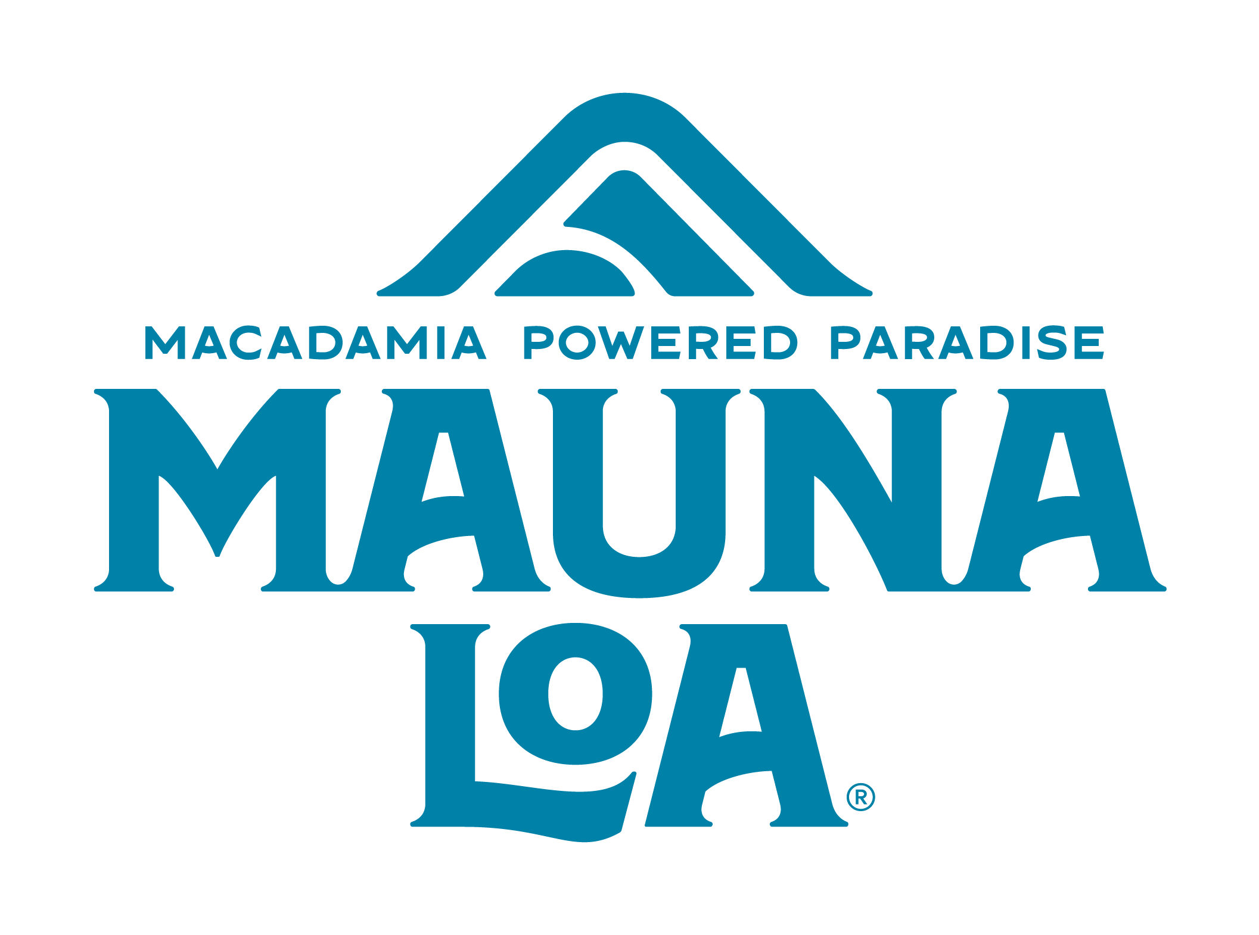
Celebrate National Ice Cream Month with FREE Mauna Loa Paradise Pops and a Celebrity Chef Collaboration!
Los Angeles, California – June 28, 2024 – In celebration of National Ice Cream Month, iconic macadamia brand Mauna Loa is thrilled to announce the launch of the freezer section’s newest indulgence with a tropical twist, Mauna Loa Paradise Pops™. Offered in select retailers in California, Hawaii, Nevada and Texas, this non-dairy option uses macadamia milk for its base, creating a rich and flavorful frozen dessert pop. Mauna Loa Paradise Pops™ bring unique differentiation with Hawaiʻi inspired flavors, like Mango Lilikoʻi Vanilla, Strawberry Guava and Kona Coffee Crunch.
Two ways to celebrate National Ice Cream Month:
- FIRST, join the fun with the Mauna Loa Ice Cream Truck LA Tour where you can try the new Mauna Loa Paradise Pops for yourself! From July 13-21, 2024 the Mauna Loa Ice Cream Truck will be touring Los Angeles, planting at popular locations throughout the city, bringing the tropical flavors of Mauna Loa Paradise Pops directly to fans. At each stop, visitors can enjoy FREE products including full size samples of our Paradise Pops, Hawaiian Sea Salt Macadamia Nuts and exclusive merchandise/giveaways. One lucky winner will even win a custom Mauna Loa surfboard and FREE macadamia nuts for a year! Eligible participants must visit ice cream truck and fill out quick entry form on-site.
Follow Mauna Loa on social media (@maunaloamacnut) or visit www.maunaloa.com/pages/ice-cream-truck-tour-2024 for real-time updates on truck locations and event details.

Date | Location | Time
Sat, July 13th | Best of LA Block Party at Paramount Studios | 6pm
Sun, July 14th | SURPRISE (follow @maunaloamacnut for details!)  Whole Foods Market Silver Lake | 12 – 3 PM  3 – 6 PM
Tues, July 16th | Pavilions Mission Viejo | 3 – 6 PM
Fri, July 19th | Pavilions Culver City | 12 – 4 PM
Sat, July 20th | COOL FAM FEST at Platform LA | 11 AM – 5 PM
Sun, July 21st | Abbot Kinney | 12 – 6 PM

- SECOND, Mauna Loa is partnering with Brique French Toastery at Westfield Century City for the month of July. Brique is home of Chef Rocky’s #RockToast, made famous by Dwayne “The Rock” Johnson as one of his favorite cheat meals. Receive one FREE SCOOP of Mauna Loa's Macadamia Milk Ice Cream with any in-store purchase of Brique French Toast. One scoop per toast, while supplies last! See more on the famous #RockToast here.
About Mauna Loa
Since 1946, Mauna Loa has been dedicated to bringing the unique taste of macadamia nuts to the world. Mauna Loa is taking the macadamia nut further than it has ever gone before with innovative products leading their success. Now, no matter where you live, you can taste paradise with Mauna Loa. Find Mauna Loa in grocery stores like Albertsons, Ralphs, Whole Foods and Pavilions. Paradise Pops flavors include Mango Lilikoʻi Vanilla, Strawberry Guava, and Kona Coffee Crunch. Paradise Pops can be found select retailers in California, Hawaii, and Texas, like Pavilions, Safeway and Smart & Final. Our frozen dessert offerings are proudly Vegan and Non-GMO verified.
To find other retailers carrying our products, please visit Mauna Loa Where to Buy.
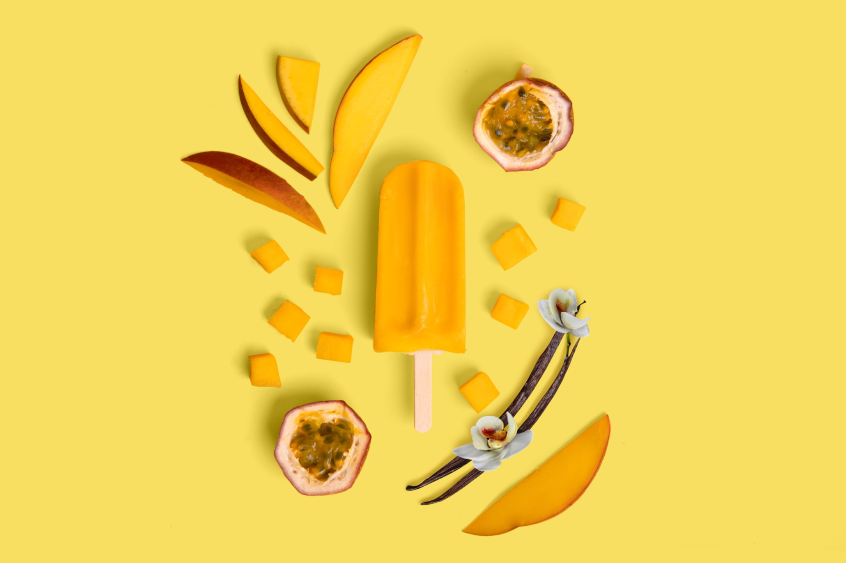
Share About Our Sweet Celebration!
We appreciate your consideration of coverage as we celebrate National Ice Cream Month. Chef Rocky of Brique has made herself available for interviews, table long displays are ready to be featured, and vendor highlights of the Best of LA Block Party and COOL FAM FEST can be made available. We look forward to working with you on sharing the news. Photos are available here. Thank you for your consideration.
For media inquiries, please contact:
Katie Natori
Associate Global Brand Manager
Mauna Loa
Email: knatori@hawaiianhostgroup.com
Phone: (808) 842-7329
Follow us on social media:
Instagram| Facebook | TikTok | Pinterest

