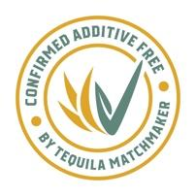
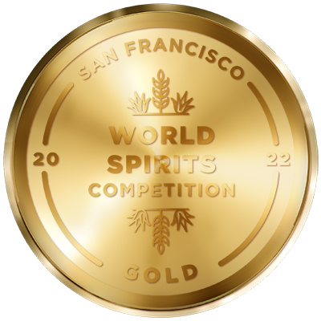
Media Contact:
Victoria Camargo
Deussen Global Communications, Inc.
vcamargo@deussenglobal.com
m. 786-271-4641

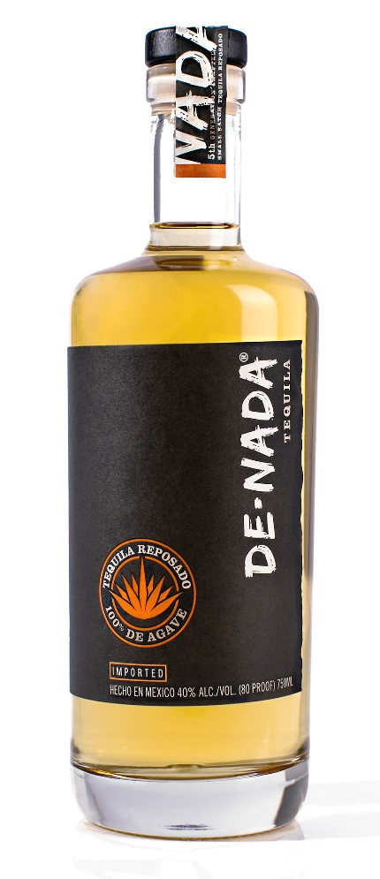
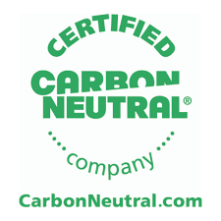

DE-NADA® Tequila Reposado
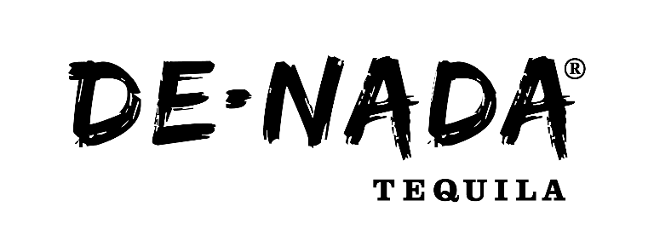
About DE-NADA Tequila: With a name that means “of nothing,” as of this writing DE-NADA is one of only 37 Tequila brands that are currently Confirmed Additive Free: even within the spirits industry, few know that Tequila can legally have hundreds of additives, including artificial color, flavorings, and added sugar; high market demand leaves few brands prioritizing quality over quantity. Conversely, DE-NADA – crafted field to bottle at the 5th-generation Vivanco family distillery – is literally pure agave. DE-NADA is proud to be part of the additive-free movement, encouraging labeling transparency and authenticity between brands and consumers. DE-NADA Tequila is also Certified CarbonNeutral.
In less than 12 months DE-NADA moved from humble car trunk beginnings to being sipped on national television during CNN’s New Year’s Eve Live with Andy Cohen and Anderson Cooper and The Tonight Show with Jimmy Fallon.
About DE-NADA Tequila Reposado (NOM 1414; Jalisco [Highlands]): Made from 100% estate-grown blue Weber agave, the hearts of which are horno-baked for more than 48 hours at 201° F (94°C) and then roll-milled to extract the sweet juices. This essence is fermented using natural yeast while classical music plays at high volumes to help optimize sugar conversion.
After double distillation in alembic copper pot stills, DE-NADA Reposado is aged in ex-bourbon American oak barrels for a minimum of four months. DE-NADA is additive-free, meaning there are no added sweeteners, perfumes, flavoring, or coloring, delivering a clean, premium, sipping tequila.
Tasting Notes: Silky aged tequila with aromas of roasted agave, peach, and pineapple, with notes of almond, cinnamon, caramel, and vanilla.
State: Jalisco
Country: Mexico
Where to Find it:
Traditional Distribution: NY (Empire Merchants), NJ (Allied Beverage Group), CT (CDI)
Available on-line in the following states: AZ, CA, CO, CT, DC, DE, IA, IN, LA, MO, MT, ND, NE, NH,
NJ, NM, NV, NY, OK, SD, WA, WI,
WV, WY

UPC: 8 60002 05641 8
Case Dimensions: 6/750mL: H=13.5” x L=8.75 x W=7.5”
Cases/Pallet: 100
Case Weight: 20lbs per 6/750mL
Packed: 6 750mL/case
Alcohol by Volume (ABV): 40%
SRP: $43.00

More information, media samples, hi-res imagery and video, recipes, and interviews available upon request.
Please drink responsibly. DE-NADA is imported exclusively by DNA Spirits, Manhasset, NY.

Instagram: @denadatequila
Facebook: @denadatequila
Twitter: @denadatequila

