Language Arts Interactive Workbooks Product Fact Sheet
The Eight Parts of Speech - Grammar 1
Description:
The Eight Parts of Speech is a digital, interactive workbook with external links to chapter videos and exercises. This workbook also contains an answer key section.
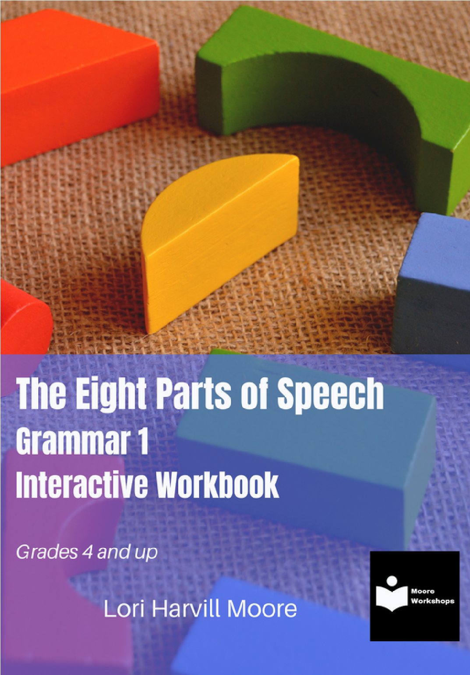
Format: Kindle
Author: Lori Harvill Moore
For ages: 8 - 11
ISBN: 978-1-4507-4335-8
Publisher: Standing Bird Press
Number of Pages: 53
Number of Video Links: 7
Number of Exercises: 22
Price: $24.99 to buy or $0 for Kindle Unlimited members to borrow
Link to Author's Page
Link to Amazon's Product Page
Moore Workshops/20220816

Language Arts Interactive Workbooks Product Fact Sheet
Topic, Message, and Form - Composition 1
Description:
Topic, Message, and Form is a digital, interactive workbook with external links to chapter videos and exercises. This workbook also contains an answer key section.
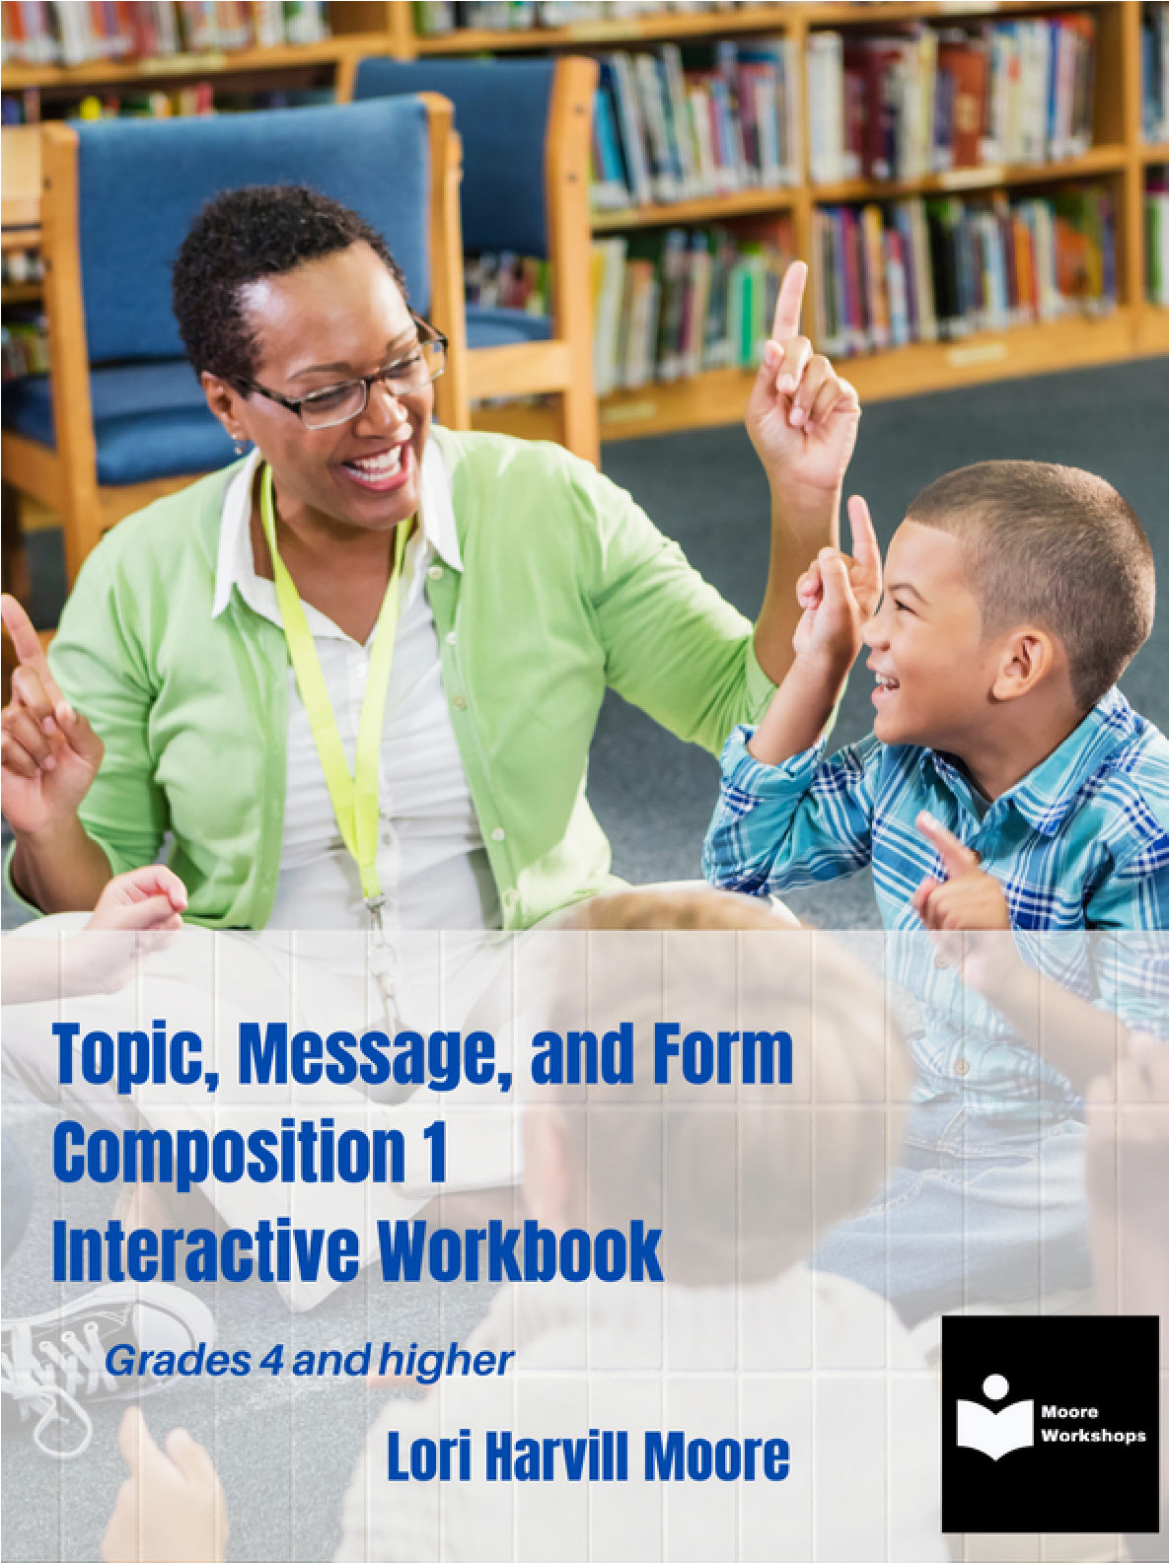
Format: Kindle
Aileron Regular
Author: Lori Harvill Moore
For ages: 8 - 11
ISBN: 978-1-4507-4338-9
Publisher: Standing Bird Press
Number of Pages: 39
Number of Video Links: 5
Number of Exercises: 9
Price: $14.99 to buy or $0 for Kindle Unlimited members to borrow
Link to Author's Page
Link to Amazon's Product Page
Moore Workshops/20220816

