To All Media
FOR IMMEDIATE RELEASE
CSF Contact:  Sara Leonard  sleonard@congressionalsportsmen.org  202-543-6850 x 11 | NationalGunTrader Contact:  Marcus Johnson  marcus@nationalguntrader.com  903-503-2062

Congressional Sportsmen’s Foundation Partners with NationalGunTrader to Enhance
Outdoor Recreation

October 16, 2018 - The Congressional Sportsmen’s Foundation (CSF) and NationalGunTrader recently signed a Memorandum of Understanding (MOU) to enhance the organizations’ shared interests of advancing opportunities for hunting, recreational shooting, and other outdoor recreation.
Both groups bring together sportsmen’s and other outdoor-related businesses and organizations with the common interest of advancing the interests of sportsmen and women across the country. CSF is the link between the sportsmen’s community and policy-makers at both the federal and state levels, while NationalGunTrader provides a marketplace-based community in an effort to connect consumers with firearm and other outdoor retailers, merchants and distributors.
“Through our partnership with NationalGunTrader, CSF has the opportunity to expand its network within the outdoor world, creating an even stronger voice for the sportsmen’s community in the halls of government,” said CSF President Jeff Crane.
NationalGunTrader Chief Compliance Officer, Marcus Johnson, echoed those remarks.
“We are committed to conservation and are absolutely grateful for the opportunity to partner with a leader like the Congressional Sportsmen’s Foundation to help advance critically important conservation efforts,” he said.
The MOU between CSF and NationalGunTrader will officially begin January 2019.
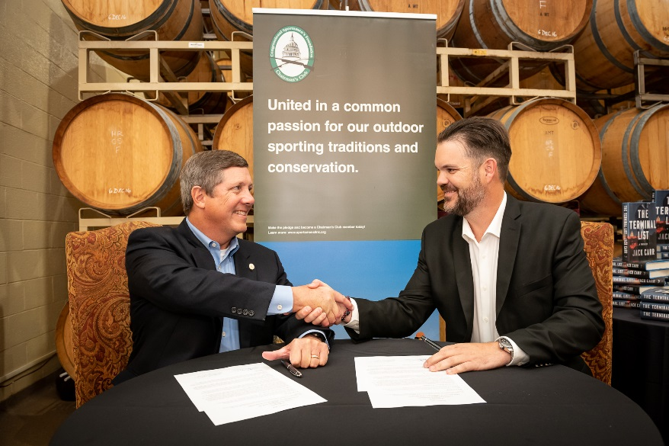
CSF President Jeff Crane and NationalGunTrader Founder/CEO Bill Voss

About CSF
Since 1989, the Congressional Sportsmen's Foundation (CSF) has maintained a singleness of purpose that has guided the organization to become the most respected and trusted sportsmen's organization in the political arena. CSF's mission is to work with Congress, governors, and state legislatures to protect and advance hunting, angling, recreational shooting and trapping. The unique and collective force of the Congressional Sportsmen's Caucus (CSC), the Governors Sportsmen's Caucus (GSC) and the National Assembly of Sportsmen's Caucuses (NASC), working closely with CSF, and with the support of major hunting, angling, recreational shooting and trapping organizations, serves as an unprecedented network of pro-sportsmen elected officials that advance the interests of America's hunters and anglers.
About National Gun Trader
NationalGunTrader’s mission is to create the leading marketplace for the outdoor and shooting sports worlds, a place where merchants can sell firearms and other related shooting sports and outdoor gear free of discrimination. By connecting outdoor and shooting merchants with those who love firearms and being outside, we will continue to build a community where enthusiasts can shop, purchase, and learn about the industry while visiting the world's largest online marketplace in the space. We are committed to providing the service, quality, and value that our customers deserve and expect.
###

