June 26, 2020 For Immediate Release

SCA Appraisal Launches Customized Client Care: Appoints Monica Diaz Senior Director of Customer Success, Lucano Figueroa, Yesenia Barreto & Amye Chow Customer Success Managers

Burbank, CA – To meet the evolving needs of its customers across a variety of industries, SCA Appraisal has implemented a Customer Success division and has re-allocated and added resources to specifically support client across various markets. Monica Diaz has been appointed Senior Director of Customer Success and will be accountable for end-to-end delivery to clients across three unique markets: insurance, third-party administrators and financial services/government.
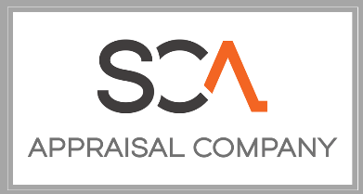
“Our industry has experienced a lot of change over the 41 years we have been in business. However, perhaps the most profound change has been our clients’ requests for company-specific requirements that leverage their own unique brands and identities.”, states Tim Davis, Jr., President of SCA Appraisal. “The IA space has long had a reputation for a one-size fits all approach, that is not acceptable at SCA. We are investing in our clients’ success and when they are successful, we are successful.”

Lucano Figueroa, an 18-year veteran of SCA will lead the Financial Services/Government group. Yesenia Barreto, brings her 13 years with SCA to lead the Third-Party Administrators group. Amye Chow, with SCA since 2011 leads the Insurance group. “All aspects of a claim will be handled by a vertically-integrated team that is familiar with our clients’ business objectives and processes.” says Monica Diaz. “We know we are an extension of our clients’ claims resources and we are aligned accordingly. Customers will see industry-leading service.”

In business since 1979, with franchise and supplier resources in all 50 states, SCA is a leading provider of private passenger auto, specialty, heavy equipment and financial services appraisals. For more information, or to request a demonstration, please contact ClientServices@sca-appraisal.com.

++++++++++++++++++++++++++++++++++++++++++++++++++++++++++
For inquiries:

ClientServices@sca-appraisal.com
1-818-845-7621

