Company Overview

A History of Innovation
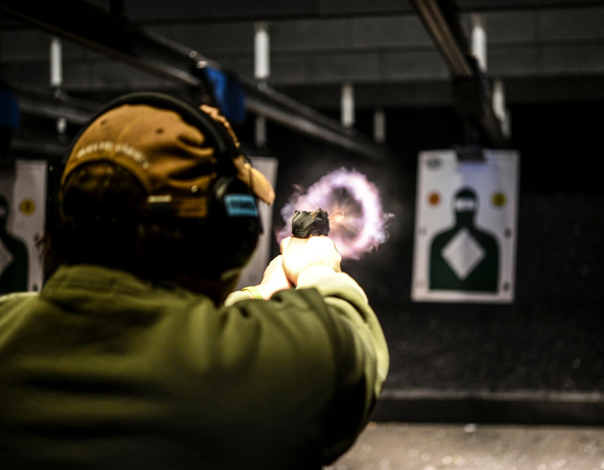
Headquartered in Minneapolis, Minn.,
and founded as Renew Resources, the company’s initial focus was on manufacturing recycled rubber products. During that time, Renew Resources was awarded a patent for a process to create a portfolio of proprietary rubber products. In the mid-1990s, the company applied the process to develop Dura-Panel™ and Dura-Bloc™, the most effective and safest ballistic rubber systems on the market. Dura-Panel and Dura-Bloc contain bullets, virtually eliminate splatter and ricochet, and minimize airborne lead contaminants in live-fire training environments.
Using its advanced ballistic encapsulation rubber, Renew Resources built its first live-fire training facility in 1997. In 1998, Renew Resources hired Charlie Baker as chief executive officer. Baker renamed the company Range Systems and changed its focus to live-fire environment and equipment production. In the early 2000s, Range Systems established a niche for building live-fire facilities for United States (U.S.) special operations forces. As other groups, including law enforcement and other national militaries, began to train at U.S. special operations facilities, Range Systems’ ballistic rubber products quickly became recognized worldwide. In response to the growing consumer demand for firearms in the last decade, Range Systems began developing commercial shooting ranges using its high-performance ballistic rubber systems. Today, the company is an industry leader building live-fire facilities and providing equipment for commercial, military, forensic, testing, law enforcement and private shooting ranges.

Custom Live-Fire Facilities
The only source for Dura-Panel and Dura-Bloc, Range Systems designs, installs and equips custom, indoor and outdoor live-fire facilities worldwide. Our experienced range design teams work with you to develop a facility, large or small, that matches your time and budget requirements. Committed to service excellence, Range Systems has built a reputation for providing high-performance, advanced products and services for:

- Fixed-position and tactical shooting ranges
- Modular and reconfigurable shoot houses
- Permanent and deployable training facilities
- Forensic and testing laboratories
- Private and in-home ranges

Ballistic Rubber, Products and Supplies
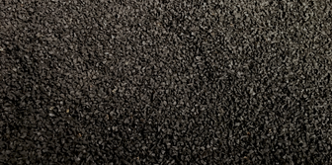
Range Systems’ Dura-Panel and Dura-Bloc are long-lasting bullet containment systems manufactured using recycled rubber particles. This ballistic rubber exceeds performance requirements for safety, reliability and acoustical control. Range Systems ballistic rubber is available in custom configurations, including baffles, sidewall, ceiling and acoustical systems.
In addition to ballistic rubber, Range Systems provides an extensive line of products for shooting ranges, shoot houses and training facilities to help maintain a clean and safe environment. Products are comprehensively tested internally and through third-party laboratories to meet or exceed safety and quality requirements. Range Systems’ superior shooting range supplies and products minimize wear and tear and support daily, weekly and periodic range cleaning and maintenance for a longer-lasting range.

Training Products
Moving targets, realistic environments and nontraditional target systems enhance training and raise the level of realism in commercial ranges, law enforcement qualification ranges or military-grade shoot houses. Range Systems’ training products include:

- Portable rubber bullet traps
- Breach doors
- Shoot house training furniture
- Robotic target systems
- Tactical target systems
- Target retrieval systems
- And more

To see Range Systems’ gallery of custom shooting ranges, shoot houses and other live-fire facilities, visit www.range-systems.com or call +1 763-533-9200 or 1-888-999-1217. Browse Range Systems’ online store and catalog at www.inrangesupplies.com.

