FOR IMMEDIATE RELEASE

My Mulan Fantasy Dance Drama Captivates Audiences at Niagara Falls
Niagara Falls, ON – August 22, 2024 – The highly anticipated performances of "My Mulan Fantasy Dance Drama" took place over two weekends from August 9-18 at the Fallsview Theatre, Niagara Falls Convention Center. Produced by Xu Hu, directed by Lin Li and choreographed by Lin Li and other choreographers, this marks the first time the production has ventured beyond the Greater Toronto Area after five successful rounds of twelve performances.
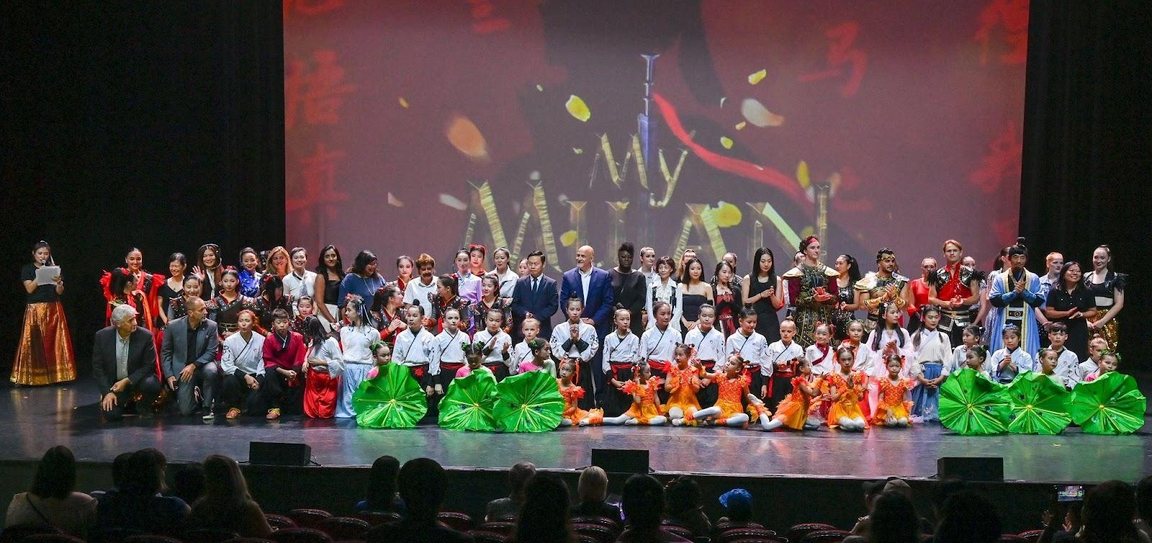
The production garnered immense support from notable figures, including Prime Minister Justin Trudeau, MP Tony Baldinelli, MPP Wayne Gates, Mayor Jim Diodati, City Councilor Mona Patel, Deputy Lord Mayor Erwin Wiens, and Doug Birrell, President of the Niagara Falls Canada Hotel Association. The presence of China's Acting Consul General in Toronto, Cheng Hongbo, and Deputy Consul General Guo Jian at the premiere further underscored the show's international significance.

"My Mulan" follows the journey of modern-day Michelle, who, despite initial self-doubt, draws inspiration from the legendary tale of Hua Mulan. Disguising herself as a man to take her ailing father’s place in the army, Mulan leads her troops to victory, empowering Michelle to reclaim her confidence and return to the stage.

With its innovative choreography, stunning visual effects, and a diverse cast of approximately 100 performers—including Molly Levay and 19 other local talents from the Niagara region—My Mulan sets a new benchmark for multicultural narratives in dance theatre. Co-presented by the Canadian Mulan Cultural Association and the Canadian International Dance Culture Association, and produced by Mulan Culture Company and Lindance Dance Academy, this original dance drama is the first of its kind in North America.
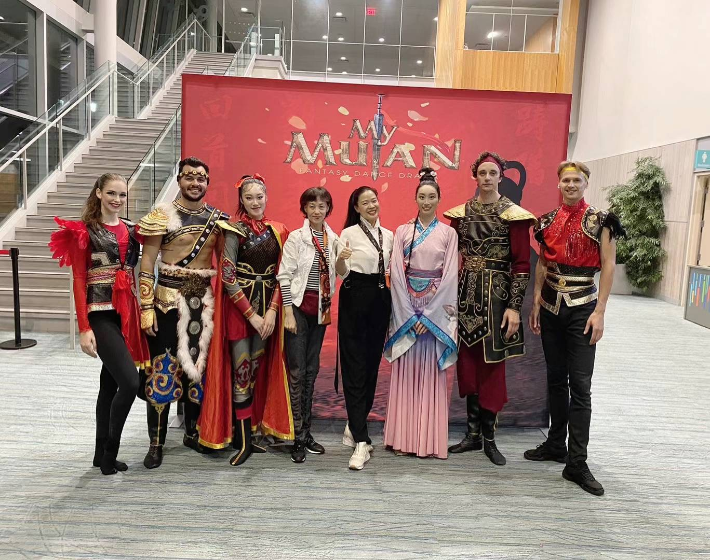

Prime Minister Trudeau commended the team's exceptional efforts in showcasing Chinese culture on Canada's multicultural stage. Acting Consul General Cheng expressed pride in "My Mulan," reaching an international audience and sharing Mulan's spirit with the world.
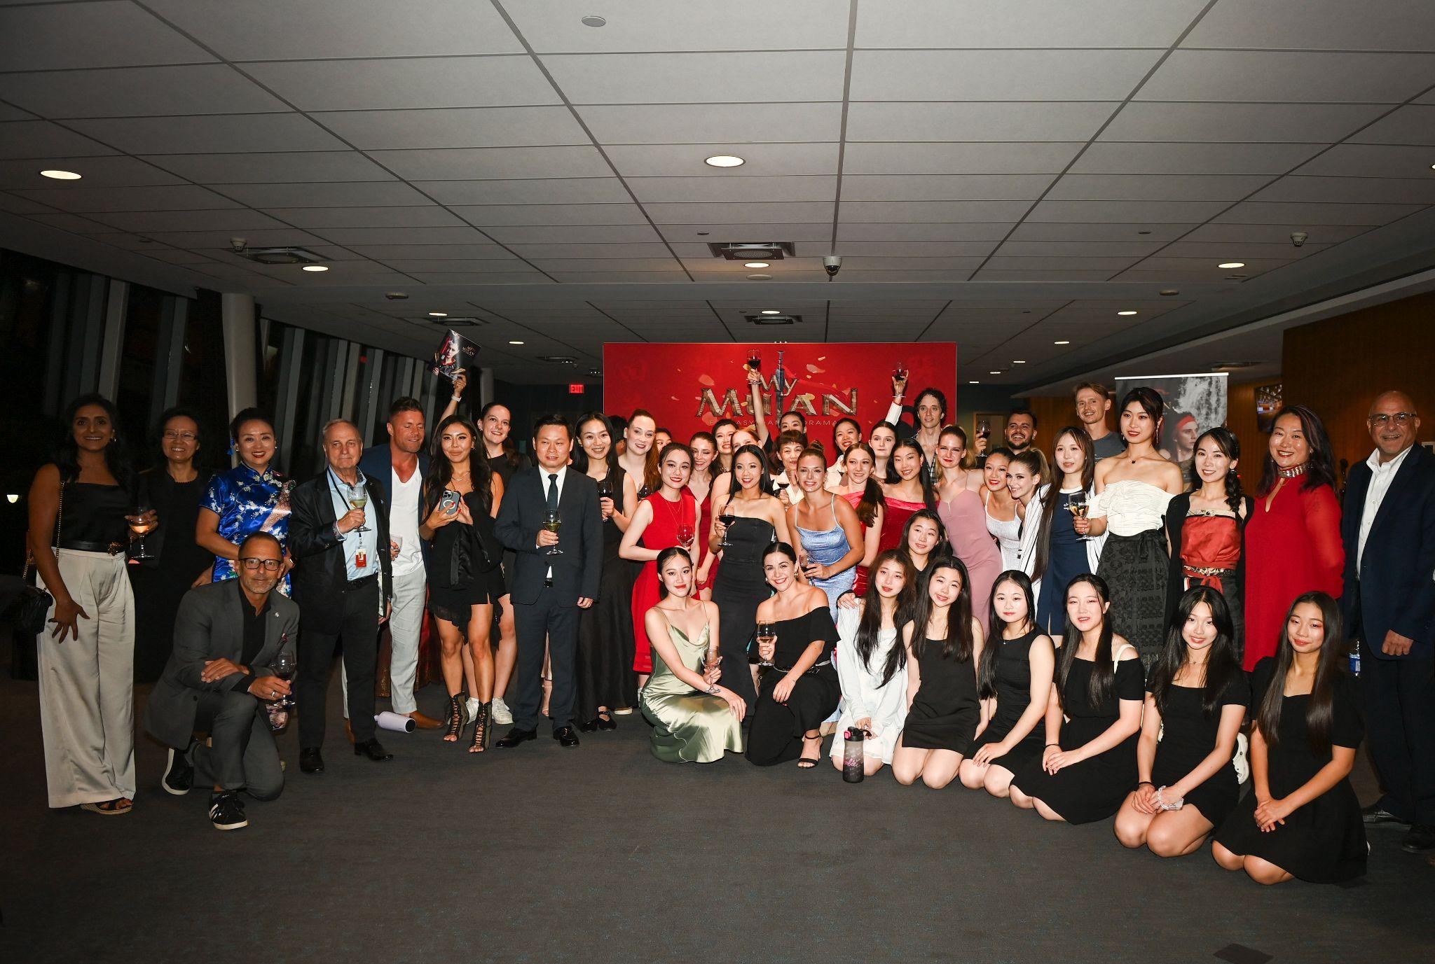

Mayor Jim Diodati praised the performance as a perfect fit for Niagara Falls, highlighting its "magnificent choreography, exquisite costumes, and professional displays of dance, martial arts, and gymnastics." He expressed hope that "My Mulan" could become a cultural landmark for the city.

Doug Birrell noted that the emotional depth and modern dialogue of "My Mulan" resonated with audiences, enhancing the cultural impact of the Niagara Falls region and attracting visitors. With his support, the production collaborated with major hotels in the area, and Ms. Anna DiCienzo, VP of Sales from Niagara Falls Hotels, provided valuable support to the show through her efforts in promoting tourism in Niagara Falls.

Following the performances, "My Mulan" received overwhelmingly positive feedback from audiences who travelled from New York, Buffalo, Ottawa, Montreal, and the Greater Toronto Area, some specifically for the show.
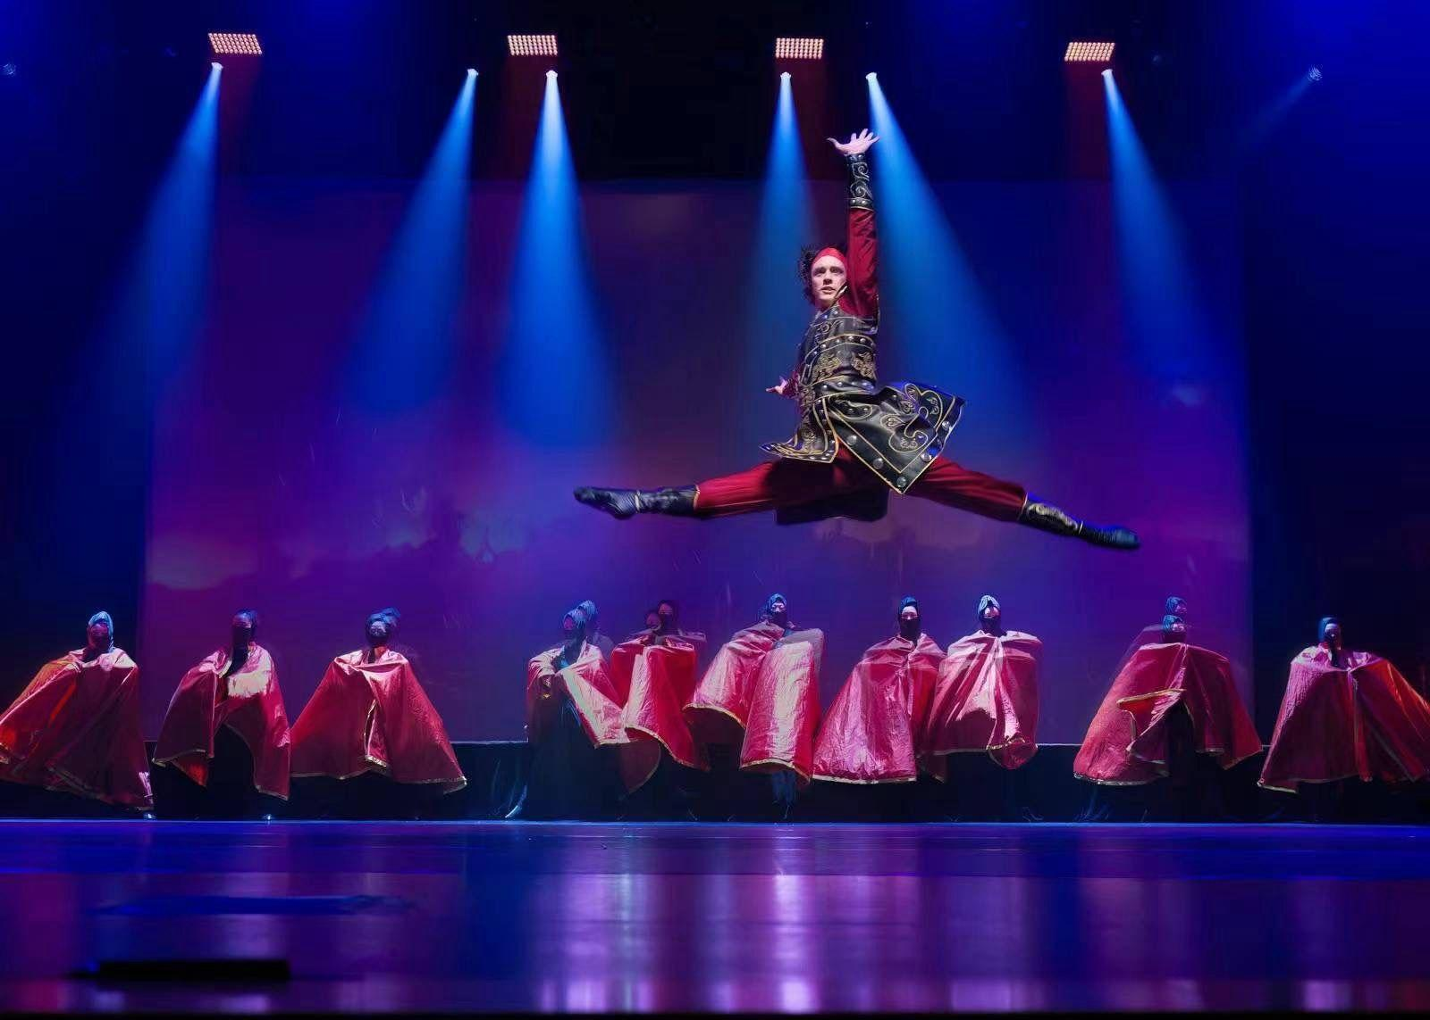
Continuously refined since its premiere in 2019, "My Mulan" aspires to become a classic cultural hallmark. This summer, the all-star cast features American dancer Xinyi Zhang, portraying the heroic Mulan, and renowned Canadian dance troupe leader Kealan McLaughlin as the loyal general. The production masterfully blends dance and martial arts, capturing the essence of Mulan’s spirit and motivational power.

The stage design features dynamic backdrops and multimedia elements, enhancing the overall experience. Additionally, the show includes special performances by Toronto's rap newcomer Forever Chen and Christina Li, along with a live choir in the lotus-picking scene, enriching the narrative in a three-dimensional way.
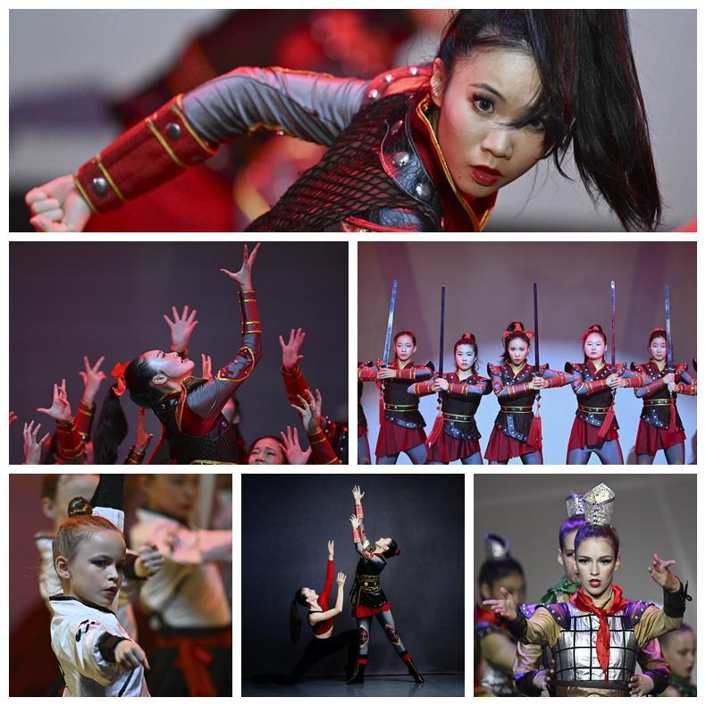
"My Mulan" not only captivated audiences with its superb performances but also continued its longstanding charitable mission, promoting the theme of "Walking with Love." In the past, they have supported SickKids Hospital, Scouts Canada, and the Yee Hong Foundation. This time, they announced that a portion of the proceeds from the performance would be donated to the Niagara Health Foundation to support the new South Niagara Hospital construction, benefiting the health and well-being of residents!
Many residents and tourists came to see the show and praised its excellence.

The choreography, exquisite costumes, original storyline, and diverse dance styles left a deep impression on them. They hope the production can have a permanent presence in the Falls and become a classic cultural landmark in the stunning Niagara Falls region! Furthermore, this show is poised to significantly enhance local tourism, enriching the cultural landscape of Niagara Falls and attracting a broader audience to the area.

For more information about My Mulan, please visit our website at https://mymulan.ca and follow us on Instagram @mymulan.ca.

For more information, contact:
Mr. Hu Xu – Producer
647.838.3268
mymulan.ca@gmaiil.com

