06 September 2023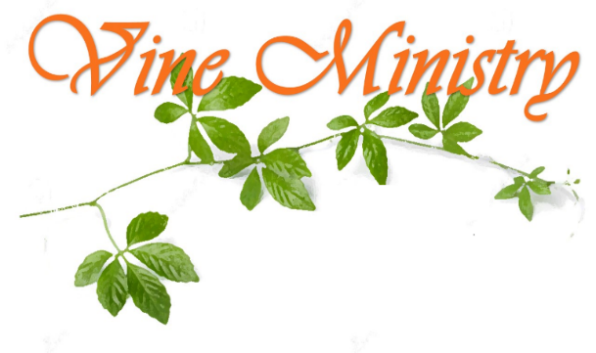

Davenport Community Food Pantry
1702 Main Street
Davenport, IA 52802

Brew MEX, LLC
Attn: Joe Kelly

Subject: Thank You

Dear Mr. Kelly,
Davenport Community Food Pantry was overjoyed to receive your donations of food and snack items. We have been distributing these items weekly on our pantry days. The Scott County Community families that we service have greatly appreciated the additional items your gifts have provided.
Again, Thank You for your donations – they have greatly benefited the families and have been a blessing to our community.

Sincerely,
Reverend Ralph Kelly, Director

