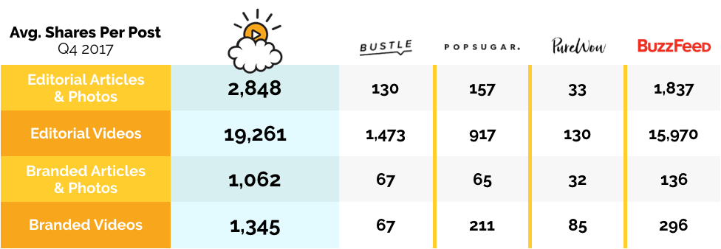
Source: Crowdtangle Q4 2017

