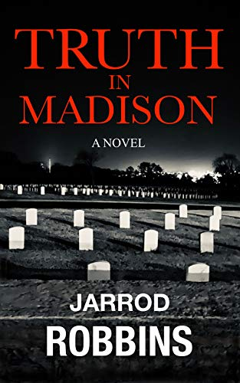
“Truth in Madison”
By Jarrod Robbins

*On Sale Now*
Price: 12.99 US Dollars
262 Pages
ISBN: 9798619652338
Category: MYSTERY / Suspense / Thriller
Comparable authors: Dennis Lehane, Elmore Leonard, Michael Connelly
A detective Noir told through a modern kaleidoscope of intricately painted characters, raw emotion and hauntingly vulnerable vignettes. TRUTH IN MADISON is as beautifully written as it is thrilling to read.
As one of the country's most respected podcast journalists, David Lambert didn't have time to drive 300 miles south to the town of Madison, Tennessee. He was neck-deep in post production on a massive case. Dropping everything to nosedive into an active investigation was simply not something David had time to do. Hell, it's not even something he was qualified to do. But, as of 2:47 this morning, all of that no longer mattered. Right as he was about to take a sip of coffee, an email chime from his laptop would signal a seismic shift in David’s world. A cryptic email from an anonymous source was about to pull him into a fight for his life in this deep fried suburb of Nashville.
Alone and far from home, David must navigate the treacherous waters between good and evil to hunt down a brutal killer in hopes of finding the one thing that matters to him most: the truth.
About the author: Jarrod Robbins (1980-present) was born in Springfield, Ohio, but raised in the nearby village of Enon. Jarrod studied English at Wittenberg University before withdrawing and moving to Los Angeles in 2006 to pursue a career in acting and screenwriting.

Availability:
Hardcover - Barnes & Noble (April)
Paperback Amazon (available now) and Barnes & Noble (April)
Truth in Madison- Amazon.com
E-book - Amazon (available now) Nook and Apple Book (April)
Truth in Madison- Amazon.com
Audiobook - Audible and iTunes (April)

Sample:
My brothers and I used to crawl around in the woods behind my Uncle Dwain's cabin in the rolling hills of Southern Ohio. His pursuit of a pensive and peaceful life, grounded in nature, lead him to the glorious hills outside of Chillicothe. We never brought anything with us to Uncle Dwain's but our rabid imaginations. Nothing else was required when a seemingly infinite world of ever-changing possibilities was at our welcome disposal.

As is the case with most young boys, our romps often took place in the violent world of war. The older brother was always the sergeant in command. The middle brother was a natural climber, so he was our overwatch sniper. I, being the smallest, was the scout. We defeated countless armies in those days. Sure, we died a thousand deaths, as well, but, back in those days, death was temporary and painless. Perhaps if JD had been struck down in the woods of Chillicothe he'd still be with us today.

But JD wasn't killed in the enchanted woods behind my uncle's cabin. He was killed in the pedestrian woods behind a Madison bar.

Audiobook Sample:
https://youtu.be/BpUdaoOF8SE
For more information or to schedule an interview please contact:
Kristen Bedno
kristen@sidehusslelife.com
310.801.8959

