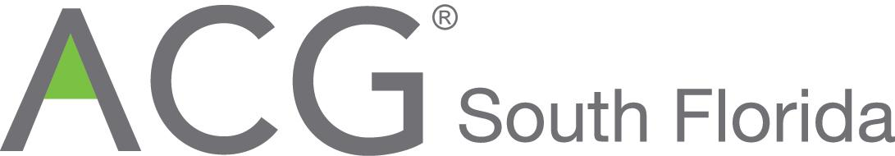

FOR IMMEDIATE RELEASE

Association for Corporate Growth South Florida’s President’s Private Equity Award: H.I.G. Capital’s Acquisition of BIC Graphic

South Florida, May 23, 2018. The South Florida Chapter of the Association for Corporate Growth (ACG-South Florida) announced today the winner of the inaugural “President’s Private Equity” award. H.I.G. Capital (“H.I.G.”) was selected for its superior track record of deal-making and portfolio company growth. H.I.G.’s recent acquisition of BIC Graphic North America is an illustration of both these areas of+ expertise.

About the BIC Graphic Acquisition:
In June 2017, an affiliate of H.I.G. Capital acquired BIC Graphic North America and the affiliated Asia sourcing operations (“BIC Graphic” or the “Company”) from Société BIC S.A. (“BIC”) (EPA:BB). BIC Graphic, headquartered in Clearwater, Florida and founded in 1969, has sales of over $300 million, and is one of the largest suppliers in the promotional products industry, specializing in customized writing instruments, hard goods and calendars. BIC Graphic’s quality, innovation, and service are highly regarded by tens of thousands of distributor customers. The Company operates three manufacturing facilities across the United States plus a highly strategic product sourcing operation in Hong Kong and mainland China.

The acquisition reflected a true partnership approach between H.I.G., Société BIC, and the Company. The groups worked together pre-close to complete the divestiture from BIC, and are pleased that the company is now a successful standalone entity.

Camilo E. Horvilleur, Managing Director at H.I.G. noted, “BIC Graphic is a clear leader in a consolidating market due to its compelling customer value proposition. To accelerate growth, we will further pursue innovative product development, and expand upon the Company's operational excellence and technology leadership. We see substantial opportunities to grow organically and through M&A. We have been thrilled with the Company’s performance since the acquisition, and are very pleased to have partnered with a new CEO, David Klatt, to lead the business through an accelerating growth plan.”

BIC Graphic is the third investment in the promotional products industry for H.I.G.

About H.I.G. Capital
H.I.G. is a leading global private equity and alternative assets investment firm with $25 billion of equity capital under management.* Based in Miami, and with offices in New York, Boston, Chicago, Dallas, Los Angeles, San Francisco, and Atlanta in the U.S., as well as international affiliate offices in London, Hamburg, Madrid, Milan, Paris, Bogotá, Mexico City and Rio de Janeiro, H.I.G. specializes in providing both debt and equity capital to small and mid-sized companies, utilizing a flexible and operationally focused / value-added approach:
- H.I.G.’s equity funds invest in management buyouts, recapitalizations and corporate carve-outs of both profitable as well as underperforming manufacturing and service businesses.
- H.I.G.’s debt funds invest in senior, unitranche and junior debt financing to companies across the size spectrum, both on a primary (direct origination) basis, as well as in the secondary markets. H.I.G. is also a leading CLO manager, through its WhiteHorse family of vehicles, and manages a publicly traded BDC, WhiteHorse Finance.
- H.I.G.’s real estate funds invest in value-added properties, which can benefit from improved asset management practices.
Since its founding in 1993, H.I.G. has invested in and managed more than 300 companies worldwide. The firm's current portfolio includes more than 100 companies with combined sales in excess of $30 billion. For more information, please refer to the H.I.G. website at www.higcapital.com.
* Based on total capital commitments managed by H.I.G. Capital and affiliates.
About the Award

The President’s Private Equity Award will be presented along with other category awards to South Florida’s leading businesses. The categories are Outstanding Growth Company of the Year (ABB Optical Group), Emerging Growth Companies of the Year (e-Builder, A Trimble Company, SMP Pharmacy Solutions), Transactions of the Year (Chewy Inc. and Modernizing Medicine) and this President’s Private Equity Awards (H.I.G. Capital). A cocktail reception, awards dinner and post event reception will be held at the Westin Fort Lauderdale, Florida, 400 Corporate Drive on June 21 beginning at 5:30pm. ACG South Florida offers a wide range of sponsorship and advertising opportunities to businesses in Miami-Dade, Broward and Palm Beach Counties, that wish to join us in honoring the best in South Florida business.

Information about the ACG-South Florida Awards Banquet, including purchases of sponsorships, advertising and tickets, can be obtained from President Ari Roloff (954-732-1291) aroloff@cbiz.com, Chapter Executive Elena Djakonova (954-947-6080; edjakonova@acg.org) and Awards Committee Chairman Thomas Hicks (954-415-639; renparlc@gate.net) and from the ACG-South Florida website http://www.acg.org/southflorida/. ACG member tickets are $150; for non-members $175.

Founded in 1954, the Association for Corporate Growth Inc. (“ACG”) is the premier global association for professionals involved in corporate growth, corporate development, and mergers and acquisitions. ACG has over 14,500 members from corporations, private equity, finance and professional service firms representing Fortune 500, Fortune 1000, FTSE 100 and middle-market companies through chapters in North America, Europe and Asia. These leaders are focused on building value. ACG serves 90,000 investors, executives, lenders and advisers to growing middle-market companies.
