Tricia Cusden Biography
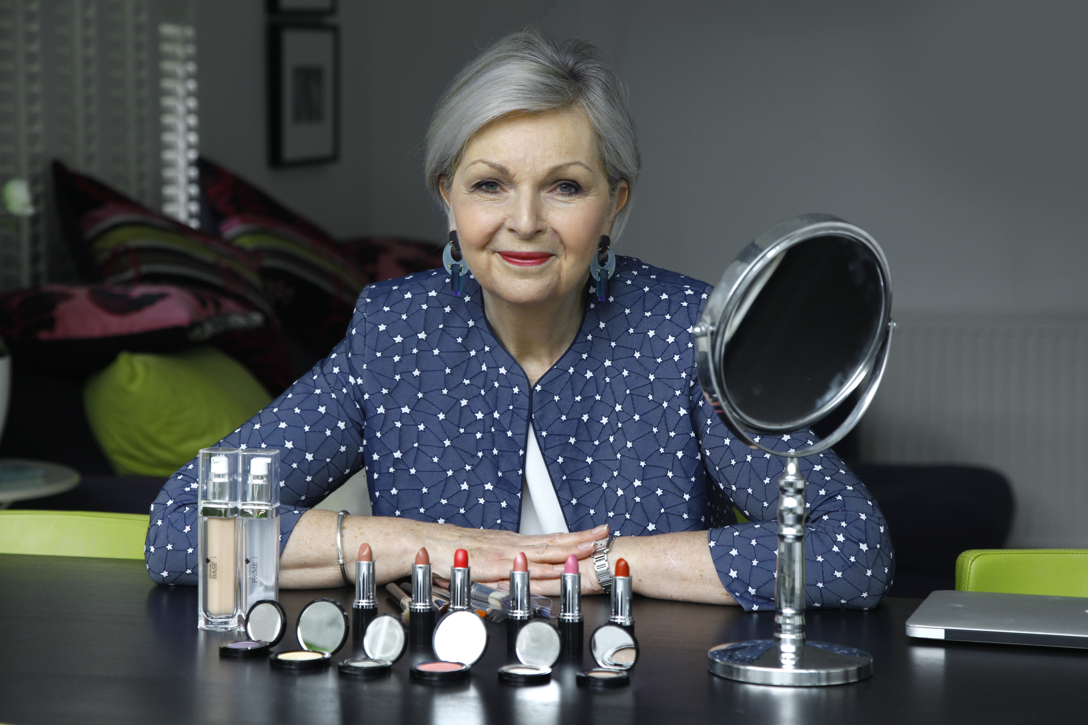
Tricia has long shown entrepreneurial flair, starting and running her own slimming club from 1974-1986 while caring for her young family. At the same time she gained a first class BA honors degree in 1986 at the age of 38. From 1986-1986 she worked as a management training consultant with The MaST Organization before setting up her own training consultancy in 1996.
Until the birth of her granddaughter India in 2012, Tricia worked with a variety of corporate clients including Accenture, Dixons Stores Group, Nomura and Esso Petroleum. Unfortunately India was born with a rare chromosomal disorder which necessitated long periods of time in hospital. Tricia therefore stopped all client work to help to support her family. Early in 2013 when India was much improved, Tricia decided that she needed a new challenge.At the age of 65, Tricia spotted a gap in the market for a new approach to cosmetics for older women.
She invested her own savings in a range of specific makeup suitable for more mature eyes, faces and lips. In October 2013, Look Fabulous Forever was launched to 80 friends and family at a party in London.At the time of the launch, two makeup tutorial videos which Tricia had made with two friends acting as models to demonstrate all the LFF products, were uploaded to YouTube. Slowly these videos gained in popularity and were the starting point for the fast growth of the business. There are now over 70 tutorials on YouTube with nearly 3m views between them.
In November 2015, she was awarded CEW’s Digital Achiever of the Year Award and in 2016 LFF was shortlisted for Amazon Digital Business of the Year part of the Lloyds National Business Awards. Tricia also recently won Nectar Small Business Awards Entrepreneur of the Year and Fabulous Ladies SME Emerging Businesswoman 2016 awarded by HSBC’s National Women in Business Awards.
Tricia has two daughters, Anna and Suzy, who both work in the business, and five grandchildren. She divides her time between London and France.

