NEWS

FOR IMMEDIATE RELEASE
June 2023
Las Vegas, Nevada
#7e

Local Executives Accept Award in International Design Competition

Mattia Forgiarini, Lead Process Engineer and Cody Cochran, General Manager, Azoth, Ann Arbor, Michigan, accepted a Grand Prize Award in the Industrial Motors/Controls & Hydraulics category for Metal Additive Manufacturing (AM) of the 2023 Powder Metallurgy Design Excellence Awards Competition. The award was given for an extremely complex fluid matter exchanger.

They accepted the award for their company at PowderMet2023: International Conference on Powder Metallurgy & Particulate Materials in Las Vegas, Nevada.

Metal AM is one of the powder metallurgy-based technologies that forms metal powders into precision components used in applications such as auto engines and transmissions, hardware, industrial machinery, medical, sporting goods, defense, and firearms.

The competition is sponsored annually by the Metal Powder Industries Federation, an international trade association for the metal powder producing and consuming industries.
# # #

Editor's Note: For further information contact Dora Schember at dschember@mpif.org or (609) 452-7700.

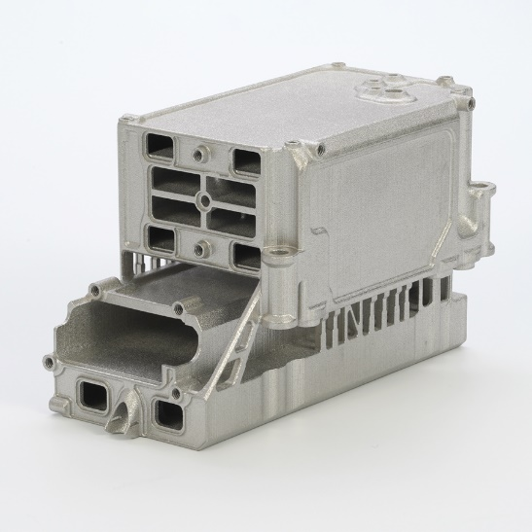

Fluid Matter Exchanger

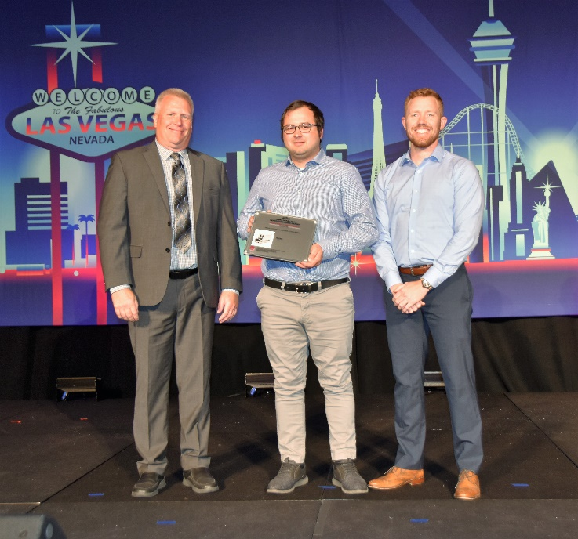

Left to right: MPIF President Rodney Brennen presents award Mattia Forgiarini and Cody Cochran

For more information or digital images contact Dora Schember (dschember@mpif.org)
Metal Powder Industries Federation
105 College Road East, Princeton, NJ 08540-6692
609-452-7700 mpif.org
About the Metal Powder Industries Federation
Metal Powder Industries Federation is the North American trade association formed by the powder metallurgy industry to advance the interests of the metal powder producing and consuming industries and provides a single point of reference for all MPIF member companies.

