Tonix’s TNX 102-SL Could Offer New Hope of Pain Relief Without Narcotics for Fibromyalgia Sufferers
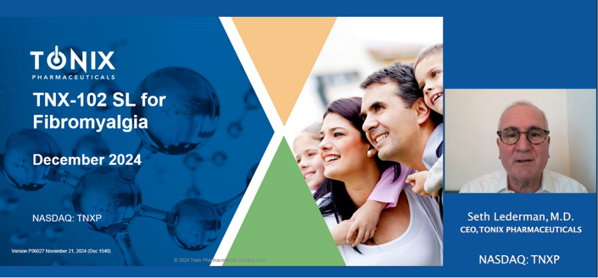
Click here for a 6-minute video of Seth Lederman, MD, reviewing the status of TNX 102-SL for fibromyalgia

This post was written and published as a collaboration between the in-house editorial team at Benzinga and Tonix Pharmaceuticals Holding Corp. with financial support from Tonix. The two organizations work to ensure that any and all information contained within is true and accurate as of the date hereof to the best of their knowledge and research. This content is for informational purposes only and not intended to be investing advice.

CHATHAM, NJ / ACCESSWIRE / Dec. 9. 2024 - Fibromyalgia, the chronic pain condition that plagues approximately ten million Americans is in need of new drug treatment options. The existing approved drugs on the market often aren’t enough. Unfortunately, many patients, at the direction of their doctors, end up taking opioids as a last resort to manage fibromyalgia.

Opioids come with their own set of problems. Opioids can be addictive and, over time, life-threatening. Of patients prescribed opioids for chronic pain, 21% to 29% misuse them, while about 8% to 12% develop opioid use disorder.

Tonix Pharmaceuticals Holding Corp. (NASDAQ: TNXP) is on a mission to bring a better drug for fibromyalgia to the market, which is estimated to grow to a value of $4.13 billion globally in 2032 from $2.8 billion in 2024. The biopharmaceutical company submitted a new drug application (NDA) to the U.S. Food and Drug Administration (FDA) in October for TNX-102 SL (cyclobenzaprine HCl sublingual tablets), Tonix’s drug candidate for the management of fibromyalgia.

Tonix expects to hear a decision on NDA acceptance by the FDA in mid-December. If the NDA is accepted, Tonix said the FDA could commit to a decision on approval in 2025, which means TNX-102 SL could be on the market as early as next year, giving fibromyalgia sufferers a much-needed new non-opioid option. As it stands, Tonix believes 85% of fibromyalgia patients fail their first-line therapy, and 79% are on multiple therapies.

Fast Track Status
The FDA previously granted TNX-102 SL Fast Track designation which expedites the review of important new drugs intended to treat “serious conditions” and address unmet medical needs. Fast Track designation has the goal of bringing new treatments to patients sooner. In granting Fast Track, FDA recognized fibromyalgia as a “serious condition”, which shows the recognition that fibromyalgia has achieved recently after being denigrated for so many years by poorly-informed health care providers. Some of these providers distrusted fibromyalgia patients to the extent they believed fibromyalgia “didn’t exist”. Fortunately, clinical science has progressed and today fibromyalgia is recognized as the prototype for a newly designated type of pain, called “nociplastic pain”.

“The Fast Track designation underscores the importance of addressing the unmet needs of fibromyalgia patients,” said Seth Lederman, M.D., Chief Executive Officer of Tonix Pharmaceuticals. Dr. Lederman continued, “Most fibromyalgia patients report dissatisfaction with current drug treatment options. If approved by the FDA, we expect TNX-102 SL to become the first new drug for fibromyalgia in over 15 years.”

Targeting Disturbed Sleep to Relieve Pain
Tonix reports that TNX-102 SL is a sublingual formulation of cyclobenzaprine hydrochloride that dissolves under the tongue and is designed to target the sleep problems that typify fibromyalgia. Poor quality sleep can have a big impact on chronic pain. Lack of quality sleep can also hyperexcite the central nervous system (CNS), which can lower pain tolerance.

With TNX-102 SL treatment, patients in Tonix’s studies experienced less pain, the company says. In the most recent phase 3 trial, called RESILIENT, TNX-102 SL showed a statistically significant improvement in fibromyalgia pain with a p-value of 0.00005. Tonix reports that in the RESILIENT study, significant results were also seen in improving sleep quality, reducing fatigue and improving overall fibromyalgia symptoms and function. TNX-102 SL was generally well tolerated and the most common adverse events were transient sensations in the mouth corresponding with the disintegration of the tablets under the tongue.

Fibromyalgia is the Poster Child of Nociplastic Pain
If the FDA approves TNX-102 SL for fibromyalgia, it could pave the way for the drug to become a first line therapy for fibromyalgia. Fibromyalgia is now recognized as the prototypic nociplastic pain disorder. Nociplastic pain, also known as central sensitization is a type of pain that occurs when the brain processes sensory signals in an altered way, which amplifies how they are perceived. This amplification of sensory information is believed to result in the pain that fibromyalgia patients experience.

Fibromyalgia sufferers around the world are in need of relief. Tonix is hoping that a new treatment option may soon be available. Tonix Pharmaceuticals awaits the FDA decision on NDA acceptance from the FDA for TNX-102 SL. If FDA accepts the NDA in mid-December, that would put the drug on track for an FDA decision on approval in mid-August 2025 for standard review. With millions suffering from the chronic pain of fibromyalgia, this could lead to potential growth for Tonix.

Click here for more information on Tonix Pharmaceuticals:

Featured photo by Tonix Pharmaceuticals

This post contains sponsored content. This content is for informational purposes only and not intended to be investing advice.

