BLUETTI To Have Power Week From August 18-August 28
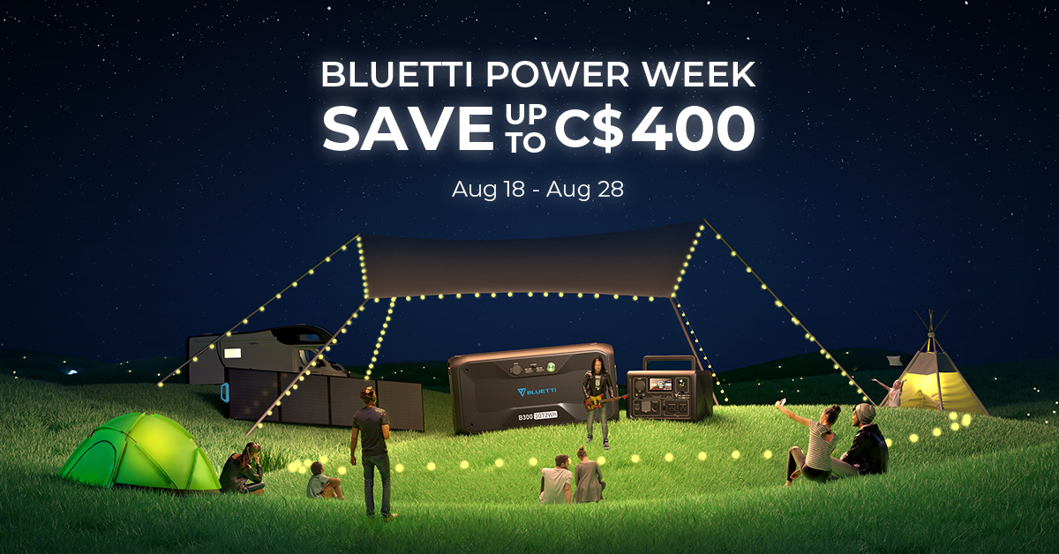

A power cut on blistering summer days is catastrophic that can drive people nuts. To ease the rising electricity tension during this summer, BLUETTI will have a Power Week from August 18 to August 28. Scroll down to learn more.

Not just a sidekick, but a hero on its own.
Not only as an expansion battery, B230 and B300 can be used as an independent power source since multiple outputs are built for versatile charging, including 1*18W USB-A QC3.0, 1*100W PD3.0 Type-C, and 1*12V/10A Cigarette Lighter.
The MPPT within B300 allows a 200W Max. solar input. While with the T500 adapter, the B230 and B300 can reach up to 500W AC input rate without connecting with AC200MAX and AC300 power stations.

The magic charging box - BLUETTI D050S (DC Charging Enhancer).
B230 and B300 can be leveraged to their full potential when teamed up with the D050S. It enables more recharging methods, like 12/24V car charging, Lead-acid battery, and even AC. It can boost a 1400W Max. solar input for AC200MAX.
Without the idle draw of the inverter, the discharge efficiency of a Pure DC Solar Generator can be over 95%. Only one battery pack is sufficient to cover all power needs during an excursion.

High Compatibility - Not just for the AC200MAX or AC300.
Besides AC200MAX and AC300, B230 and B300 are also compatible with other units like AC200, AC200P, EB150, and EB240 while connecting with D050S, increasing the overall capacity to survive blackouts and other emergencies.

LiFePO4 - Safe and durable.
Safety and durability are things to consider before purchasing a power station, so BLUETTI adopts LiFePO4 technology while producing solar generators in recent years.
B230 and B300 provides better electrochemical performance, lower resistance, and more stable cathode materials compared to NCM chemistry in the market.

Recommendations During BLUETTI Power Week 2022
2*B230: 4096Wh LiFePO4
B230+PV350: 2048Wh LiFePO4, 350W Solar Power
2*B300: 6144Wh LiFePO4
B300+PV350: 3072Wh LiFePO4, 350W Solar Power

Note: Any of the above purchase can get a FREE D050S (Qty limited, first come first served).

About BLUETTI
Over the last decade, BLUETTI has tried to stay true to a sustainable future through green energy storage solutions while delivering an exceptional eco-friendly experience for everyone and the world. BLUETTI is making its presence in 70+ countries and is trusted by millions of customers across the globe. For more information, please visit BLUETTI online at https://www.bluettipower.ca/ .

