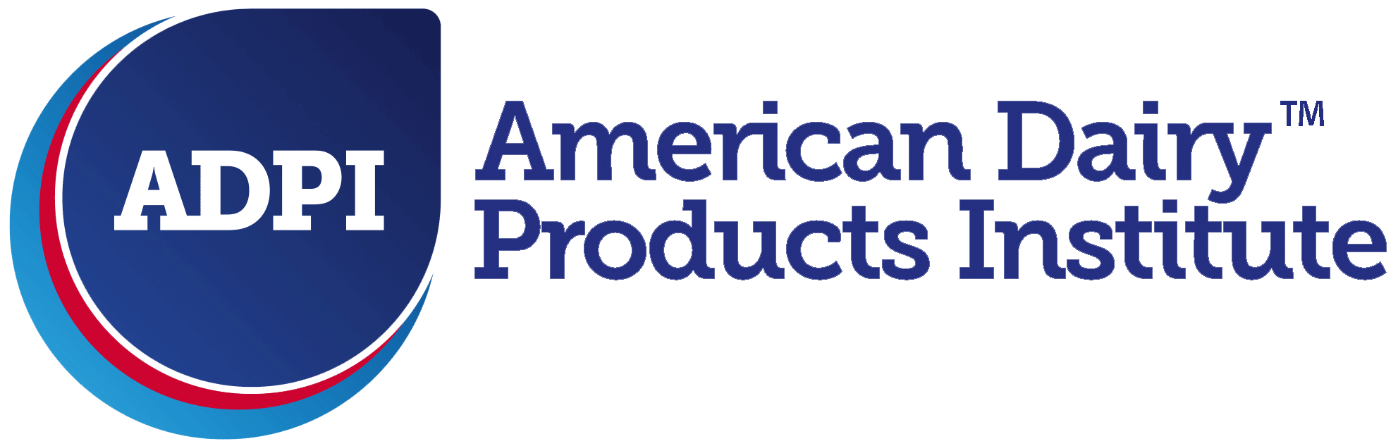


For Immediate Release
September XX, 2019

Lactalis brand Pronativ® Joins Industrywide Communication Initiative to Educate Consumers on Protein Ingredients

Buffalo, NY -- September XX, 2019 -- Lactalis Ingredients, a division of Lactalis Retail Dairy, Inc. has partnered with the American Dairy Products Institute (ADPI) and the industry-led Dairy Product Messaging Initiative (DPMI) to educate consumers about the benefits of proteins from milk. “The Strong Inside” campaign is designed to communicate the positive attributes of proteins from milk, with a focus on protein ingredients. This proactive and impactful platform will serve as an informational tool to guide targeted consumers (“Protein Seekers,” millennials, and women) with regards to their protein choices.
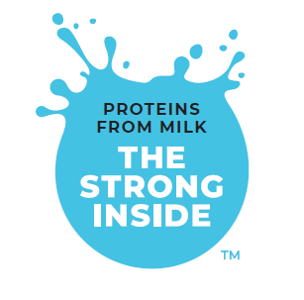
The Strong Inside message is the foundation of the Dairy Protein Messaging Initiative. Backed by science, but designed to appeal to consumers’ emotions, it emphasizes the unique value of proteins from milk in an engaging and positive way. According to the International Food Information Council, 68% of American consumers want to eat more proteins, but many are turning to alternatives.

With its Pronativ® products, Lactalis Ingredients has come up with the ideal solution to meet the demands of consumers seeking pure protein powder. Most alternative protein sources are heavily processed, often using additives, but Pronativ brand protein has only one single ingredient: farm-fresh milk that is cold filtered. Using a cold filtration, experts have been able to get straight to the whey protein naturally present in milk, preserving its nutritional value and making it more bioavailable. Pronativ brand protein is not a byproduct of any other food products, it skips heavy processing steps and heat treatments, has no added ingredients, and gently removes the carbs, lactose and fat naturally present in milk – it is protein in its purest form.

“As a leader in the dairy industry, our role is to educate consumers about the benefits of products and ingredients made with milk. The nutrients present in milk naturally match some of the body needs and those cannot be replaced by alternatives. This industrywide initiative is key to helping consumers make the best choice to support their healthy lifestyle,” says Yann Connan, Lactalis American Group Vice President of Ingredients.

With more than 15 years of research to back it, the unique benefits and quality of Pronativ brand protein are undeniably clear. Packed with essential nutrients and bioavailable leucine, Pronativ brand products are protein in its purest form. The powder gives consumers a natural, nutrient-dense protein that helps activate muscle protein synthesis.

For more information regarding the Dairy Product Messaging Initiative (DPMI) and The Strong Side Campaign, please visit www.thestronginside.com.
###

ABOUT LACTALIS RETAIL DAIRY, INC.
Lactalis Retail Dairy, Inc. is a subsidiary of Lactalis Group, a third-generation, family-owned business founded in France the in the 1930s. Lactalis came to the United States in the 1980s and opened the first U.S. manufacturing facility devoted exclusively to French brie. Today, the company is the world leader in dairy, with over 250 facilities around the world, and is committed to bringing consumers a broad range of products in all dairy categories.

ABOUT THE AMERICAN DAIRY PRODUCT INSTITUTE (ADPI)
ADPI, The American Dairy Products Institute is the leading national trade association representing manufacturers and marketers of dairy-based ingredients. ADPI's sole mission is to increase the worldwide use of dairy ingredients by marshaling the technical, manufacturing, and marketing resources of its members and others. For more information, visit our website at www.adpi.org

ABOUT THE DAIRY PROTEIN MESSAGING INITIATIVE (DPMI)
DMPI, The Dairy Protein Messaging Initiative is a creative, positive, industry-led and funded effort to defend the sector, by increasing consumer knowledge of dairy proteins and benefits vs. alternative proteins, and reposition dairy proteins in a positive, fresh and new perspective. It is focused on millennials, women, flexitarians and protein consumers.

MEDIA CONTACT | Curtis Rogers | curt@kcpublicrelations.com| 716.860.2331

