NEWS RELEASE
WESTERN ALASKA MINERALS INTERSECTS FIRST GOLD INTERCEPT
AT WARM SPRINGS
4.68 meters of 1.29 g/t Au including 0.18 meters of 12.5 g/t Au

TUCSON, ARIZONA, US – August 29, 2024 - Western Alaska Minerals (the "Company" or "WAM") (TSXV: “WAM”) is pleased to announce initial gold assay results from their first ever drilling at the Warm Springs target on the Illinois Creek project in western Alaska.
Highlights:
- Two gold zones intercepted in drill hole IC24-0004:
  - 1.29 g/t Au over 4.68 meters within massive pyrite, including:
    - 12.5 g/t Au and 0.9% Cu over 0.18 meters
  - 2.13 g/t Au over 2.96 meters, including:
    - 5.57 g/t Au over 1.01 meters
- Discovery of a new and separate mineralized structure parallel to the Illinois Creek Fault, opening the potential of a new “spoke” to the system.
- First significant copper and gold mineralization intercepted since WAM initiated exploration in 2021.
- The gold bearing zone is located approximately 1.4 km southeast of the Illinois Creek gold-silver resource (Figure 1).
“Finding gold at Warm Springs opens up a whole new gold target zone within the eight-kilometer-long trend between the Illinois Creek and Waterpump Creek resources,” said Kit Marrs, founder and CEO of Western Alaska Minerals.
Mr. Marrs continues, “This is an exciting complement to our high-grade silver-zinc-lead resource at Waterpump Creek.”
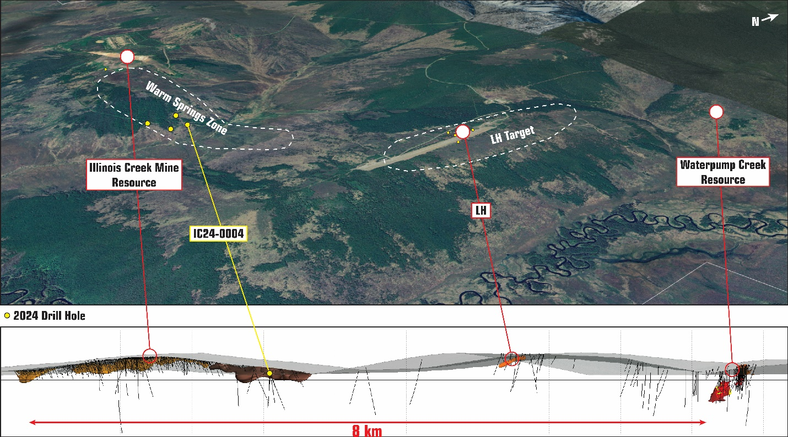
Figure 1. Top: Google Earth view looking down and to the northwest of the Illinois Creek CRD system, encompassing Illinois Creek resource - Warm Springs - LH - Waterpump Creek resource. Bottom: LeapFrog 3D model of the mineralized areas.
Warm Springs Target
Dr. Peter Megaw, Technical Advisor and world-renowned silver and CRD geologist stated, “The appearance of gold and copper in the multiply brecciated alteration and mineralization zones cut in these latest holes at Warm Springs clearly indicates we’re zeroing in on a repeatedly reactivated structure that acted as a major pathway for proximal/near-source mineralizing fluids. The CRD continuum model suggests the next steps are to link this to the distal silver-lead-zinc resource at Waterpump Creek and the more proximal gold-copper resource adjoining the historical Illinois Creek mine. The possibility that this is a separate structure parallel to the Illinois Creek Fault is especially intriguing as it may indicate a whole new “spoke” to the system.”
Western Alaska Minerals has completed nine drill holes at Warm Springs. Extensive alteration and oxide mineralization along with local base-metal sulfide mineralization has been intercepted in seven of the nine drill holes.

Table 1. Table of highlight intercepts from drill hole IC24-0004
Hole | From (m) | To  (m) | Length (m) | Au  (g/t) | Ag  (g/t) | Pb  % | Zn  % | Cu  % | Sulfide/Oxide
IC24-0004 | 84.17 | 88.85 | 4.68 | 1.291 | 11.6 | 0.26 | 0.05 | 0.038 | Sulfide
Including | 84.17 | 84.35 | 0.18 | 12.50 | 167 | 2.44 | 0.03 | 0.914
IC24-0004 | 244.40 | 247.36 | 2.96 | 2.13 | 7.0 | 0.35 | 0.30 | .025 | Oxide
Including | 246.35 | 247.36 | 1.01 | 5.57 | 12.8 | 0.38 | 0.26 | .054
All intercepts are core length and are close to true width. Core recovery averaged 90.1% for reported intercepts.
Table 2. Coordinate locations and angles for drill holes IC24-0004
Hole | Easting | Northing | Plunge | Azimuth | TD (m)
IC24-0004 | 555150 | 7101350 | -60 | 000 | 451.41

Significance of Warm Springs Drill Results – Technical Discussion
The Warm Springs mineralization is a major extension to the Illinois Creek CRD system and shows significant complexly overprinted mineralization stages. Exploration this year followed up on the Warm Springs siliceous breccia outcrop and two Anaconda drill holes from 1982*. The target was thought to be either an extension of the East IC Manto down-dip to the south or possibly a new mineralizing structure parallel to that of the Illinois Creek Mine mineralization. The drill results show numerous stages of mineralization including early-stage recrystallized ankerite with trace base-metal sulfides and cross-cutting late-stage silica and oxide mineralization. The first hole, IC24-0004, was a 310m step-off south of Anaconda drill holes 11 and 12*, and 1.2 km west of the WAM 2022 drill holes.
IC24-0004 intercepted four mineralization zones consisting of numerous mineralization stages (Figure 4) including 1) pyrite + hydrothermal quartz breccia with elevated Au, As and Cu values as shown in Table 1, 2) recrystallized ankerite with trace galena 3) pervasive silica + oxide breccia including limonite-dominant and hematite-dominant sub-zones and 4) oxidized elevated Pb + Mn (assay results not shown) manto gossans. These elevated metal zones ranged from 18.7 to 53.65 meters thick with a combined total mineralization thickness of 100 meters.
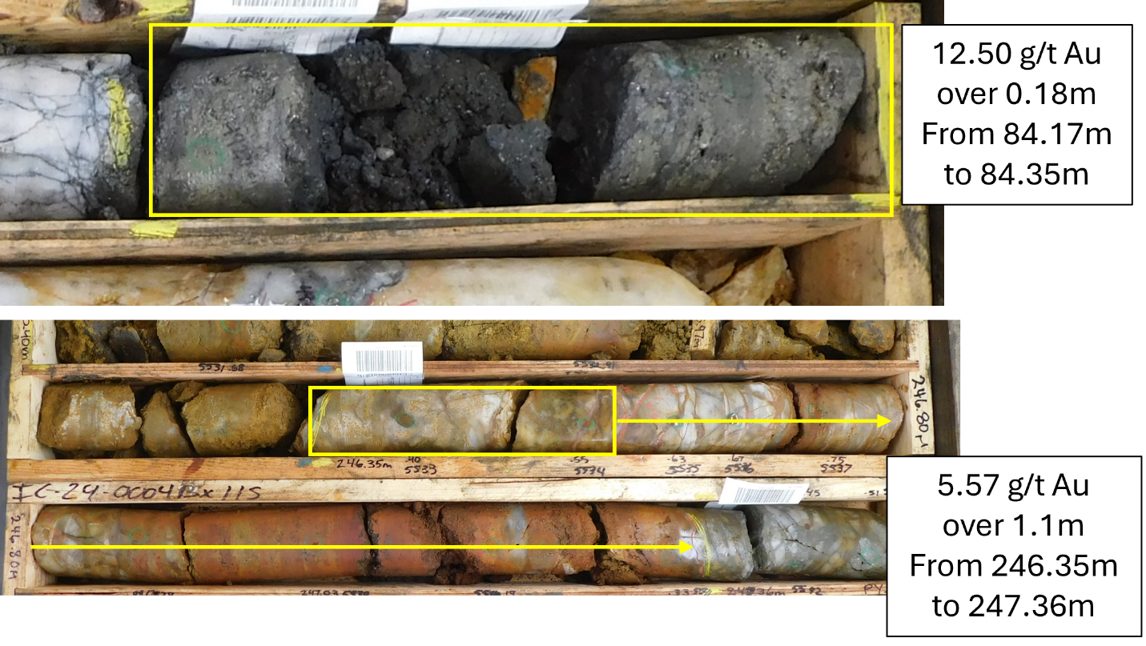Figure 3. Massive pyrite with breccia texture for the intercept reported in Table 1.
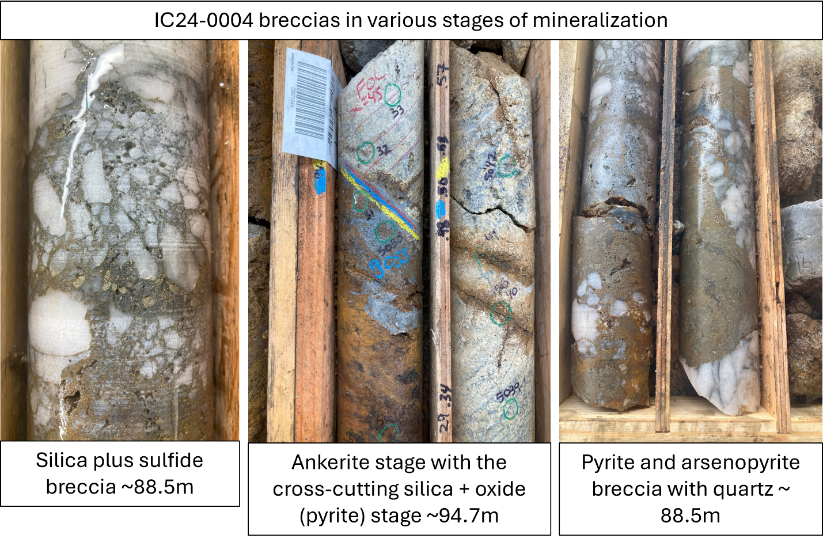
Figure 4. Breccias in various stages of mineralization

LH Target Zone Update
The 2024 drill program also included drill testing of the LH target zone, located on the west side of the airstrip. The LH Target has generated significant interest as a potential high-grade extension of the Waterpump Creek zone. It was first drilled by NovaGold in 2005/2006*. WAM drilled four holes in 2024 which cut a few gossans, but no significant sulfide manto mineralization. In addition, four surface trenches were cut to better understand the LH target. Assays for the drilling and trenching are pending. The drill holes this year plus the trenching have refined our exploration model and target for the LH zone. It is now interpreted to be a vertically oriented feature and likely higher in the CRD system than Waterpump Creek and mineralization is thought to be deeper than originally anticipated.
The LH target remains a priority target.
Drilling Statistics
- Drill program was completed on August 24th, totalling 4,230 meters
- LH Zone: four drill holes totalling 1,347 meters
- Warm Springs Zone: nine drill holes totalling 2,883 meters
- Assay results pending for all holes except IC24-0004
Quality Assurance and Quality Control
Quality Assurance/Quality Control of drill sample assay results are monitored by WAM staff through a quality assurance/quality control (“QA/QC”) protocol which includes the insertion of blind standard reference materials, blanks, and duplicates samples at regular intervals.
Core logging and sampling is completed at the Illinois Creek mine camp in Alaska. Drill core is logged under an established procedure using GeoSpark commercial logging software. Core intervals selected for assay are sawn lengthwise in half. One half of the core interval is bagged and labeled for assay. The remainder is stored on site for reference.
The bagged core samples are transported to the ALS Minerals laboratory in Fairbanks, Alaska, USA, for sample submission. ALS Minerals Fairbanks is a satellite sample preparation facility accredited under ALS Minerals. The ALS Minerals Fairbanks laboratory then shipped the samples to ALS Minerals in North Vancouver, B.C., Canada, for sample preparation and analysis. ALS Minerals North Vancouver is an independent laboratory certified under ISO 9001:2008 and accredited under ISO/IEC 7025:2005 by the Standards Council of Canada. ALS Minerals includes its own internal quality control samples comprising certified reference materials, blanks, and pulp duplicates.
At ALS the half-core samples were weighed (WEI-21), dried if excessively wet (DRY-21), coarse jaw crushed to 70% passing 6 mm (CRU-21), fine jaw crushed to 70% passing 2 mm (CRU-31), riffle split to 250 g subsamples (SPL-21) and pulverized to 85% passing 75 μm (PUL-31). Crushed duplicates were created by riffle splitting crushed samples into two parts.
The gold content is determined by fire assay of a 30-gram charge with an AA finish (Au-AA23). Silver, lead, copper, and zinc along with other elements are analyzed by ICP utilizing a four-acid digestion (ME-ICP61). Over-limit samples for silver, lead, copper, and zinc are determined by using either an ore grade four-acid digestion and ICP-ES finish (ME-OG62) or ore-grade titration analysis (VOL50 or VOL70) for very high-grade samples. Au from the high-grade interval from 84.17 to 84.35 was analyzed a 30 gram fire assay charge and gravimetric finish.
ALS Minerals’ laboratory also performs its own internal QA/QC procedures to assure the accuracy and integrity of results. Parameters for ALS’ internal and WAM’ external blind quality control samples are acceptable for the elements analyzed. WAM is unaware of any drilling, sampling, recovery, or other factors that could materially affect the accuracy or reliability of the data referred to herein.
Qualified Person
The Qualified Person who reviewed and approved the technical disclosure in this release is Andrew West, Certified Professional Geologist, a Qualified Person as defined under National Instrument 43-101. Mr. West is the Vice President for Western Alaska Minerals with a MS in Geology and 30 years of experience in mineral resources, mine, and exploration. He is a Certified Professional Geologist with the American Institute of Professional Geologists (AIPG CP-11759).
His review verified the technical data disclosed, including geology, sampling, analytical and QA/QC data underlying this news release, including reviewing the reports of ALS, methodologies, results, and all procedures undertaken for quality assurance and quality control in a manner consistent with industry practice.
About WAM
Our mission is to advance a mineable and scalable CRD, ultimately reshaping the mineral landscape of western Alaska and establishing a new CRD district.
WAM’s CRD system encompasses a 373K oz AuEq NI 43-101-compliant indicated and 152K oz AuEq Inferred resource* at the past producing Illinois Creek gold-silver mine*, and the Waterpump Creek high-grade silver-lead-zinc deposit with an inferred resource estimate of 74.9Moz at 980 G/T AgEq*, open to the north. Within the same CRD system sits the Honker gold vein prospect. Twenty-five kilometers northeast of the Illinois Creek CRD lies the Round Top copper and the TG North CRD prospects. All prospects were originally discovered by Anaconda Minerals Co. in the early 1980’s*. WAM’s 100% owned claims and uplands mining lease cover 73,120 acres (114.25 square miles or 29,591 hectares), approximately 45 km east of an ocean barge-compatible section of the Yukon River. Since 2010, WAM, along with its precursor company, Western Alaska Copper & Gold, reassembled the Anaconda land package and has been engaged in exploring the district.
Headquartered in both Alaska and Arizona, WAM brings together a team of seasoned professionals with a shared vision of pioneering new frontiers in mineral exploration. Our strategic approach is underpinned by cutting-edge technology, innovative techniques, and a deep understanding of the geological intricacies of the region.
*Information on our historical gold and Waterpump Creek resources, as well as historical work performed by Anaconda Minerals Co. and NovaGold (2005/2006) can be found on our NI 43-101 report, dated April 2, 2024, authored by Bruce Davis, PhD, FAusIMM, titled “Western Alaska Minerals Corp. ILLINOIS CREEK PROJECT UPDATE Illinois Creek Mining District, Western Alaska, USA” on our website: https://www.westernalaskaminerals.com/_resources/pdfs/Illinois-Creek-NI43101-Technical-Report.pdf?v=0.317
On behalf of the Company
“Kit Marrs”
Kit Marrs
President & CEO
Phone: 520-200-1667
For further information please contact:
Vanessa Bogaert, Director of Corporate Communications/IR at vanessa@westernalaskaminerals.com
Or visit our website at: www.westernalaskaminerals.com
Forward Looking Information
This news release contains “forward-looking information” within the meaning of applicable Canadian securities legislation. “Forward-looking information” includes, but is not limited to, statements with respect to the activities, events or developments that the Company expects or anticipates will or may occur in the future. Generally, but not always, forward-looking information and statements can be identified by the use of words such as “plans”, “expects”, “is expected”, “budget”, “scheduled”, “estimates”, “forecasts”, “intends”, “anticipates”, or “believes” or the negative connotation thereof or variations of such words and phrases or state that certain actions, events or results “may”, “could”, “would”, “might” or “will be taken”, “occur” or “be achieved” or the negative connation thereof.
Such forward-looking information and statements are based on numerous assumptions, including among others, Although the assumptions made by the Company in providing forward-looking information or making forward-looking statements are considered reasonable by management at the time, there can be no assurance that such assumptions will prove to be accurate and actual results and future events could differ materially from those anticipated in such statements.
Important factors that could cause actual results to differ materially from the Company’s plans or expectations include risks relating to market conditions, metal prices, and risks relating to general economic, market or business conditions, uninsured risks, regulatory changes, defects in title, availability of personnel, materials, and equipment on a timely basis, accidents or equipment breakdowns, unanticipated environmental impacts on operations and costs to remedy same, and other exploration or other risks detailed herein and from time to time in the filings made by the Company with securities regulators. Although the Company has attempted to identify important factors that could cause actual results to differ materially from those contained in the forward-looking information or implied by forward-looking information, there may be other factors that cause results not to be as anticipated, estimated or intended. There can be no assurance that forward-looking information and statements will prove to be accurate, as actual results and future events could differ materially from those anticipated, estimated or intended. Accordingly, readers should not place undue reliance on forward-looking statements or information.
Neither TSX Venture Exchange nor its Regulation Services Provider (as that term is defined in the policies of the TSX Venture Exchange) accepts responsibility for the adequacy or accuracy of this release.

