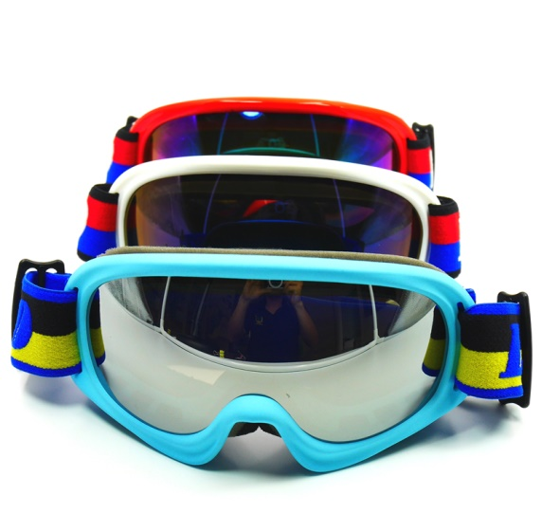
WeeTect Photochromic Goggles (WPG) also names photochromatic goggles, cycling photochromic goggles or transition goggles. It is made from photochromic film and polycarbonate goggle lenses co-injection molding or photochromic coating on polycarbonate goggle lenses. WeeTect Photochromic Goggles (WPG) can be applied to photochromic ski goggles, photochromic snowboard goggles, photochromic motorcycle goggles, photochromic anti-fog goggles, photochromic mountaineering goggles, photochromic transition goggles, photochromic polarized goggles and more.

As WeeTect is a capable photochromic lens manufacturer, WeeTect Photochromic Goggles (WPG) is one of the best photochromic goggles with a super high VLT when it is photochromic clear in house, and turns to photochromic tint on exposure to UV light quickly. In advance, WeeTect Photochromic Goggles (WPG) can be added more surface treatment such as anti-fog coating, anti-scratch coating, iridium coating and more. As an eye and face protection solution provider, WeeTect holds the know-how of photochromic coating and co-mold photochromic technology. We are glad to develop other special combination such as photochromic polarized ski goggles to support your niche market.
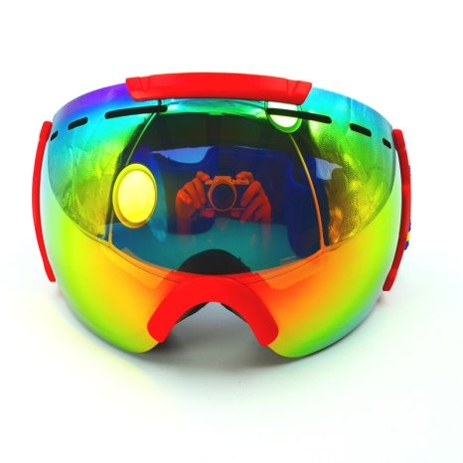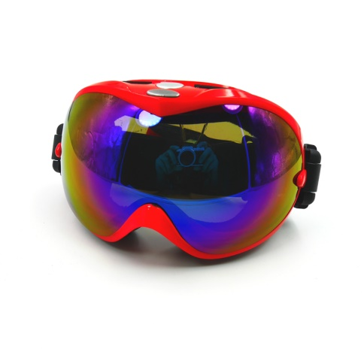
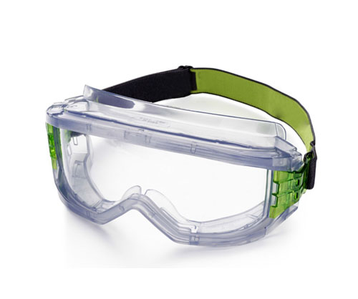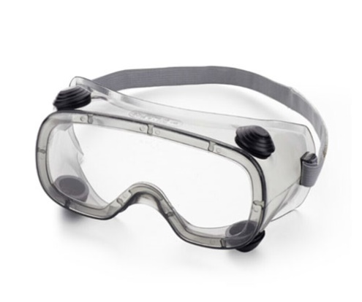

Photochromic Goggles Review of Advantages:
- Safety: Your customer can be safe with one pair of photochromic goggles for the varying light conditions.
- UV protection: WeeTect Photochromic Goggles (WPG) filters 100% harmful UV radiation.
- One stop solution: WeeTect Photochromic Goggles (WPG) also offers anti-fog coating, hard coating, abrasion resistant coating, iridium coating or other color tinting.
- Reduce cost: As a capable photochromic lens manufacturer, WeeTect can share cost advantage to you.
WeeTect Photochromic Goggles (WPG) Technical Data
