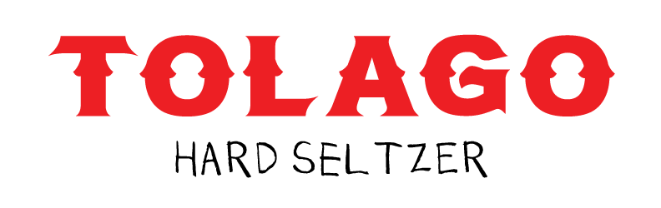

General: Founded by Nick Greeninger in 2020, Tolago Hard Seltzer stands for more than great beverages. As a collective of like-minded artists, musicians, athletes, and creative entrepreneurs, it is a business that does not believe in shortcuts. Rather, Tolago believes in working together to share and inspire culture, community, innovation, and environmental responsibility.

Inspired by the active, health-conscious Southern California lifestyle, Tolago’s superior flavors come straight from natural fruit juices, purées, and botanicals from California, as well as 100% organic agave nectar which is fair trade sourced from Mexico. The packaging is also 100% recyclable, and the company commits annually to 1% for the Planet.

About Tolago Hard Seltzer:
As the first super-premium, better-for-you hard seltzer, Tolago is elevating the category. Flavors include Ginger Pear, Agave Lime, Cherry Rose and Guava Mango. There is nothing artificial involved, and the product is gluten free.

Where to Find it: Tolago can be found in more than 400 brick and mortar outlets in California, as well on e-commerce sites including Pink Dot, PostMates, GrubHub, and Drizly. Tolago will launch in New Jersey on Feb. 1, 2021.
About the Flavors:
- Ginger Pear: This blend of fresh-pressed ginger and pear juice make a deliciously balanced sparkling spritz inspired beverage.
- Agave Lime: The combination of 100% organic agave nectar and fresh-squeezed lime has become a staple in modern-day drinks with or without alcohol.
- Cherry Rose: Naturally sweet cherry juice gives the seltzer a slight blush hue capturing the echoed in the rose’s natural color, perfect to pour out of the can and enjoy in your go-to wine glass.
- Guava Mango: The fullest flavor of the line with natural, tropical flavors of guava nectar and mango.

Packaging:

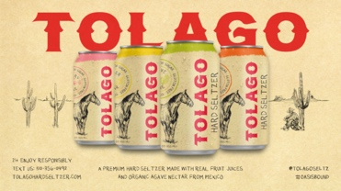
6- and 12-Can Packs: Tolago comes only in fully-recyclable, printed aluminum cans; most aluminum cans are actually wrapped in plastic, which makes them non-recyclable. Designed by co-founder and fine artist Matt McCormick, the packaging was inspired by the gritty reality of downtown LA, as well as the homestead towns, gold rush bonanzas, and 1920s Hollywood glamour that captivate popular imagination.
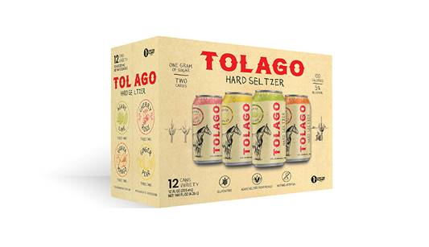

Tolago’s carton is also fully recyclable.

Pricing: 6-Pack: $12.99
12-Pack: $24.99

Alcohol: 5% ABV

Nutrition Facts (per 355mL / 12 oz.) Social
Calories: 100 Carbohydrates: 2g Twitter: @tolagoseltz
Fat: 0g Dietary fiber: 0g Instagram: @tolagoseltz
Saturated fat: 0g Sugars: 1g Facebook: @tolagoseltz
Sodium: 5mg Protein: 0g

