

“The Blue Angels” Wins for Outstanding Achievement in Sound Editing for a Feature Documentary at the MPSE Golden Reel Awards
The Blue Angels is recognized among other Golden Reel feature winners, including Wicked, The Wild Robot, Emilia Pérez, Saturday Night, and Dune: Part 2

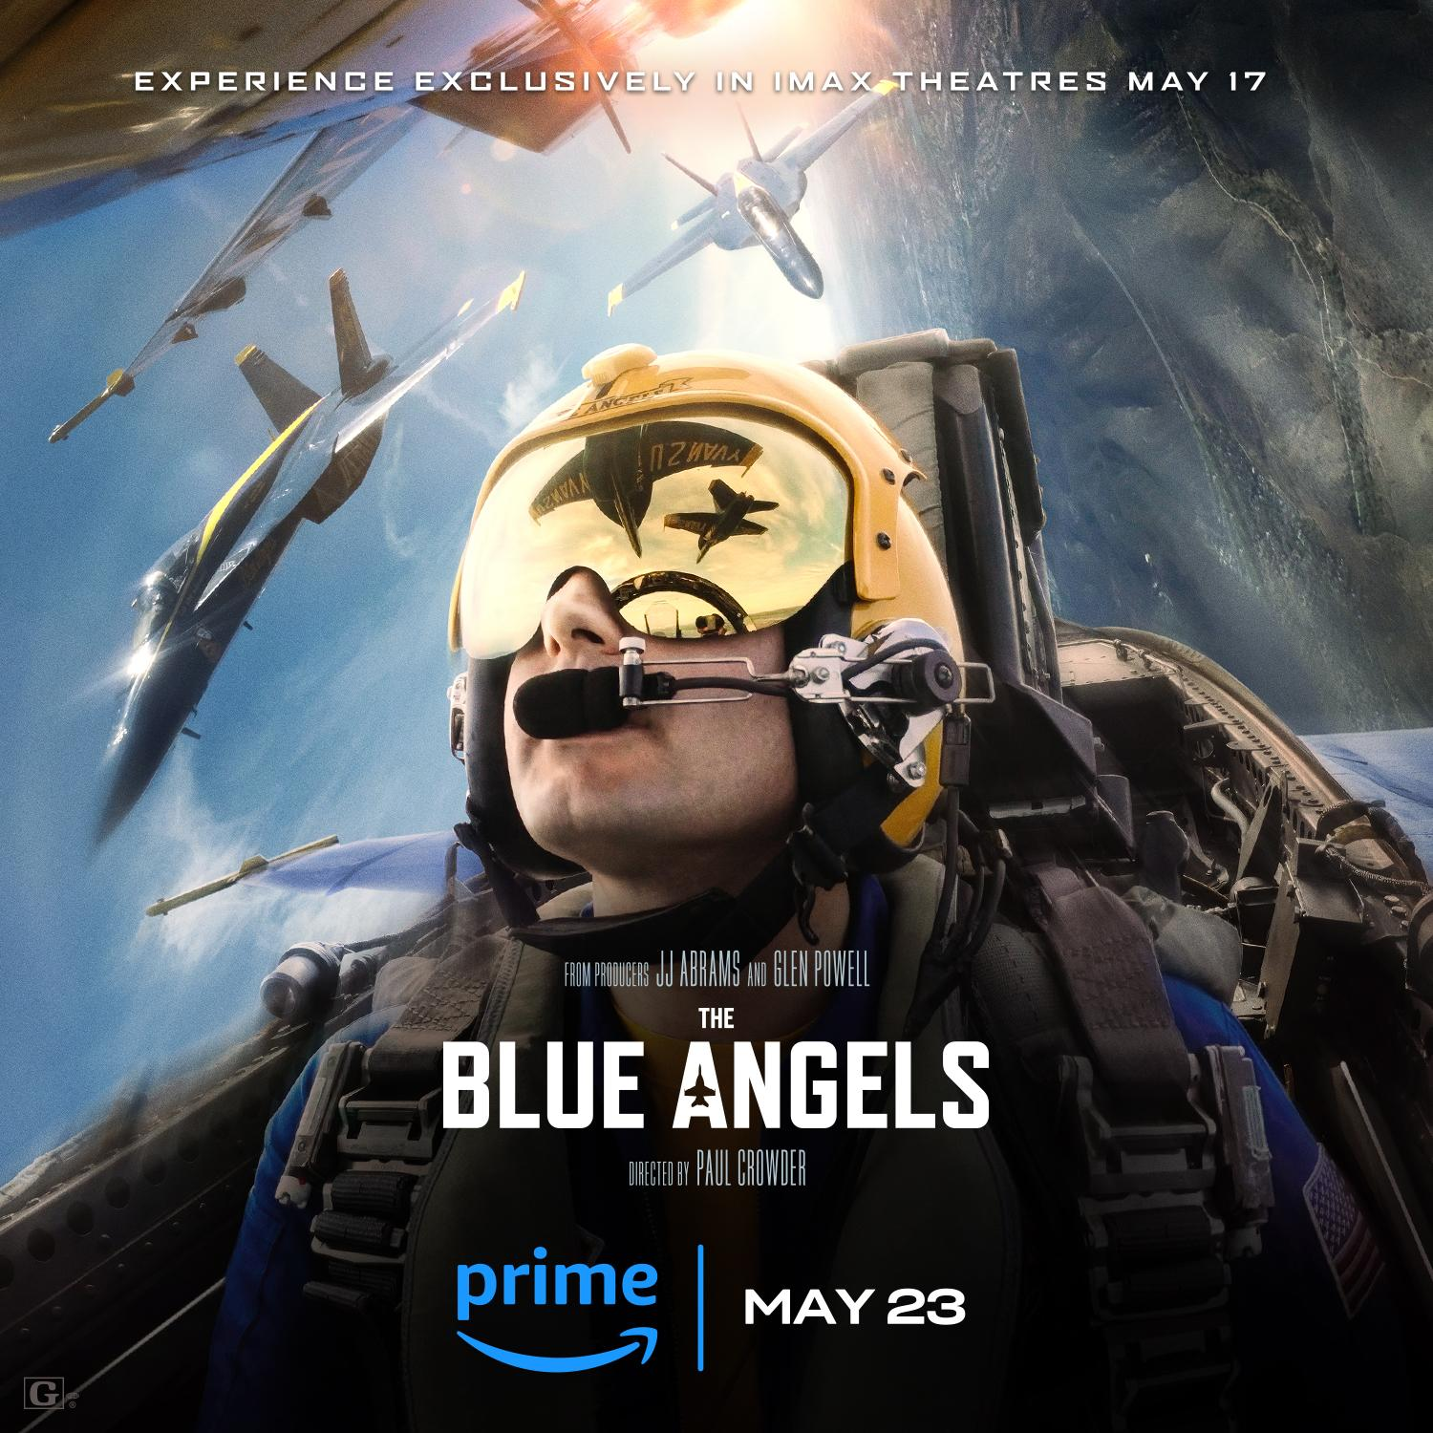

MIAMI, FL / ACCESS Newswire / February 27, 2025 / The Motion Picture Sound Editors’ 72nd Golden Reel Awards recognized Supervising Sound Editor Robert Stambler MPSE, Sound Effects Editor Ryan “Sully” Sullivan, and Dialogue Editor Emma Present of The Blue Angels for Outstanding Achievement in Sound Editing for a Feature Documentary. The awards honor outstanding achievement in sound editing and foley artistry in film, television and gaming. Other film winners included Wicked, The Wild Robot, Emilia Pérez, Saturday Night, and Dune: Part 2.
Filmed For IMAX® immersive footage puts viewers directly into the cockpit for a firsthand view of the Blue Angels' precision flying, while the aerial shots deliver a spectacular showcase of the breathtaking maneuvers that have made them the world's premier jet team. The filmmakers behind The Blue Angels were granted unprecedented access-on the ground and in the air-to invite audiences along, from the first days of rigorous training through to the final show and the passing of the torch to a new team. But even as the documentary lifts the veil of the Blue Angels mystique, it only magnifies the Blue Angels magic.

The documentary, from Bad Robot, Glen Powell's Barnstorm Productions, Zipper Bros Films, IMAX Entertainment and Dolphin Entertainment (NASDAQ: DLPN) reached over $2 million at the box office and was #1 on Prime Video when it was first released last summer.
All winners and nominees of the MPSE Golden Reel Awards can be found here.
About Dolphin
Dolphin (NASDAQ:DLPN), founded in 1996 by Bill O'Dowd, has evolved from its origins as an Emmy-nominated television, digital and feature film content producer to a company with three dynamic divisions: Dolphin Entertainment, Dolphin Marketing and Dolphin Ventures.
Dolphin Entertainment: This legacy division, where it all began, has a rich history of producing acclaimed television shows, digital content and feature films. With high-profile partners like IMAX and notable projects including "The Blue Angels," Dolphin Entertainment continues to set the standard in quality storytelling and innovative content creation.
Dolphin Marketing: Established in 2017, this division has become a powerhouse in public relations, influencer marketing, management, branding strategy, talent booking and special events. Comprising top-tier companies such as 42West, The Door, Shore Fire Media, Special Projects, The Digital Dept., Elle Communications and Always Alpha, Dolphin Marketing serves a wide range of industries - from entertainment, music and sports to hospitality, fashion and consumer products.

Dolphin Ventures: This division leverages Dolphin's best-in-class cross-marketing acumen and business development relationships to create, launch and/or accelerate innovative ideas and promising products, events and content in our areas of expertise.
About IMAX Corporation
IMAX, an innovator in entertainment technology, combines proprietary software, architecture, and equipment to create experiences that take you beyond the edge of your seat to a world you've never imagined. Top filmmakers and studios are utilizing IMAX systems to connect with audiences in extraordinary ways, making IMAX's network among the most important and successful theatrical distribution platforms for major event films around the globe.
IMAX is headquartered in New York, Toronto, and Los Angeles, with additional offices in London, Dublin, Tokyo, and Shanghai. As of December 31, 2024, there were 1,807 IMAX systems (1,735 commercial multiplexes, 11 commercial destinations, 61 institutional) operating in 90 countries and territories. Shares of IMAX China Holding, Inc., a subsidiary of IMAX Corporation, trade on the Hong Kong Stock Exchange under the stock code “1970”.
IMAX®, IMAX® 3D, Experience It In IMAX®, The IMAX Experience®, DMR®, Filmed For IMAX®, IMAX LIVE™, and IMAX Enhanced® are trademarks and trade names of IMAX Corporation or its subsidiaries that are registered or otherwise protected under laws of various jurisdictions. For more information, visit www.imax.com. You may also connect with IMAX on Instagram (www.instagram.com/imax), Facebook (www.facebook.com/imax), LinkedIn (www.linkedin.com/company/imax), X (www.twitter.com/imax), and YouTube (www.youtube.com/imaxmovies).
Contact Information
James Carbonara
Partner, Hayden IR
james@haydenir.com
646-755-7412
This press release contains 'forward-looking statements' within the meaning of the Private Securities Litigation Reform Act. These forward-looking statements may address, among other things, Dolphin Entertainment Inc.'s offering of common stock as well as expected financial and operational results and the related assumptions underlying its expected results. These forward-looking statements are distinguished by the use of words such as "will," "would," "anticipate," "expect," "believe," "designed," "plan," or "intend," the negative of these terms, and similar references to future periods. These views involve risks and uncertainties that are difficult to predict and, accordingly, Dolphin Entertainment's actual results may differ materially from the results discussed in its forward-looking statements. Dolphin Entertainment's forward-looking statements contained herein speak only as of the date of this press release. Factors or events Dolphin Entertainment cannot predict, including those described in the risk factors contained in its filings with the Securities and Exchange Commission, may cause its actual results to differ from those expressed in forward-looking statements. Although Dolphin Entertainment believes the expectations reflected in such forward-looking statements are based on reasonable assumptions, it can give no assurance that its expectations will be achieved, and Dolphin Entertainment undertakes no obligation to update publicly any forward-looking statements as a result of new information, future events, or otherwise, except as required by applicable law.
###

