With the incredible challenges we face, how can one individual make a difference in the world?

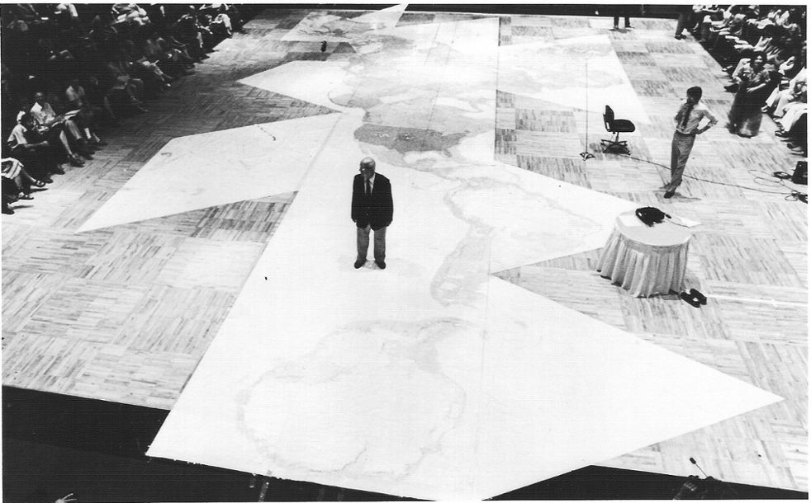
Join Marshall Thurber, LIVE at Los Angeles Trade Technical College (LATTC) in a one-day experience to find out how?

Date: December 4, 2015
Arrival Time: 8:30am
Event Time: 9am to 6pm
Location: LATTC – NORTH TENT LATTC Campus Map
Address: 400 W. Washington Blvd, Los Angeles, CA 90015
Attire: Comfortable. At times, you may be seated on the floor.
Lunch: Lunch is provided as part of the Game. Enjoy a hearty breakfast prior to arrival.
To Register for the Global Game Visit: www.burklynglobal.com/register/
Special Pricing only $199 - a $500 value
Brought to you by LATTC, presented by Burklyn Global
More Information Contact: Greg Rex 619-247-4739 or Greg@GregRex.com

Global Game Overview
The Global Game is an educational simulation developed by Buckminster Fuller in 1961 and updated by Marshall Thurber in 2013 to help create solutions to issues such as terrorism, climate change, overpopulation and the uneven distribution of global resources.
The essence of this experience is to realize how, together, we can "make the world work for 100% of humanity in the shortest possible time through spontaneous cooperation without ecological damage or disadvantage to anyone", thus increasing the quality of life for all people.

Don’t miss this life-changing EXPERIENCE with Marshall Thurber!

“The learning from this simulation will positively change your life forever.” -Marshall Thurber

“Marshall Thurber is an evolutionary event!”
-R. Buckminster Fuller

The Global Game – Additional Background

One (1) Day Interactive Experience created by Buckminster Fuller & Marshall Thurber - presented by Burklyn Global . . .

In 1927, at the age of 32, Buckminster Fuller stood on the shores of Lake Michigan, prepared to throw himself into the freezing waters. His first child had died. He was bankrupt, discredited and jobless, and he had a wife and new-born daughter. On the verge of suicide, it suddenly struck him that his life belonged, not to himself, but to the universe. He chose at that moment to embark on what he called "an experiment to discover what the little, penniless, unknown individual might be able to do effectively on behalf of all humanity."

Marshall Thurber was with Buckminster Fuller when he originally created and played
“The World Game”.

The World Game, sometimes called the World Peace Game, was an educational simulation utilizing Fuller's theories allowing groups of players to strategize solutions to global problems, matching human needs with resources. The game challenges the dominant nation-state perspective with a holistic "total world" view. The underlying question is “how to make the world work for 100% of humanity in the shortest possible time through spontaneous cooperation without ecological damage or disadvantage to anyone", thus increasing the quality of life for all people.

The Global Game is an updated version of Buckminster Fuller’s World Game. The World Game was created in 1961 and updated by Burklyn Global in 2013.
During this one (1) day of transformational playing, you will have the opportunity to experience:
- How to change the world and create a world that works for ALL.
- A meta-perspective, the biggest picture of Global Convergence.
- A comprehensive approach to the problems of the world.
- How real change is accessible to everyone, not just the elite few in power who are “running the show”.

Additional benefits include:
- Enhanced Critical Thinking
- Improved Conflict Resolution
- Heightened Global Awareness
- Strengthened Leadership Skills

