DOOGEE introduces the S88 Pro IP68 rugged phone with triple camera, unique LED back lighting and 10,000mAh battery
The S88 Pro is the perfect phone for adventures with an impressive camera, long lasting battery life and reverse charging

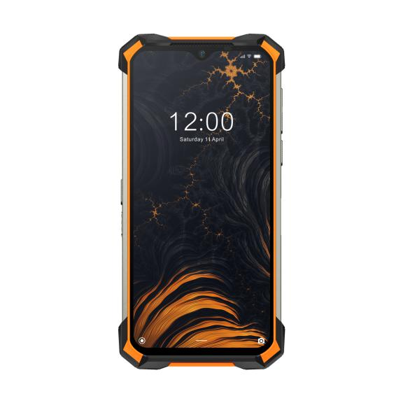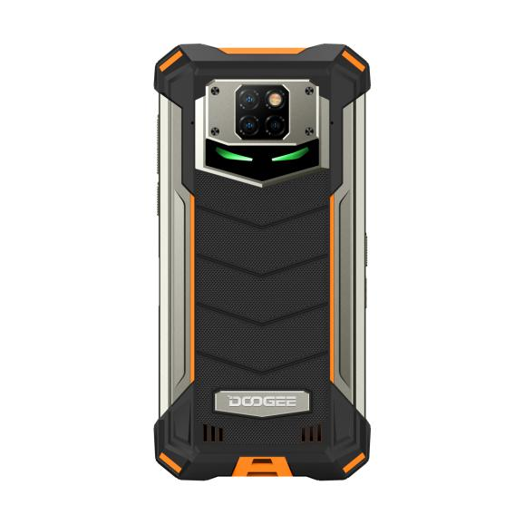
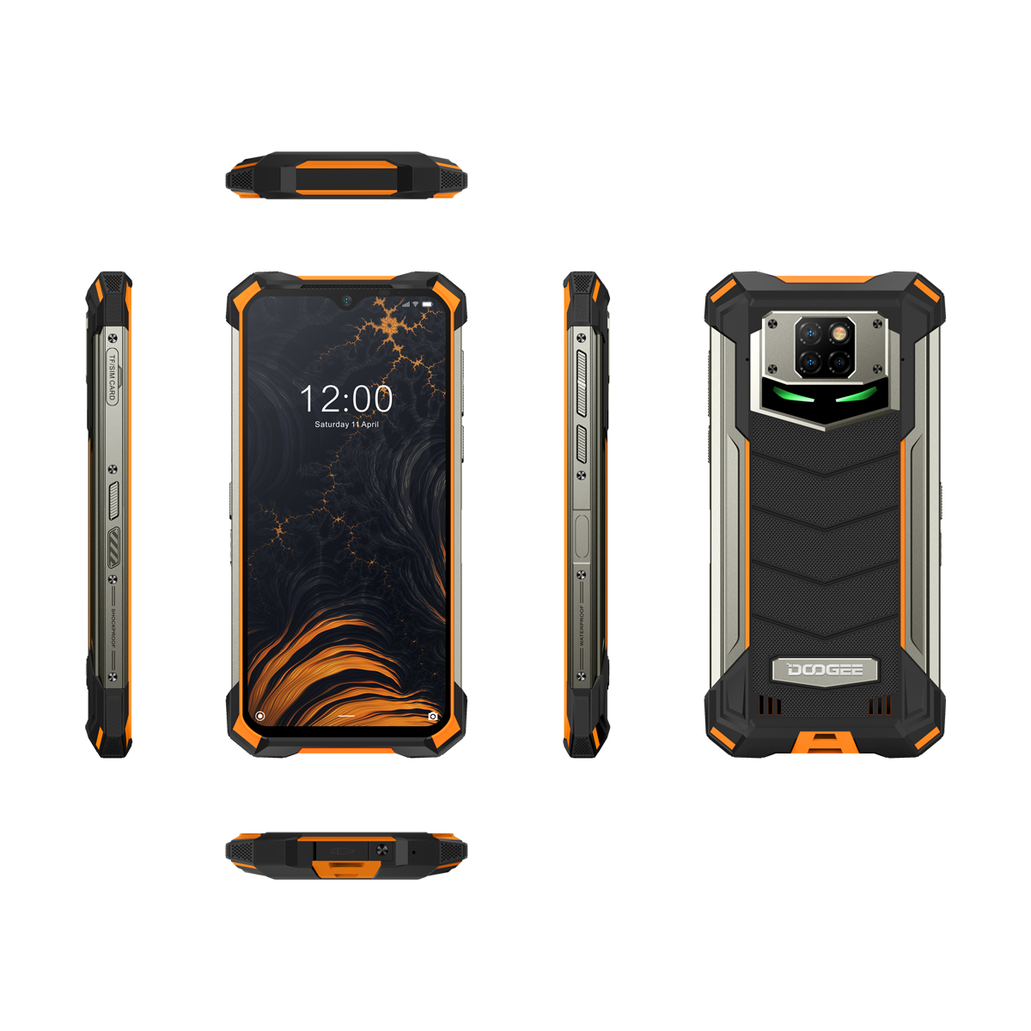

HONGKONG, June 2020: Innovative technology company, DOOGEE Hengtong Technology Co. Ltd, is today pleased to announce the launch of its latest phone, the DOOGEE S88 Pro. The DOOGEE S88 Pro is a rugged smartphone that is packed full of features including a 10,000 mAh battery, unique LED lights, a triple camera and has IP68 protection. The S88 Pro is available in Army Green, Fire Orange and Carbon Black. With a Helio P70 processor, the S88 Pro incorporates a powerful Arm Cortex-A73/A53 octa-core CPU complex with an impressive Arm Mali-G72 class GPU. This makes the phone 13% faster than those with a P60 processor and provides 10-30% more AI processing efficiency. Running on Android 10 OS, it offers more f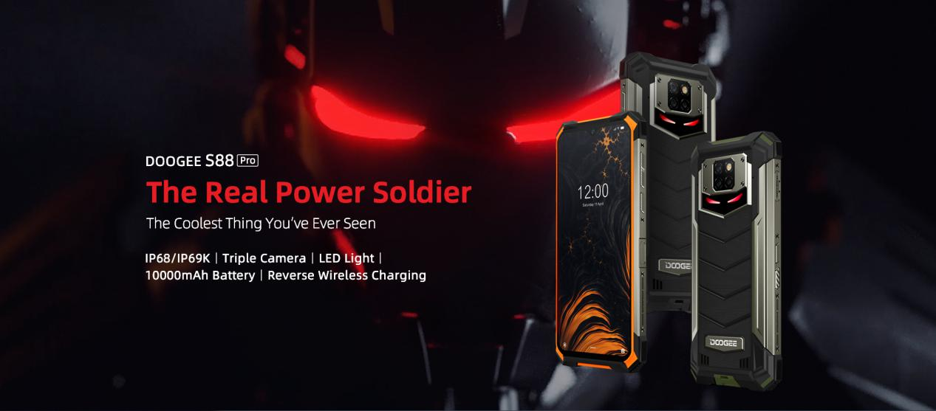eatures than ever before and an intuitive and fluid performance.

Boasting an impressive screen, the S88 Pro has support for 20:9 displays at full HD+ resolution that allow users to enjoy the smartphone with full fascia coverage. With 128GB ROM there is plenty of room for storage and it is able to hold up to 420 episodes of a favourite show, 80 2D games or 1600 albums as well as 6GB RAM so content can be appreciated at high quality with a smooth multitasking experience.
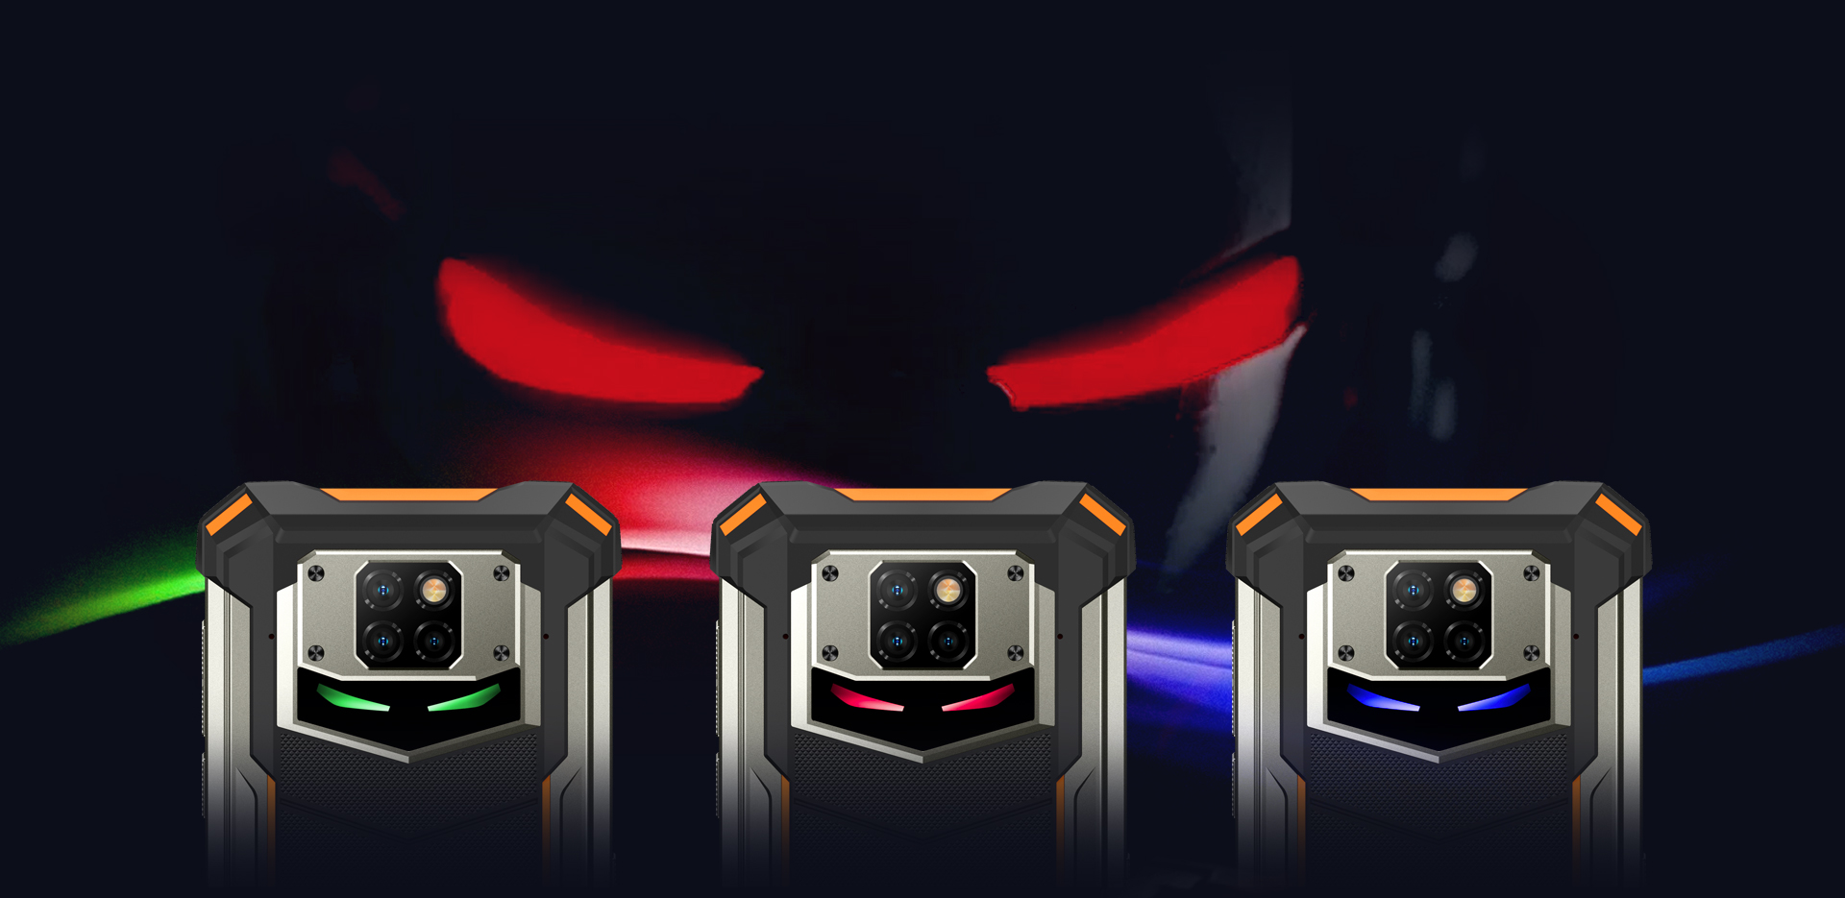
LED Back Light & Screen
The unique LED back light that is under the black translucent tempered glass is the pioneer design of the DOOGEE S88 Pro. It works and lights up for calls, messages, music and other notifications in different colours dependent on the notification. For example, the LED back light shows as blue for messages and calls, red for other notifications and can be blue/green/red for music.
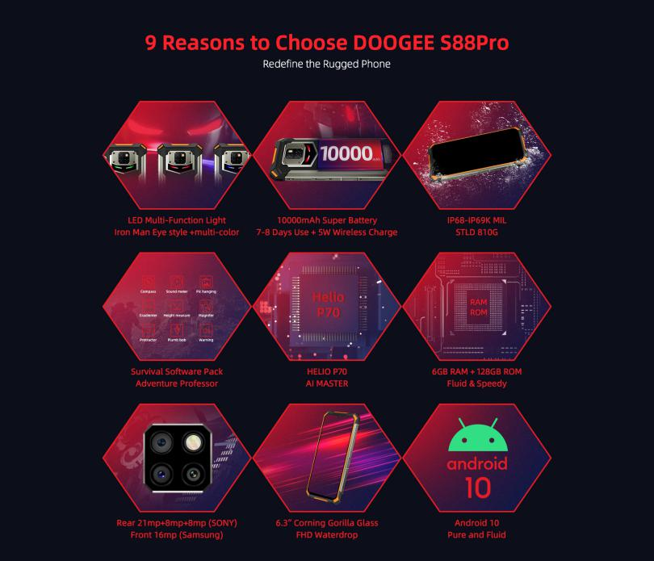
The 6.3” Full HD waterdrop screen gives an immersive experience whilst using the phone. Providing superior clarity and vivid colours, it is also protected by Corning Gorilla Glass to allow it to resist daily drops and scratches easily. With 1500:1 contrast, 410 PPI pixel density and 1080*2340 resolution, it will impress whilst in use. The new gesture navigation system is also simple and easy to control by swiping to open different aspects of the menu, apps or to operate Google Assistant.
Rugged Capabilities
Built for intensive outdoor use and to withstand all environments, the rough and rugged DOOGEE S88 Pro has an IP68 rating and has been tested in all conditions to ensure it is resistant to damage from being dropped and water immersion as well as shock and impact. The rugged phone has been tested to be drop-proof up to 1.5 meters height as well as testing to be waterproof up to 2 meters depth and has also had brick pressure and sand immersion tests. Made using top two-colour injection molding techniques, the hard and soft rubber of the phone are integrated to create a protective shield.
The S88 Pro also has a survival software pack to make it not only a great rugged phone but also a professional phone for any hiking lovers. The apps available are ideal for those adventurous walkers, including compass, sound meter, height measure, magnifier and plenty more essential apps for activities.

Camera
Featuring an impressive SONY 21MP+8MP+8MP AI triple rear camera, the phone is ideal for capturing pictures and clips whilst travelling or exploring. The powerful camera system includes a 21MP SONY IMX230 main camera, 8MP 130° ultra-wide-angle lens and 8MP macro lens to give a premium quality and experience for photography. The SONY IMX230 chip ensures that images taken of fast-moving objects or people remain clear and sharp as well as having an integrated HDR for high resolution stills and 4K video when in dark or night-time scenes making it ideal for use no matter the time of day. The 130° ultra-wide-angle lens expands the view of images to capture a whole scene in one frame effectively.
In addition to the rear camera, the S88 Pro also includes a Samsung S5K3 16MP selfie camera with an 80° wide angle lens. This camera can be used to enhance facial features and it automatically identifies ages and smoothens different skin tones depending on gender to give the highest quality and best image of users – Instagram worthy pictures instantly!
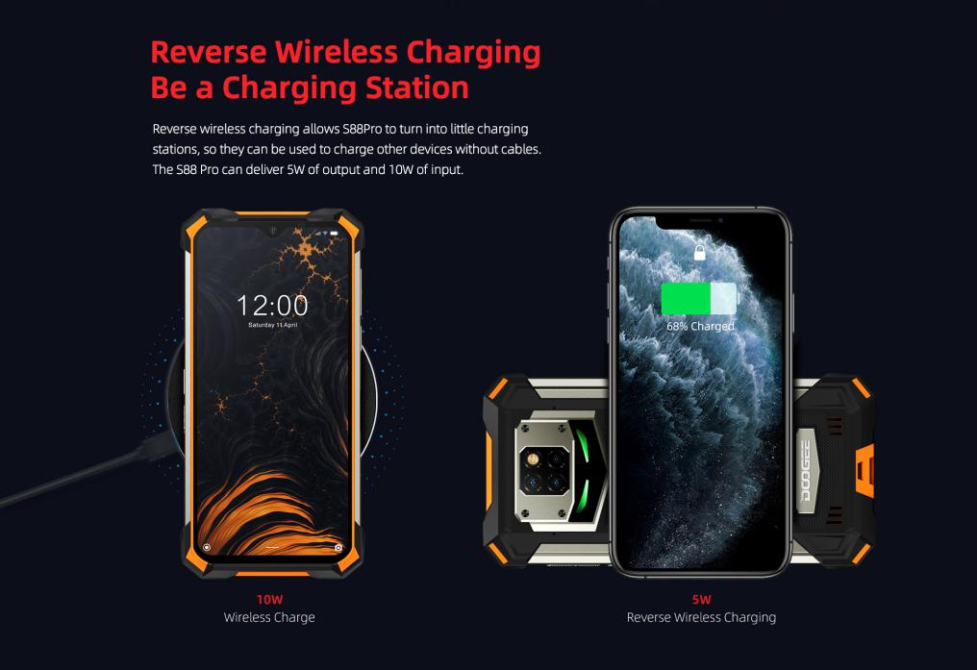

Battery & Reverse Wireless Charging
Featuring a huge 10,000mAh battery, the DOOGEE S88 Pro gives the ultimate solution for smartphone users. Ideal for travelling, the battery can provide 10-15 days of normal use meaning that there is no need for low battery anxiety or to pack an extra power bank. Offering a massive 900 hours of standby and 23/45 hours of talk time, it is ideal for keeping connected whilst on the move. Additionally, the S88 Pro features 5W reverse wireless charging allowing it to charge other devices without cables for ultra-convenience.
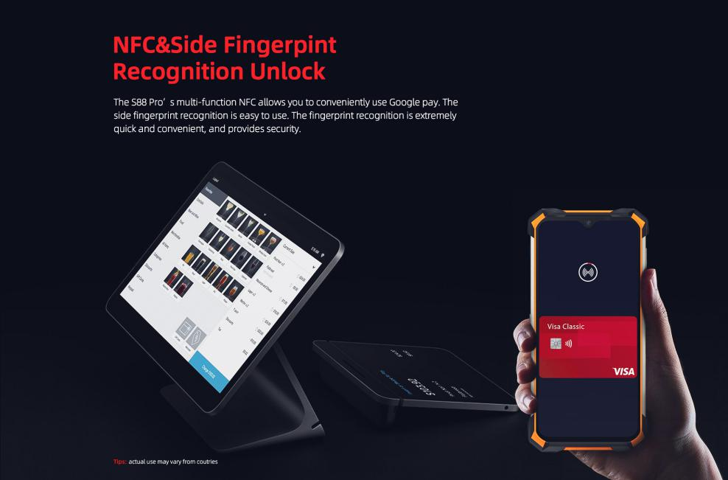
Security
For enhanced security, the S88 Pro includes both face recognition as well as NFC and side fingerprint recognition to unlock the phone. The multi-function NFC allows users to conveniently and safely use Google Pay. Designed to be extremely quick and easy to use, it makes unlocking the device as simple and secure as possible.
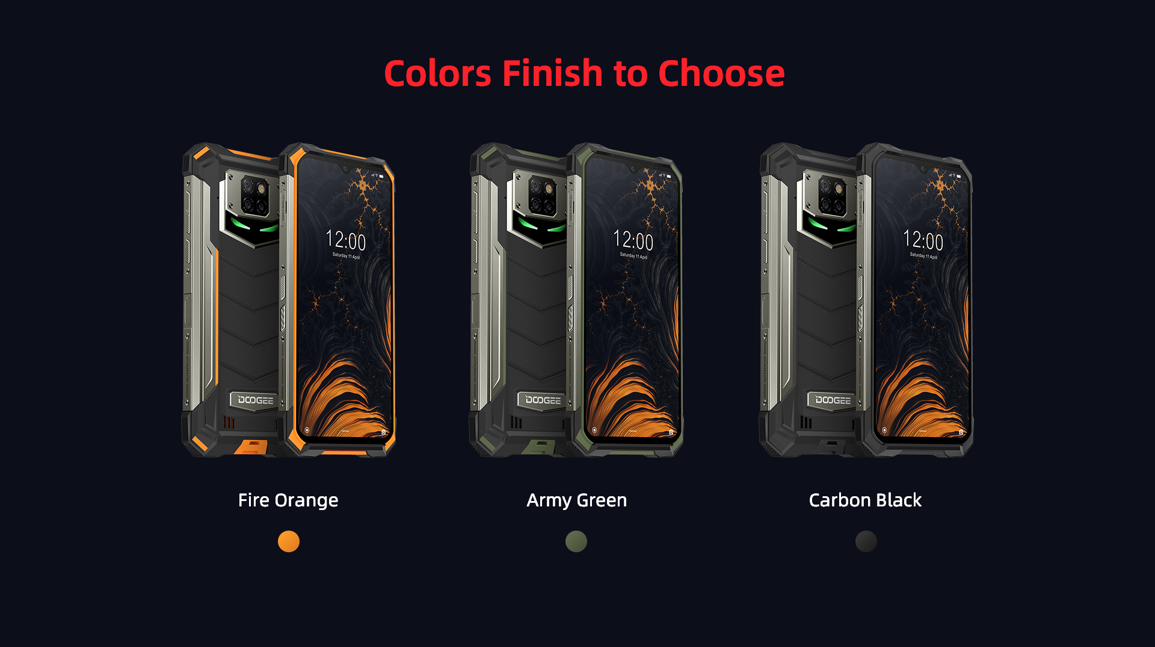
S88 Pro Preview :https://promotion.doogee.cc/doogee-s88pro/
DOOGEE S88 Pro DOOGEEMALL: https://bit.ly/2yXDcfQ
DOOGEE S88PRO ALIEXPRESS : https://bit.ly/2AmsWhz
DOOGEE High resolution imagery: https://photos.app.goo.gl/A6nyoHzp1iFuSAw4A

Preorder price:199.99 (249.99 normal price)

S88 Pro frequency: GSM：2/3/5/8
WCDMA：1/2/4/5/8
FDD：1/3/7/8/20
LTE base band: B1/3/7/8/20
4G: B1/3/7/8/20

- ENDS-

About DOOGEE Hengtong Technology Co., Ltd:
DOOGEE is a technology company that was set up in Spain in March 2013. This contributes to the high performance of its products as well as their beautiful design and features, smart operation, and “micro-innovation”.
DOOGEE’s new slogan is “Live Your Life,” delivering fashionable products with new technology, with the aim of becoming the most popular smartphone supplier in the world.
For more information or to discuss a review sample, please contact Lucy Major, Sara Wingrove, Millie Walters or Ross Perrin at firstname.surname@nononsensepr.co.uk

